
Review Paper on
A Comprehensive Review of Electric Vehicles (EVs), Plug-in Hybrid Electric Vehicles (PHEVs), and Hybrid Electric Vehicles (HEVs)
1st Draft Submission
Course No.: MCE 4391
Course Name: Basic Mechanical Engineering
Department: EEE
Section: C
Group members:
- Md. Azmain Hasan (230021307) - Introduction & Background
- Ishrak Samin (230021303) - Review Methodology
- Taqi Yasir (230021319) - Vehicle Classification & Powertrain Architectures
- Shaheen Rahman Dibya (230021315) - Battery & Energy Storage Systems
- Nasif Faiyaz (230021305) - Electric Motors & Power Electronics
- Samia Jahan Tisha (230021321) - Charging Infrastructure & Grid Interaction
- Nafisa Naimun (230021345) - Energy Efficiency & Environmental Impact
- Sadia Afrin (230021342) - Economic Analysis & Market Trends
- Atib Zawad Wasi (230021312) - Policies, Regulations & Global Adoption
- Tall Ali Boureima (230021347) - Challenges, Future Trends
- Rifat Rahman Nirjhor (230021318) - Conclusion & Abstract

Nomenclature
PSD Power Split Device
PG Multiple Planetary Gear
MG Motor/Generator
PHP Parallel Hybrid Powertrain
Abstract:
This review paper illustrates a comprehensive analysis of electrified vehicle technologies, together with Battery Electric Vehicles (BEVs), Hybrid Electric Vehicles (HEVs), and Plug-in Hybrid Electric Vehicles (PHEVs). It systematically inspects their operational ethics, powertrain architectures, and key enabling technologies such as energy storage systems, electric motors, and power electronics. The study further appraises charging infrastructure, grid integration, and system-level performance considerations. Environmental impacts, energy efficiency, and economic perspectives are critically uttered in the context of global decarbonization goals. Additionally, the paper highlights current challenges, including battery limitations, infrastructure constraints, and cost factors, while marking out emerging trends and future research directions. Overall, this review provides a structured and technical overview of electrified transportation as a sustainable solution for decreasing greenhouse gas emissions and relying on fossil fuels.
1. Introduction and Background
1.1 Overview of Electrified Vehicle Technologies
The global transportation system is about to change more than it did when cars replaced horse-drawn carriages a hundred years ago. Three main forces drive this change - the need to slow climate change, the need to secure energy supplies, and the need to clean the air in cities. In the United States, transport uses about twenty-eight percent of all energy-related CO₂ emissions, and road vehicles release the largest part of that share ​[1]​ . Countries have strengthened their promises to reach net zero emissions under the Paris Agreement—cutting carbon from transport has turned from a green goal into a required policy for rich plus developing nations ​[2]​ .
Electrified vehicles range from mild hybrids to cars that run only on battery power, and they now lead the only clear route to cut carbon from road transport. Conventional cars burn only petroleum, but electrified models add an electric drive that turns fuel into motion with fewer energy losses and can expel no exhaust gases at the tail pipe ​[3]​. Transport uses about sixty percent of all oil—any drop in that demand threatens the balance between oil supply plus consumption - for this reason, shifting to electric drive is treated as a security issue for national energy policy. The change does not follow a single template. It proceeds through a sequence of designs that differ in how much carbon they avoid, how far they travel on a charge, how much new infrastructure they need, and how much they cost ​[4]​.
1.2 The Three Pillars of Electrification: EVs, PHEVs, and HEVs
Electrified vehicles available today fall into three broad groups - Hybrid Electric Vehicles, Plug in Hybrid Electric Vehicles besides Battery Electric Vehicles. Each group uses a different method of electrification, works with a specific set of supporting systems, and leaves a distinct mark on the environment.
A Hybrid Electric Vehicle carries both an internal combustion engine and an electric motor, but it has no socket for an external charge. The vehicle creates its own electricity when the driver brakes or when the engine has spare capacity ​[2]​. While the car moves, the engine delivers most of the torque to the wheels - the motor plus its small traction battery adds extra torque when needed. Because the battery recharges itself, the driver refuels only with liquid fuel and enjoys a fuel economy gain of roughly thirty to fifty percent compared with a purely combustion car, without the need to locate a charger ​[5]​.
A Plug in Hybrid Electric Vehicle carries a larger traction battery - it can cover twenty to eighty kilometers on grid electricity alone. The driver plugs the car into an external supply to refill the battery. Once the battery reaches a low threshold, the vehicle behaves like a hybrid - the engine, the motor or both units together can send torque to the wheels, and the battery continues to collect energy from the engine but also from regenerative braking ​[3]​.
1.3 Historical Evolution of Electrified Powertrains
Electric vehicles appeared multiple decades before gasoline engines took over. In the late 1800s and early 1900s, cars with electric drive systems sold well against gasoline plus steam models because they ran silently, gave immediate pulling force and started without a hand crank. The later discovery of large oil fields, the arrival of an electric starter that removed the need for the risky crank besides Ford's high volume assembly lines for gasoline cars pushed electric drive into minor roles for most of the 1900s ​[6]​ .
Renewed attention to vehicles with electric drive began in the 1990s, after California required manufacturers to sell a set number of zero emission cars. Small batch models like General Motors’ EV1 showed that electric drive worked but lead acid batteries kept the range short but also the price high. When Toyota launched the Prius in Japan in 1997 and worldwide in 2000, it demonstrated that a hybrid layout - an engine paired with an electric motor as well as a modest battery - raised fuel economy by 30 - 50 percent compared with standard cars without asking drivers to change habits or build new fuel stations ​[3]​.
The modern wave of vehicle electrification started when Nissan released the Leaf besides Tesla released the Roadster in the late 2000s. General Motors added the Chevrolet Volt, a plug-in hybrid, in 2010. All three models used lithium-ion cells, a chemistry that stores more energy per kilogram, survives more charge discharge cycles and delivers power more briskly than the older nickel-metal-hydride or lead acid batteries. From that point onward, factories have multiplied their battery output; prices have fallen as production experience has grown, and engineers have created many vehicle layouts, ranging from small city cars to large trucks ​[7]​.
1.4 The Environmental Imperative for Transportation Electrification
Vehicle electrification is driven by two linked goals - cutting the gases that warm the planet and cleaning the air people breathe. In 2022, moving people plus goods produced twenty eight percent of all greenhouse gases released in the United States, the largest share from any single part of the economy. Cars and light trucks alone gave off fifty seven percent of transportation total - the rest came from larger trucks, planes, trains but also ships. Because almost all this movement still relies on petroleum, the system both warms the atmosphere and leaves the country exposed to oil price spikes as well as supply disruptions.
Even though engines and fuels have become more efficient, the number of miles driven keeps climbing - carbon dioxide output from transportation keeps rising in many places. Electric models break the link between distance traveled or barrels of oil burned ​[8]​. A battery electric vehicle and a plug-in hybrid running on battery power, release no carbon dioxide, nitrogen oxides or particulate matter from the tailpipe. The absence of those pollutants is valuable in cities, where traffic is the main reason air quality limits are breached.
The total environmental gain from electric vehicles hinges on the kind of electricity that feeds the chargers. No smoke leaves the car - instead, the smoke comes from the power station that produces the kilowatt hours. Because of that, each mile driven in a plug in EV releases an amount of pollution equal to whatever mixture of coal, gas, wind, sun or other sources the local grid used at that hour, in that season and in that region. Over decades, that same mile will release a different amount as the grid adds more wind, solar, and other renewable capacity ​[9]​. The result shows that cleaning the grid must move in step by putting more EVs on the road.
1.5 Technologies and System Integration
Electric vehicle technologies now change quickly, and the changes reach past the cars themselves into wider system links plus new ways to charge. When an EV joins a smart grid or an intelligent traffic network, the car stops being only transported - it becomes a small power plant that can feed energy back, steady the grid and raise the share of renewable power. Wireless charging technology has appeared as a useful innovation. It gives convenience and safety. It also allows cars to charge while they move - the battery can be smaller, plus the car can travel farther. If the car drives itself, the recharge needs no human help [2], [10]. The car simply parks over a pad and power flows. This removes the driver from the task but also supports new business models that sell trips instead of cars. Network links and self-driving systems now meet. Together they let traffic flow more smoothly, waste less energy, as raises the efficiency of the whole transport network.
1.6 Scope and Key Themes of this review
This review encompasses the following key thematic areas:
Battery storage - Studies show that how lithium-ion cells have changed over time, from nickel- cobalt- manganese and lithium-iron-phosphate to lithium-titanate-oxide. Additionally, by looking at the solid-state designs it can be proved. Researchers insist the reuse of retired packs, and they also list energy density, cycle count, safety but also price trends side by side ​[10]​.
Charging points – The documents mainly list the three supply levels - Level 1 at 120V AC, Level 2 at 240V AC besides Level 3 DC fast charge - along with the main plugs next to protocols CCS, - SAE J1772, GB/T and also the North American Charging Standard. They not only state power ratings but also describe hardware those are found in home garages, office parks plus roadside stations, and note where stations remain scarce ​[11], [12]​. Some Apps but also payment systems serve houses, workplaces and public lots as well as analysts largely agree that wider charger access still governs how fast electric vehicles spread.
Grid integration - This work measures how the connection of electric vehicle chargers changes the whole distribution network. It also records the rise in peak load along with the risk of transformer overload, the shift in voltage level and the drop in power quality ​[12], [13]​. It also tests smart charging methods that shape demand - those operating under central, local, or layered control. Additionally, it helps in checking the use of vehicle to grid power flow that lets parked cars feed energy back to the utility by supporting the grid, and it checks the joint operation with solar or wind plants.
Commercial and fleet use - We look at the depot chargers that electric trucks, buses plus delivery fleets need, how to set charging times so trucks do not all plug in at once, how to keep the power draw below the local limit and what daily work must change ​[14], [15]​. Those vehicles demand high power but also often want it at the same moment - the job is harder than for cars. New Jersey runs a Zero Emission Incentive Program that has put USD 75.5 million into medium- and heavy-duty commercial vehicle –the program shows that states now watch this market closely​[16]​.
Policy and market analysis covers purchase incentives, tax exemptions plus non-monetary advantages like permission to use restricted lanes and reserved parking spots. It also includes infrastructure policies, regulatory standards like fuel economy rules but also zero emission vehicle mandates and adoption patterns in China​[17]​, Europe besides North America. Yang et al. study how different government policies affect electric vehicle spread - reviewing 516 policies across 25 countries. They find that electric vehicles spread faster when policy design matches each country's economic as well as social conditions ​[18]​.
1.7 Rationale for This Comprehensive Review
Electrified vehicle technologies changed quickly during the last five years - a full, current summary of knowledge is now required. In 2010 a battery cost more than one thousand dollars for each kilowatt hour - in 2025 the price fell to about one hundred and fifty dollars for the same amount and this shift alters basic economic calculations for electrifying vehicles ​[4], [19], [20]​. Charging infrastructure grew fast - at the end of 2024 China had thirty one point four million new energy vehicles plus twelve point eight one eight million charging points, a rise of forty nine point one percent compared with the previous year but the points are spread unevenly across regions - some places still face lower adoption chances​[20]​. Studies now give a clearer picture of grid integration problems - they show the dangers of unplanned charging and the benefits of smart charging together with vehicle-to-grid systems ​[16], [21]​.
Research on electrified vehicles now covers many separate topics but studies that treat vehicle design, batteries, chargers, grid impacts and policy as one system are still scarce. The present work closes this gap - combining results from all five areas. It relies chiefly on peer reviewed papers published at recent times to deliver an up-to-date, reliable picture of both the present state and the expected path of electrified vehicle technology ​[22]​
2. Review Methodology
This section highlight the methodologies and criteria used to collect, evaluate, and synthesize literature relevant to Electric Vehicles (EVs), Plug-in Hybrid Electric Vehicles (PHEVs), and Hybrid Electric Vehicles (HEVs).
2.1 Research Scope and Guiding Questions
The review focused on technological, environmental, economic, and policy dimensions of EV, HEV, and PHEV systems. To guide the literature the following topics were established:
- Current Classifications of Electric and Hybrid vehicles.
- Modern energy storage systems, electric motors, and power electronics and their support for vehicular performance
- What advancements exist in charging infrastructures and grid integration?
- The environmental, economic, and regulatory implications of large-scale adoption of electrified transportation.
These questions facilitated in determining inclusion and exclusion criteria and maintain thematic coherence across all sections of the review.
2.2 Literature Search Strategy
A structured literature search was conducted using major scientific and technical databases:
IEEE Xplore, Schimago, Google Scholar, sciencedirect.com, Advanced Online Library Wiley, Science Direct, IEA authority, Climate.ec, transport.ec, acea.auto, irs.gov, oecd.org, MDPI, theicct.org and some governmental official website
The search period emphasized literature from 2020 to 2025, with seminal foundational works from earlier years included when necessary. However the policies were stagnant if not the same over the period, therefore it was taken from 2015 to 2025.
2.3 Inclusion and Exclusion Criteria
Inclusion Criteria
Sources were considered if they were related directly to EV, HEV, or PHEV technologies. Moreover, they were also included if they addressed engineering, environmental, economic, or regulatory aspects relating to EV, HEV or PHEV
Exclusion Criteria
Sources were excluded from the review if they lacked adequate technical depth or a clear scientific or research foundation, focused exclusively on fossil-fuel vehicle technologies which include ICE powertrains, fuel injection systems, conventional automatic or manual transmissions designed for ICE vehicles solely, without providing relevance to electric propulsion, appeared as duplicates across multiple academic databases, or contained outdated or superseded information that did not offer meaningful historical context.
2.4 Data Extraction and Organization
The literature was categorized into the following sections:
Vehicle Classification & Powertrain Architectures
Battery & Energy storage systems
Electric Motors & Power Electronics
Charging Infrastructure & Grid Interactions
Energy Efficiency & Environmental Impacts
Policies, Regulations & Global Adoption
Challenges and Future Trends.
The key details which were extracted included system specifications of the machines, performance metrics, comparative analyses within EV, HEV and PHEV, and of course, real-world case studies.
Vehicle Classification
1) BATTERY ELECTRIC VEHICLES (BEV):
BEVs, depicted in Figure 1(a), run solely on electricity from rechargeable batteries for propulsion. They lack an internal combustion engine (ICE), making them emission-free during use. BEVs employ electric motors and recharge through external power sources like home charging units or public stations [23], [24], [25]. Recent improvements in battery technology have enhanced BEVs, providing longer driving ranges and quicker charging, making them a viable choice for consumers. Notable models like the Tesla Model 3 and Nissan Leaf contribute to lowering environmental impact and reducing reliance on fossil fuels [26], [27], [28], [29].
2) PLUG-IN HYBRID ELECTRIC VEHICLES (PHEV):
PHEVs utilize both an electric motor and an ICE, as shown in Figure 1(b). They can operate solely on electricity for short distances, usually between 20 and 50 miles, before reverting to gasoline when the battery runs out [30], [31], [32], [33], [34]. PHEVs utilize external power sources for charging and provide enhanced flexibility for longer journeys due to their gasoline engine. This combination of powertrains improves fuel efficiency and lowers emissions. Notable models like the Toyota Prius Prime and Chevrolet Volt are perfect for those seeking electric driving without concerns about range [35].
3) HYBRID ELECTRIC VEHICLES (HEV):
HEVs are powered by an internal combustion engine (ICE) and by an electric motor that uses energy stored in a battery [36], but unlike PHEVs, they cannot be plugged into a charger, as exhibited in Figure 1(c). Alternatively, the battery gets charged by means of regenerative braking and its own engine [37], [38]. The motor-driven EV assists the engine during acceleration or low speeds, enhancing fuel efficiency and lowering emissions [39], [40]. HEVs have been available for years, exemplified by the Toyota Prius. They provide environmental advantages but mainly depend on gasoline, making them ideal for those focused on better fuel efficiency rather than complete electric driving [41].
4) FUEL CELL ELECTRIC VEHICLES (FCEV):
FCEVs are electric vehicles that generate electricity through a chemical reaction between hydrogen and oxygen in a fuel cell, as illustrated in Figure 1(d). This process powers the vehicle's motor and emits only water vapor, ensuring FCEVs are very environmentally friendly [33], [42], [43], [44], [45], [46], [47]. In FCEVs, the battery acts as an energy reservoir, capturing energy from regenerative braking and providing extra power while accelerating. It contributes to the energy generation of the fuel cell, promoting efficiency. It also smoothes power output, reducing system stress. Moreover, the battery enables cold starts by supplying initial power until the fuel cell reaches its optimal temperature. Hydrogen refueling is quicker than charging conventional electric vehicles, and fuel cell electric vehicles are built for longer driving distances compared to battery electric vehicles. However, the use of FCEVs is constrained by the availability of hydrogen refueling stops. Prominent examples of FCEVs are the Toyota Mirai and Hyundai Nexo, showcasing hydrogen's potential as a sustainable fuel for the future [48].
Table I: System-Level Comparison of BEV, HEV, PHEV, and FCEV Powertrain Architectures
Powertrain Type | Primary Energy Source | Energy Conversion Mechanism | Drivetrain Architecture | Energy Storage System | System Complexity | Charging / Refueling Method | Emissions  Characteristics
Battery Electric Vehicle (BEV) | Grid-supplied electrical energy [49] | Electrical energy stored in the traction battery is converted via a power inverter to drive electric motor(s), which transmit torque to the wheels [49] | Fully electric propulsion system employing one or more electric motors coupled with a single-speed reduction gearbox [49] | High-capacity lithium-ion battery pack (approximately 40–80 kWh) [51] | Low architectural complexity due to absence of internal combustion engine (ICE) and multi-speed transmission [51] | External plug-in charging (AC Level 2 or DC fast charging infrastructure) [51] | Zero tailpipe emissions during vehicle operation [53]
Hybrid Electric Vehicle (HEV) | Conventional liquid fuel (gasoline/diesel) combined with a supplementary battery [49] | Chemical energy from fuel is converted by the ICE to mechanical power; electric motor provides propulsion assistance and regenerative energy recovery [50] | Parallel or power-split hybrid configuration integrating mechanically coupled ICE and electric motor [50] | Small-capacity battery pack (approximately 1–8 kWh) [51] | High system complexity due to integration of ICE, electric motor, transmission, and power electronics [51] | No external charging; battery recharged through regenerative braking and ICE-driven generation [51] | Tailpipe CO₂ emissions present, though generally lower than conventional ICE vehicles [53]
Plug-in Hybrid Electric Vehicle (PHEV) | Combination of gasoline and grid electricity [50] | Operates in charge-depleting (electric-only) mode using battery energy; transitions to hybrid mode where ICE supplements propulsion [50] | Hybrid drivetrain (parallel or power-split) with dedicated EV-only capability [50] | Medium-capacity battery pack (approximately 10–15 kWh) in addition to fuel tank [51] | Very high complexity owing to dual propulsion systems and onboard charging components [51] | External plug-in charging capability (typically AC) in addition to conventional fuel refueling [51] | Zero tailpipe emissions in electric-only mode; CO₂ emissions generated during ICE operation [53]
Fuel Cell Electric Vehicle (FCEV) | Compressed hydrogen gas (H₂) [52] | Hydrogen undergoes electrochemical conversion in a fuel cell stack to produce electricity, which is supplied via inverter to the electric motor [52] | Electric propulsion system comparable to BEV, supplemented by fuel cell stack and hydrogen storage system [4] | High-pressure hydrogen storage tank (~700 bar) with auxiliary buffer battery [52] | Moderately high complexity due to integration of fuel cell system, hydrogen storage, and electric drivetrain [52] | Hydrogen refueling at dedicated stations; refueling time approximately 3–5 minutes [52] | Zero harmful tailpipe emissions; water vapor is the only byproduct [52]

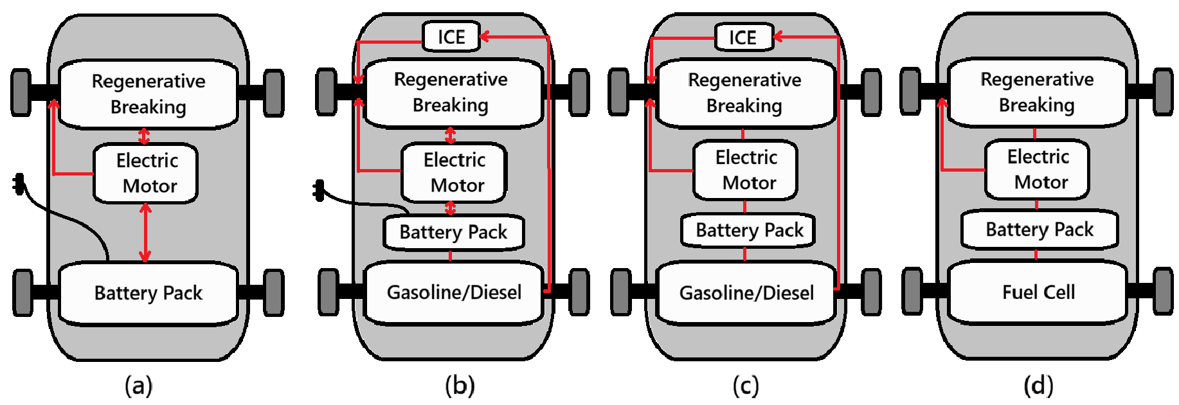
Fig. 1: HEV configurations are classified into series, parallel, power-split, and multi-mode.
Powertrain Architectures
The four main powertrain configurations used by hybrid electric vehicles are power-split, series, parallel, and multi-mode. Each of these architectures offers unique performance and efficiency characteristics, and they vary in how they mechanically couple the engine and electric motor. Power-split systems use planetary gears to continuously blend power, parallel designs enable both power sources to drive the wheels, and series configurations use the engine only as a generator. The most sophisticated option is multi-mode hybrid powertrains, which incorporate several operating modes that alternate between power-split, parallel, and series configurations on demand. Because of their adaptability, multi-mode systems can take advantage of the advantages of all three traditional architectures, maximizing drivability and fuel efficiency while optimizing performance under a range of driving circumstances.
1. Parallel hybrid powertrain
1.1. Operation mechanism
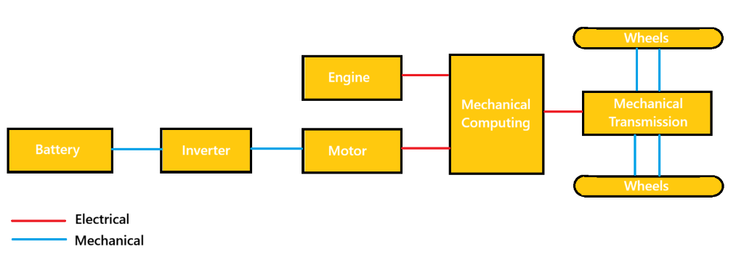
Fig. 2. Schematic of Parallel Hybrid Powertrain
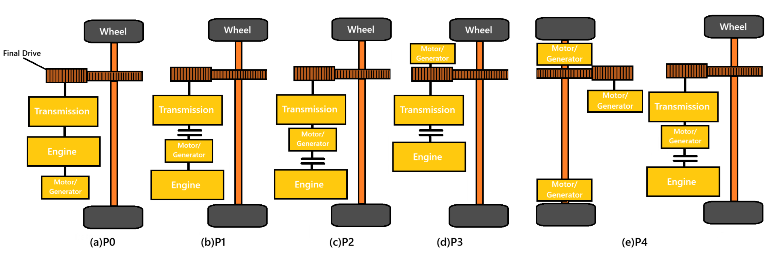
Fig. 3. Configuration of subtypes P0 to P4 in parallel HEVs
In parallel HEVs, the output shaft is mechanically connected to both the ICE and MG, as illustrated in Fig. 2. ICE can drive the wheels mechanically or assist the motor electrically, giving a direct high-efficiency path when ICE alone is used. [49]. The engine operating points are moved to a region with higher efficiency using the available MG. When power demand is low, it functions as a generator; when power demand is high, it functions as a motor. This allows the engine to operate more efficiently than it would in a traditional car. Furthermore, a transmission is required for parallel hybrids in order to balance the high engine speed with the low vehicle speed. [50].
1.2. Sub-types and typical models
The parallel configuration requires comparatively little engineering work and investment, and it can be thought of as an incremental addition to a conventional powertrain. Depending on the location and size of the MG, PHP can be further divided into five subtypes: P0, P1, P2, P3, and P4 [51].
The arrangement known as subtype P0 involves a motor that is mounted ahead of the ICE and is belted to it. As a result, another name for it is a belt-driven starter/generator HEV. The starter/generator can only perform the start-stop operation and is small due to the belt's torque limitation [52].
The P1 subtype describes the configuration in which the motor is placed on the engine's crankshaft. This motor is consistently called an integrated starter generator (ISG) [52], [53]. The ISG's size is always limited by where it is installed, which prevents it from producing enough torque to drive the car. Only a few features, like acceleration support, regenerative braking, and start-stop, can be used.
The two most widely used parallel HEV subtypes are P2 and P3. In these setups, the motor is installed on the transmission's input and output, respectively. Compared to P0 and P1, the motor in P2 and P3 is substantially larger and can drive the vehicle at comparatively high speeds [50].
The P4 configuration represents a parallel hybrid layout where the electric motor is placed directly on the driveline or integrated into the wheel hub through in-wheel motor systems, as shown in Fig. 3(e). This architecture is rarely implemented on its own and is typically paired with other parallel arrangements such as P2 or P3, especially in vehicles equipped with four-wheel drive. A design parameter–based comparison further indicated that P2 achieves improved fuel efficiency compared to P1 due to its higher motor capacity, while P2 and P3 exhibit nearly equivalent fuel economy performance [54].
1.3. Limitations and challenges
Parallel HEVs are effective in urban stop-and-go traffic. This might not be the most effective setup, though. Because clutches or transmissions are needed to connect or disconnect the engine, it has more mechanical complexity. Because the powertrain is heavier, a larger engine and motor sized for maximum power are needed [49]. Furthermore, MG cannot be used to help power the engine and charge the battery at the same time, so power assist and EV operations need to be carefully managed to prevent battery depletion. This issue is made worse when driving in cities because the engine must produce power in its low-efficiency region due to frequent starts and stops, which can use a substantial amount of battery energy. Despite a range of models becoming available, parallel HEVs have a lower market share percentage due to these disadvantages [54].
2. Series hybrid powertrain
2.1. Operation mechanism
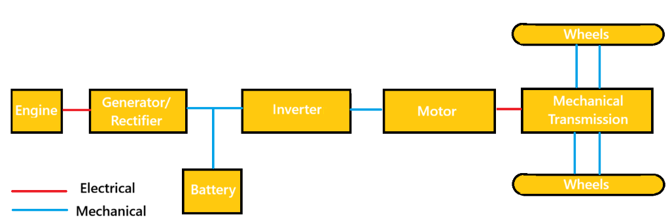
Fig. 4. Schematic of Series Hybrid Powerstrain
Only the electric motor or motors power the wheels; the ICE powers a generator or alternator. The ICE and the wheels are not mechanically connected [49]. In a series hybrid electric vehicle, propulsion is typically provided solely by the electric drive motor, while the internal combustion engine (ICE) is mechanically linked to an electrical generator rather than the wheels, as illustrated in Fig. 3. The electric machines receive energy from both the battery pack and the generator, and they may be installed at the front as well as the rear axle to enable an all-wheel-drive electric arrangement. Because there is no direct mechanical link between the internal combustion engine and the drive wheels, the engine can be run within its optimal efficiency region independent of vehicle velocity or driver power demand. In addition, the propulsion motor offers a broader speed–torque capability and typically achieves better efficiency compared with the engine. As a result, the gearbox required in traditional vehicles may be eliminated in a series hybrid layout. Consequently, this type of hybrid drivetrain features a more straightforward structure than other architectures, both in hardware configuration and in control strategy for energy management. [55]. Series hybrids typically require a smaller battery than BEVs.
2.3. Limitations and challenges
Series hybrid electric vehicles may achieve improved fuel efficiency compared with traditional automobiles. Nevertheless, significant conversion losses arise because the entirety of the engine’s mechanical output must initially be transformed into electrical energy. A portion of this generated electricity is directed to charge the battery pack, while the rest supplies power to the drive motors that move the vehicle. Although the motor-generators operate with comparatively high efficiency, and the engine can run near its optimal efficiency region; the repeated energy transformation processes reduce the overall system effectiveness. Furthermore, this layout demands a high-capacity traction motor to satisfy torque demands, since propulsion relies exclusively on the electric machine [54].
3. Power-split hybrid powertrain
3.1. Operation mechanism
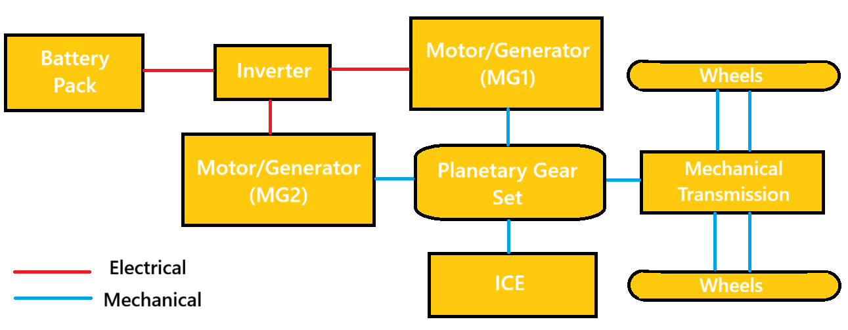
Fig. 5. Schematic of Power-Split Hybrid Powerstrain
Power-split hybrid electric vehicles integrate characteristics of both parallel and series architectures by employing a planetary gear mechanism that functions as an electrically controlled continuously variable transmission [49]. In most designs, either a single or a dual set of planetary gears is employed to connect the internal combustion engine, two motor–generator units, and the vehicle’s driveshaft, as illustrated in Fig. 4. [56], [57]. Planetary gear mechanisms constitute the core element of a power-split hybrid propulsion system. This power division unit isolates the engine’s functioning from direct coupling with wheel rotational speed and performs the role of a continuously variable transmission, allowing the engine to remain within its optimal efficiency region over varying driving speeds. Consequently, in these hybrid configurations, the power division arrangement is often described as an electronically managed CVT, commonly abbreviated as E-CVT [58]. Owing to this separation between engine operation and wheel speed, power-split hybrid electric vehicles typically achieve superior fuel efficiency compared with both series and parallel configurations, especially under urban driving conditions [54].
The PSD enables engine power to reach the driveshaft via two possible routes: a direct mechanical connection or an indirect electrical path [59], [60]. In the electrical route, the PSD works like a series hybrid, with part of the engine’s output converted into electricity by a generator to drive the motor or charge the battery. In the mechanical route, it allows the engine to deliver power directly to the driveshaft, similar to a parallel hybrid. Thus, power-split HEVs combine the advantages of both series and parallel systems [54].
3.2. Sub-types and typical models
Power-split hybrid drivetrains can be categorized into three subtypes based on where the power is divided: input-split, output-split, and compound-split [37]. In an input-split HEV, the engine’s power is divided at the transmission input by placing a motor–generator on the output shaft, sometimes with extra gears in between. For an output-split vehicle, the power is divided at the transmission output by positioning a motor–generator alongside the engine, again occasionally with additional gears. In a compound-split configuration, no motor–generator is directly collocated with either the engine or the output shaft [54].
The input-split subtype is the most commercially successful power-split hybrid, exemplified by the Toyota Hybrid System (THS) or Hybrid Synergy Drive (HSD) developed by Toyota Motor Corporation [61]. This subtype was initially introduced in the Toyota Prius in Japan in 1997 and later expanded to the Camry and Lexus hybrid models. The second-generation THS, released in 2004, provided higher efficiency, greater power output, and improved scalability [62]. Scalability in the THS enables adaptation to different vehicle sizes by modifying the reduction paths of ICE/MG1 and MG2. A similar input-split approach was implemented by Ford in its Fusion Hybrid and C-Max models. Meanwhile, two types of power-split drivetrains were developed by General Motors using the other subtypes, with the Voltec Hybrid Powertrain operating in an output-split configuration [63]. Additionally, the Allison Hybrid System (AHS) was designed to operate using both an input-split and a compound-split mode [63].
Power-split HEVs exhibit numerous design variations that result from altering the placement of their key components [69]. To investigate all potential configurations, Liu and Peng developed an automated modeling approach to efficiently simulate the dynamics of a power-split HEV and pinpointed a design achieving optimal fuel efficiency [70]. Using a bond graph, Bayrak et al. identified all feasible powertrains and produced comprehensive design sets through exhaustive search [71]. Kim et al. structured all possible single-PG configurations into a compound-level design space and selected the optimal layout by balancing fuel efficiency and drivability [72], [73].
3.3. Limitations and challenges
The electrical path in power-split HEVs experiences higher energy losses than the mechanical path due to additional conversions. Greater ICE power routed through the electrical path increases losses from the PSD. When either MG is stationary, the engine–generator–motor route transmits no power, achieving maximum efficiency—this is called the "mechanical point." As a result, energy losses in the electrical path can make power-split HEVs less efficient than parallel HEVs in certain cases, especially during high-speed cruising [58].
4. Multi-mode hybrid powertrain
4.1. Operation mechanism
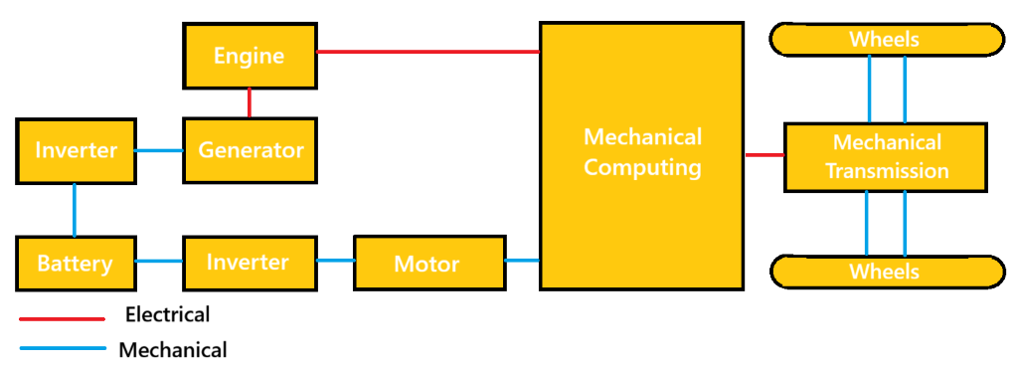
Fig. 5. Schematic of Multi-Mode Hybrid Powerstrain
The multi-mode hybrid powertrain is created by incorporating clutches into parallel or power-split systems, allowing a single drivetrain to operate in series, parallel, or power-split modes. Each mode is considered a subtype or operating mode. This flexibility enables higher energy efficiency and performance compared with the previously discussed HEV configurations [54].
4.2. Sub-types and typical models
Multi-mode hybrids are classified into two subtypes—series-parallel and PG-coupled—depending on whether planetary gear sets are used to link the powertrain components.
(1) Series-parallel multi-mode configuration
The series-parallel subtype was first introduced by Honda in 2014 in its i-MMD system, which is installed in the Accord plug-in hybrid. Two MGs are used in this configuration: One is fully coupled with the ICE, and the other connects directly to the drive shaft [48]. A clutch disconnects the ICE from the output shaft, enabling three modes: EV, series, and parallel. The mode-shifting strategy prevents inefficient engine operation—EV mode is used when battery SOC is high, while series and parallel modes engage at low and high speeds, respectively. A conventional transmission is no longer needed, reducing drivetrain cost. However, because a mechanical link remains between the ICE and driveshaft in parallel mode, the engine cannot operate at optimal efficiency across all speeds [54].
(2) PG coupling multi-mode configuration
The PG-coupling subtype is created by inserting clutches between the planetary gear nodes in a power-split layout, with the Advanced Hybrid System, patented by General Motors in 2002, serving as a typical example [68]. By engaging and disengaging the two clutches, the system can operate in either input-split or compound-split mode. Input-split delivers high output torque, ideal for low-speed driving, while compound-split improves efficiency at high speeds by limiting MG2’s speed rise with vehicle velocity. Proper mode selection thus enhances fuel economy and launch performance, especially for buses that demand high torque at low speeds. [54].
Alongside AHS, GM launched the Voltec multi-mode powertrain in 2011, starting with a single-PG setup and three clutches (Gen1) [76], which was upgraded to a dual-PG design (Gen2) in 2015 [63]. The Gen2 system’s three clutches provide five distinct operating modes, featuring input-split and compound-split modes like AHS, as well as two EV modes to support plug-in operation.
Toyota created a multi-mode hybrid system by integrating a Ravigneaux-type planetary gear and two clutches into its THS [75], [76]. The second MG’s gear ratio is shifted between low and high settings for low- and high-speed operation, respectively. In 2017, Toyota enhanced the THS by integrating a four-speed automatic transmission to increase output torque for a more powerful hybrid system [77]. This configuration forms the multi-stage hybrid system used in Lexus LC 500h and LS 500h models [78].
Despite numerous patented multi-mode designs, a significant portion of possible configurations has yet to be investigated [79]. A multi-mode hybrid can be created through two approaches. The first adjusts the placement of key powertrain components—engine, two MGs, and the output node to the drive axle—allowing each element to connect to any node of the PG sets. The second approach varies the number and arrangement of permanent links and clutches, producing distinct hybrid configurations. The total number of clutches that can link two nodes, or a node to the ground, is determined by a combinatorial formula, which is as follows [54]:
N_{clutch} = C_{3Np}² + 3N_{p} - 2N_{p} – 1 (1)
The first term counts clutches that can connect any two nodes, while the second term accounts for all possible grounding clutches. The third term removes duplicates, as locking any two of the three PG nodes results in identical dynamics. The output node is excluded from grounding. By varying component placements and clutch positions, the number of potential configurations reaches into the billions [81].
4.3. Limitations and challenges
Using multiple operating modes can lead to significant mode-shift issues [80], and incorrect transitions may elevate noise, vibration, and harshness (NVH) levels [80]; raise energy consumption [81]; and negatively affect ride comfort [82] as well as vehicle drivability [83].
To mitigate the adverse effects of mode shifts, researchers have focused on studying transitions in series-parallel HEVs, especially from EV mode to hybrid-drive modes [84].
Compared with series-parallel HEVs, PG-based multi-mode HEVs exhibit higher NVH, as they use PG sets to mechanically link the engine and driveline without a torque converter or clutch, which in series-parallel HEVs helps passively damp vibrations. Studies on PG-based multi-mode HEVs have approached mode shifts from two angles, the first being mode-shift map design [85] and mode-transition control. Mode-shift duration should be kept as short as possible to minimize torque gaps and energy losses during transitions. At the same time, driveline torsional vibrations and engine torque pulsations must be controlled to reduce NVH [80] and enhance vehicle drivability [83], [86], [87]. Fortunately, the fast torque response of the electric motor can help offset these torque disturbances [87].
Table II: Comparisons Between Power Strains of EV
Aspects | Series | Parallel | Power-Split (Series–Parallel) | Multi-Mode
Wheel propulsion | Electric motor only | Engine and/or motor | Engine + motor  via planetary gear | Engine + multiple motors via clutches & gearsets
Engine mechanically coupled to wheels | No | Yes | Yes | Yes
Electric motor drives wheels | Always | Sometimes | Yes | Yes
Primary components | ICE, generator, traction motor, battery | ICE, motor, transmission, battery | ICE, two motors, planetary gear, battery | ICE, two or more motors, planetary gears, multiple clutches, battery
Operating principle | Engine generates electricity; motor provides traction | Engine and motor provide torque in parallel | Power is split between mechanical and electrical paths | Discrete operating modes using clutches and gearsets
Typical operating modes | EV, engine-generated EV | EV, ICE, combined | EV, series, parallel (continuously blended) | EV, series, parallel, multiple fixed gear modes
Energy conversion path | Mechanical → electrical → mechanical | Mostly mechanical | Mixed mechanical–electrical | Mostly mechanical with electrical assist
City driving efficiency | High | Moderate | High | High
Highway driving efficiency | Low–moderate | High | Moderate–high | High
EV-only capability | Strong | Limited | Moderate to strong | Strong
Mechanical complexity | Low | Medium | Medium–high | High
Control complexity | Low–medium | Medium | High | Very high
System cost | Low–medium | Low | Medium | High
Packaging flexibility | High | Moderate | Moderate | Low
Representative implementations | Nissan e-Power, BMW i3 REx | Hyundai/Kia hybrids | Toyota Hybrid System (Prius) | GM Two-Mode, modern PHEV SUVs
Key advantages | Simple drivetrain, strong low-speed efficiency | Efficient cruising, low cost | Smooth operation, good all-round efficiency | High efficiency over wide speed/load range
Key limitations | Conversion losses at high speed | Limited electric driving | More complex control and hardware | High cost and system complexity

4. Battery and Energy Storage Systems
Energy storage is the central enabling technology for battery electric vehicles (BEVs) and plug-in hybrid electric vehicles (PHEVs), and remains a key bottleneck that couples range, cost, safety, and charging convenience. From a systems point of view, a traction battery needs to have a long life (calendar and cycle), a lot of specific energy (range), a lot of specific power (acceleration and regenerative braking), and a lot of safety when it comes to electrical, thermal, and mechanical abuse. To meet these goals, there must be co-design between (i) cell chemistry and format, (ii) mechanical/electrical pack architecture, (iii) battery management systems (BMS), (iv) thermal management, and (v) end-of-life solutions like recycling and second life. This section will talk about the best batteries and energy storage options for electric cars. It talks about lithium-ion systems and the limits of engineering that make them less useful in the real world.

4.1 System requirements and performance metrics
The design of traction batteries is based on a set of goals that are not separate from each other. Some important metrics are: (a) gravimetric and volumetric energy density (Wh/kg and Wh/L) at the cell and pack level, (b) power capability (W/kg) for acceleration and regenerative braking, (c) efficiency and heat generation, (d) lifetime, usually measured by capacity retention and resistance growth over time and cycling, (e) safety margins against thermal runaway and propagation, and (f) cost per usable kWh and supply-chain risk. Pack-level integration adds structural parts, busbars, cooling plates, and safety devices, so the pack-level specific energy is always lower than the cell-level value. As a result, modern EV battery engineering is putting more and more emphasis on "system-level" optimization. This means getting rid of unnecessary materials, making module structures simpler, and combining thermal and structural functions while still meeting safety and serviceability requirements [88], [91].
Different types of vehicles and driving cycles need different amounts of energy and power. Highway cruising uses less energy, but driving in the city with frequent high-power pulses and thermal transients uses more energy. Fast-charging adds another, more dangerous operating mode: high current at high cell voltage, and often at low ambient temperature. This regime raises overpotential and the chance of lithium plating, speeds up parasitic reactions, and can cause temperature differences inside the battery to rise, which means that thermal and electrochemical management must be done very carefully [93], [94], [96]. So, the best way to evaluate is not to look at just one "energy density" number, but to look at a map that shows the maximum charge/discharge power for different temperatures and states of charge (SOC), along with a degradation model that shows how that map changes over time [89, 90, 96].
Fig. 1 is referenced here to introduce the fundamental charge transport pathways in a lithium-ion cell, which later connects directly to heat generation, aging, and safety topics.
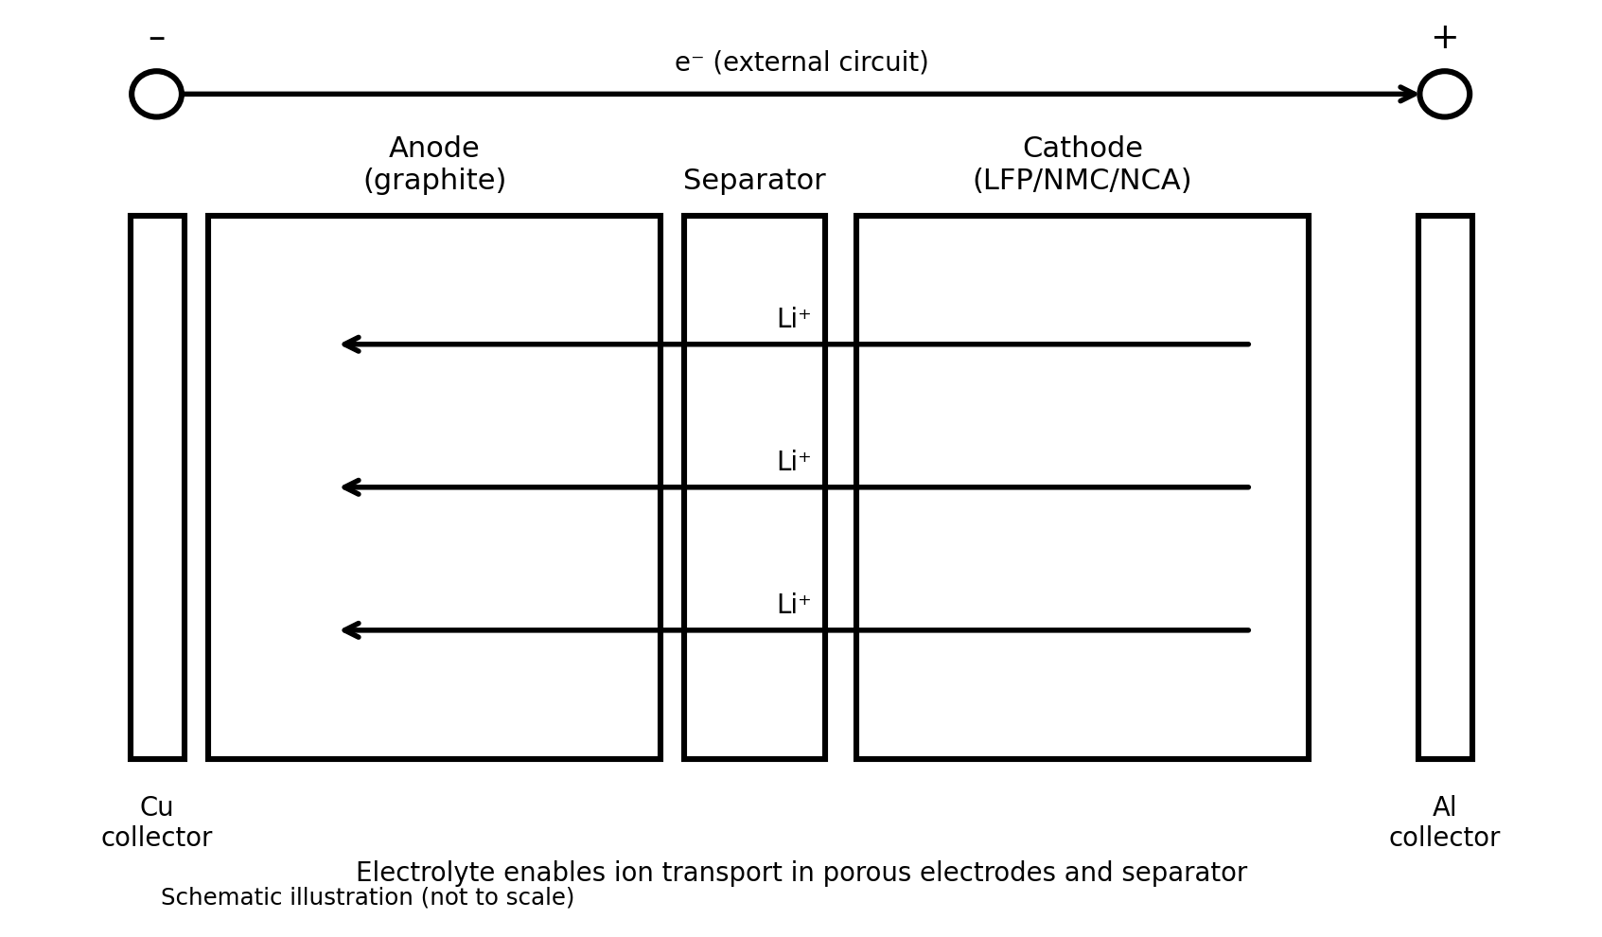
Fig. 1. Schematic illustration of a lithium-ion cell showing electron flow through the external circuit and Li⁺ transport through the electrolyte/separator (created for this review).

4.2 Lithium-ion battery fundamentals for EV applications
Lithium-ion (Li-ion) batteries are the most common type of traction battery for commercial electric vehicles because they are cheap, easy to make, and have a good balance of power, energy, and cost. A Li-ion cell has a negative electrode (usually graphite, but it can also be mixed with silicon), a positive electrode (usually layered oxides like NMC/NCA or phosphates like LFP), a porous separator, and a liquid electrolyte. When lithium ions are discharged, they go from the anode to the cathode and then back to the anode. Electrons travel through the outside circuit (Fig. 1). The directions change while charging. At the particle and electrode levels, transport limitations in the solid and electrolyte, charge-transfer kinetics, and interfacial film formation affect both short-term power capacity and long-term aging [96].
In vehicle engineering, cells are put into modules and packs that have a thermal system (Fig. 2), high-voltage interconnects, contactors/fuses, and sensing and control (BMS). The electrical setup decides the voltage and capacity, and the mechanical design has to be strong enough to handle crash loads and keep tolerances for the thousands of cells that can be made. Thermal design must keep the temperatures of the cells within a certain range and make sure that there are not too many differences in temperature between different areas. This is very important because temperature speeds up degradation and can cause thermal runaway when used incorrectly[88], [91], [92], [96].
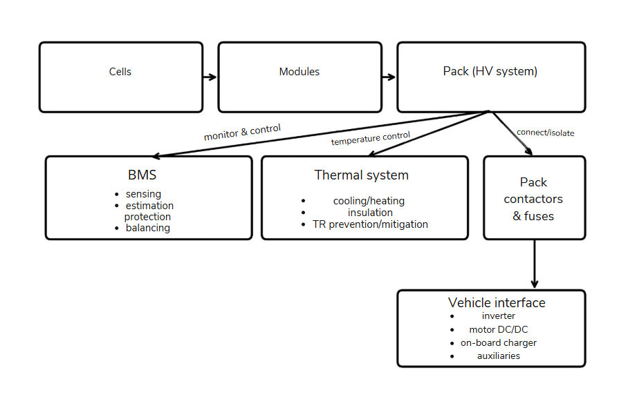
Fig. 2. Cell–module–pack hierarchy and key pack subsystems (BMS, thermal system, and contactors/fuses) that enable safe and reliable vehicle operation (created for this review).

4.3 Energy storage landscape and technology positioning
Electric automobiles can store energy in a number of methods, such as batteries, supercapacitors, and, in rare situations, fuel cells. But the greatest way to store energy is in the traction battery. People often use the Ragone plot (specific energy vs. specified power) to see how well different technologies operate together. Supercapacitors have a lot of power and last a long time, however they don't hold a lot of energy. This is why they work better for peak shaving or buffering regenerative braking than for range. Modern EV traction systems usually employ lithium-ion batteries instead of lead-acid and NiMH batteries because they don't carry as much energy. But you can still use them in different ways. Li-ion families have a lot of energy and power at the same time. The trade-offs depend on the chemistry, such as LFP vs. NMC/NCA [93], [96], and [98]. New technologies like solid-state batteries and sodium-based batteries aspire to shift this trade area by making things safer or cheaper and less dangerous to supply, even if they lose some energy density [97, 98].
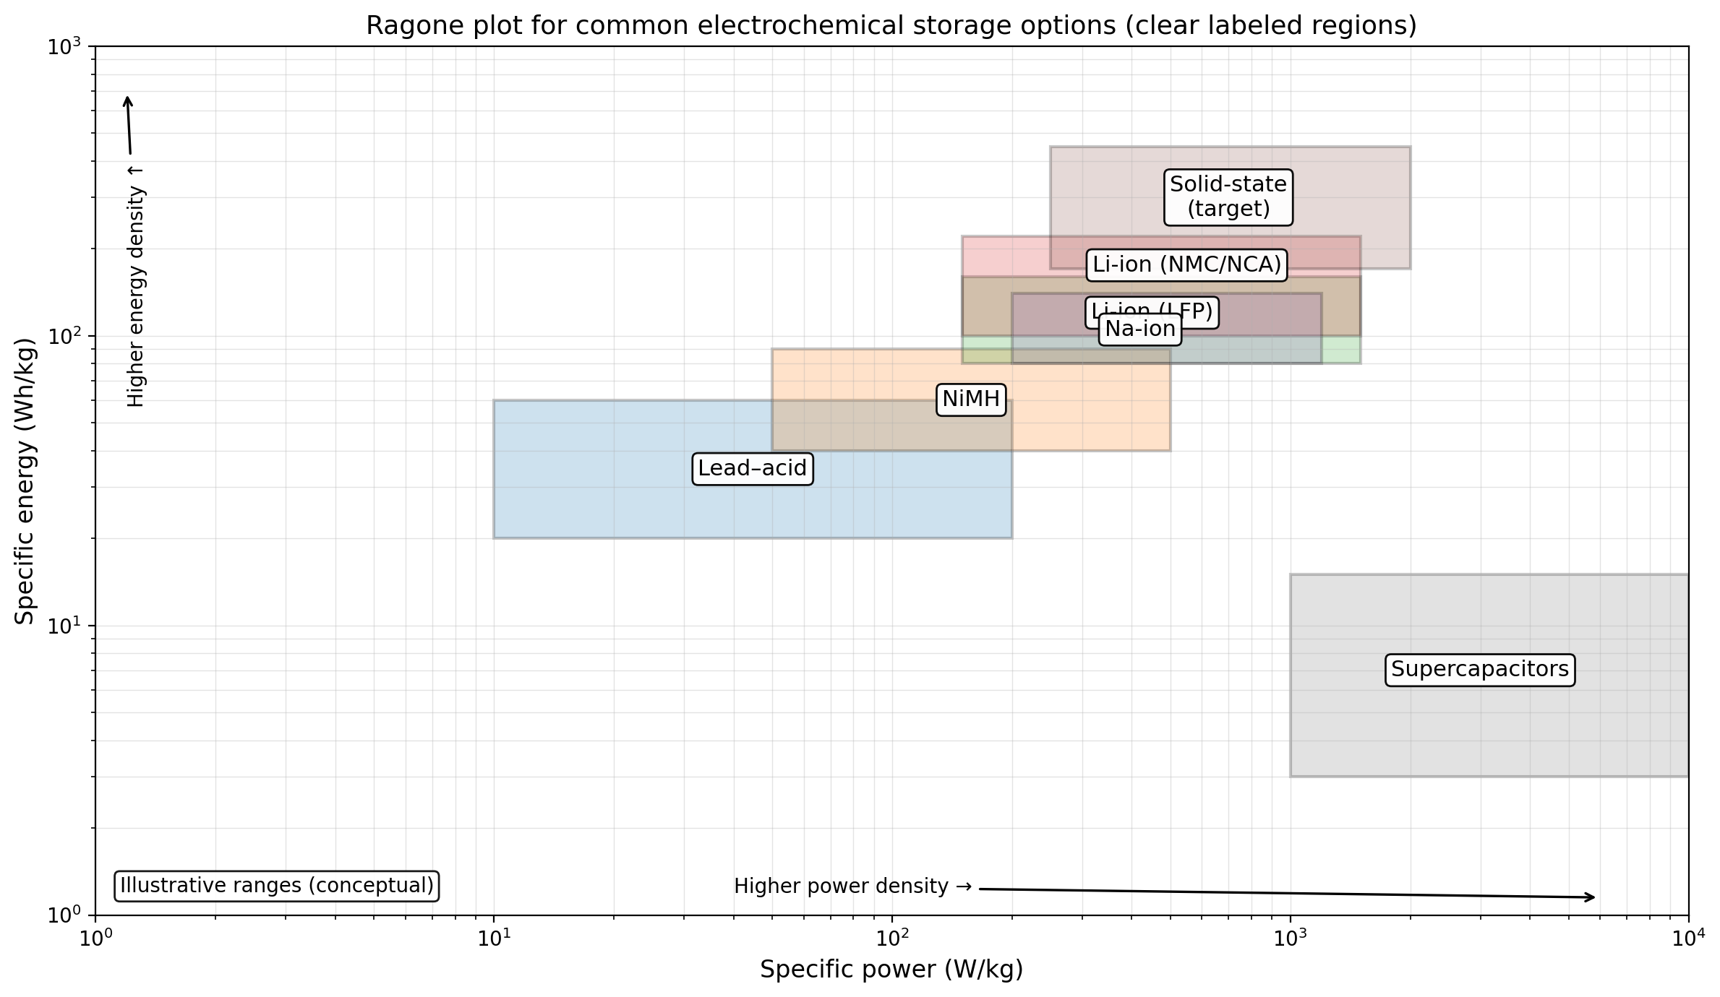
Fig. 3. Illustrative Ragone plot showing conceptual ranges of specific energy and specific power for selected storage technologies relevant to vehicles (created for this review).

4.4 Cell chemistries, materials, and EV-relevant tradeoffs
The main types of Li-ion cathodes used in electric vehicles are (i) layered transition-metal oxides (NMC/NCA) and (ii) olivine phosphate (LFP). Layered oxides usually have a higher energy density, but LFP is better for thermal stability, costs less (no nickel or cobalt), and lasts longer under a wide range of conditions. But the choice of chemistry affects the design of the pack: higher-energy chemistries can lower the pack's mass for a given range, but they may need stricter safety and thermal management measures [88], [91], [92]. Graphite is still the most common material at the anode. Adding more silicon can increase capacity, but it also causes big changes in volume that make mechanical integrity and interfacial stability harder to maintain, which could speed up degradation [96].
The cell's ability to take in lithium without plating is very important for fast charging. The speed of fast charging is limited by how lithium ions move through the electrolyte and solid, as well as how quickly charge transfers at the anode. Lithium plating can happen when the anode potential drops below 0 V vs. Li/Li⁺ during charging. This part is dangerous and it speeds up capacity loss. The materials-level solutions discussed in [93] involve altering the shape and porosity of particles to reduce the diffusion length, facilitating electrolyte movement, and establishing stable interphases. System-level methods can also change the temperature and charging processes to keep the cell from going into plating-prone states [94].
Table I. Comparison of traction-battery chemistries and emerging alternatives for electrified vehicles (typical qualitative trends).
Chemistry / system | Strengths | Limitations / risks | Fast-charge outlook | Safety outlook | Representative refs.
Li-ion (LFP) | Good thermal stability; long cycle life; lower cost | Lower energy density than layered oxides; cold-temp power limits | Moderate; benefits from thermal control & tailored protocols | Strong intrinsic stability; still requires pack-level mitigation | [88], [91], [92]
Li-ion (NMC/NCA) | High energy density; good power with optimized design | Higher thermal reactivity; Ni/Co supply risk; aging sensitivity | Good potential but plating/heat constraints dominate | Requires robust sensing, cooling, and propagation barriers | [88], [93], [94], [96]
Li-ion (LTO anode) | Very high power and fast-charge capability; long life | Lower cell voltage and energy density; cost | Excellent; widely used where power > energy | Generally strong; lower risk of lithium plating | [93], [96]
Solid-state (Li-metal target) | Potential for higher energy; improved nonflammable electrolyte options | Interface resistance; manufacturability; dendrite/short risks at interfaces | Potentially good but constrained by interfaces and heat removal | Potentially improved vs liquid electrolyte, but failure modes remain | [97]
Sodium-based batteries (Na-ion, Na-metal variants) | Lower-cost/supply risk; scalable materials base | Lower energy density (today); cathode/anode stability and electrolyte maturity | Developing; may prioritize cost and moderate range | Depends on chemistry; promise for safer and cheaper systems | [98]
Supercapacitors (hybrid storage) | Ultra-high power; very long cycle life | Very low energy; self-discharge | Excellent for pulse buffering rather than full fast charge | Generally strong; limited energy reduces hazard magnitude | [88]
Note: Table entries summarize trends commonly discussed across the cited papers; specific numerical values depend on manufacturer design and operating window.

4.5 Battery management systems: architecture, state estimation, and controls
A battery management system makes sure that the pack works at safe levels of voltage, current, and temperature. It also gives the right amount of power and makes the pack last longer. The main jobs of a BMS are to (i) measure the voltage, current, and temperature of a cell or pack; (ii) find out the state of charge (SOC); (iii) find out the state of health (SOH) (capacity and resistance); (iv) find out the state of power (SOP); (v) balance the cells; (vi) coordinate thermal and charging control; and (vii) find and fix problems. According to modern reviews, state estimation is the "brain" of the BMS. We can use the battery in the best way possible and avoid situations that speed up aging or make it less safe if we know the SOC, SOH, and SOP [89], [90], [91].
Wang et al. [89] categorize BMS-related models into three categories: equivalent circuit models (ECMs), electrochemical models, and data-driven models. A lot of people use ECMs for onboard estimation and control because they are simple to use and don't use up a lot of computer power. But their parameters change with temperature and how old they are. Electrochemical models give us a mechanistic understanding, but they are hard to break down into simple parts that can be used in real time. Data-driven models can handle complex nonlinearities when there is a lot of good data, but they are still hard to use with different chemistries and operating conditions. Recent studies amalgamate hybrid methodologies that integrate physical constraints into learning-based models to augment robustness [90].
Table II. BMS state estimation and safety functions: representative approaches and practical considerations.
BMS function | Why it matters | Common approaches | Main pitfalls | Key refs.
SOC estimation | Range prediction; fast-charge and power limits | Coulomb counting + correction; Kalman filters; observer-based ECMs; hybrid learning | Sensor drift; parameter changes with temperature/aging; dynamic hysteresis | [89], [90]
SOH estimation (capacity/resistance) | Warranty and lifetime management; derating decisions | Incremental capacity/voltage methods; impedance features; model-based aging states; machine learning | Requires representative aging data; confounding by temperature and SOC history | [89], [90], [96]
SOP prediction | Power limits for traction and regen; safety margins | Model-based prediction using ECM + constraints; temperature-aware limits; hybrid approaches | Inaccurate thermal state leads to unsafe overestimation; aging shifts limits | [88], [90]
Cell balancing | Avoid overcharge/overdischarge of weakest cell; maximize usable capacity | Passive bleed; active balancing converters; scheduling based on SOC/SOH | Balancing heat; complexity/cost; aging-induced imbalance growth | [89], [90]
Thermal runaway early warning | Prevent fires and propagation; trigger isolation | Temperature/voltage anomalies; pressure/gas sensing; model-based residuals; fusion | Limited sensors; false positives; propagation speed can exceed detection time | [91], [92]
As shown in Table II, real-time estimation is inseparable from sensing quality and thermal control, which motivates integrated electro-thermal modeling and robust diagnostic strategies [88]–[92].

4.6 Thermal management: heat generation, control strategies, and integration constraints
There are three basic goals for thermal management in EV packs: (i) keep the cell temperature within an optimal range during normal operation, (ii) reduce temperature differences between cells to avoid uneven aging, and (iii) reduce and limit aberrant heat escape during failures [88], [91], [92]. Ohmic losses and entropic effects cause heat to build up. At high C-rates (rapid charging or high-power discharge), ohmic heating is the main cause of heat buildup, hence it is important to be able to get rid of heat effectively. Hwang et al. [88] analyze battery thermal management systems (BTMS) and point out that the design of the cooling system needs to take into account not just steady-state heat removal but also transient behavior, packing limits, and the effects of the environment. Air cooling is simple but doesn't move heat very well. Liquid cooling can move heat more quickly and keep temperatures more even. Refrigerant-based systems can use the vehicle's HVAC loop for aggressive cooling, but they make integration more difficult [88].
Thermal design is especially important for quick charging. Charging at different C rates can quickly raise the temperature of the cell, and if not done carefully, it can cause temperature differences between the core and the surface. On the other hand, low-temperature charging is sometimes limited by the risk of plating, which is why preheating or temperature-assisted techniques are used. The conceptual operating envelope in Fig. 4 shows how raising the temperature can raise the charge rate limit. However, these kinds of methods need to be used with care because higher temperatures speed up some degrading processes while slowing down plating [93], [94], and [9].
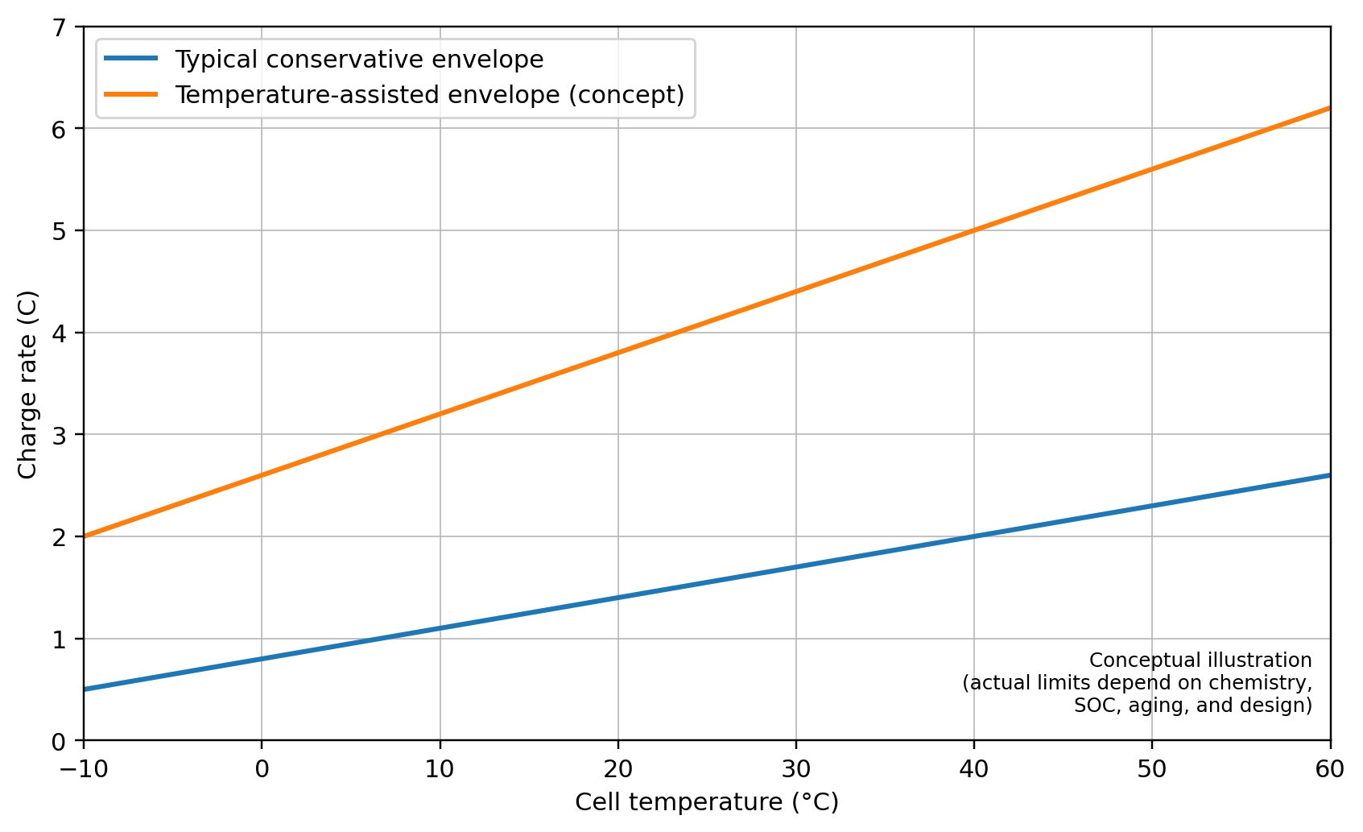
Fig. 4. Conceptual map showing how allowable charge rate can expand with higher cell temperature; actual limits depend on chemistry, SOC, aging, and pack thermal design (created for this review).

4.7 Degradation mechanisms and lifetime management
Battery aging is usually seen as (i) a loss of active material and cyclable lithium, which lowers capacity, and (ii) an increase in internal resistance, which lowers power capability and raises heat generation. Edge et al. [96] give a mechanistic overview of how Li-ion batteries break down, focusing on important processes including the formation of the solid electrolyte interphase (SEI), lithium plating, the breakdown of the cathode structure (which includes cracking and the solubility of transition metals), and the oxidation of the electrolyte. The relative importance of these pathways changes according on the chemistry, temperature, SOC window, and current profiles. From the point of view of a vehicle, two use cases are especially bad: long-term storage at high SOC and high temperature (calendar aging) and repetitive quick charging (cycle aging).
Lifetime management is now an optimization problem: use the battery hard enough to match user expectations (range, fast charging) while keeping costs down. Charge control (current restrictions based on temperature and SOC), balancing approach, and thermal management are all ways that BMS algorithms might affect degradation. But these decisions about control depend on how accurate the model is. Recent analyses advocate for integrated electro-thermal-aging models and resilient online parameter adaptation to elucidate behavior modifications generated by aging [89], [90], [96].

4.8 Fast charging: materials, protocols, and system-level demonstrations
A big reason why people don't buy electric vehicles is that they don't charge quickly. Weiss et al. [93] look at the materials side of fast charging at the cell level and find that lithium plating at the anode under high overpotential is often the limiting factor. Mitigations include making ionic and electronic transport better, making the material less tortuous, stabilizing interfaces, and finding the best thickness and porosity for electrodes. At the system level, fast charging needs to be in line with safety and thermal management rules. Wang et al. [94] show that managing temperature can make charging energy-dense Li-ion cells much faster while keeping their cycle life the same. This shows that protocol design and thermal control and cell design are all part of the same process.
Practical fast-charging protocols typically combine a constant-current phase (limited by plating and thermal constraints) with a constant-voltage phase (limited by diffusion and polarization). Emerging approaches introduce multi-stage currents, temperature-assisted charging, or model-predictive strategies that explicitly optimize time subject to electro-thermal constraints. Such approaches place heavy demands on BMS estimation accuracy and sensing (Table II) because small SOC or temperature errors can push cells into unsafe regimes [89], [90], [93], [94].

4.9 Safety: thermal runaway, propagation, and mitigation strategies
Safety is a first-order design constraint for high-energy packs. Thermal runaway (TR) is a self-accelerating sequence of exothermic reactions that can be triggered by internal short circuits, overcharge, external heating, mechanical crush, or manufacturing defects. Ren et al. [92] discuss TR mitigation mechanisms and emphasize that preventing initiation is only part of the problem; pack design must also slow or stop propagation between cells. Xu et al. [91] give a general overview of ways to reduce risk at the cell level (current interrupt devices, shutdown separators, vents, electrolyte additives) and the pack level (thermal barriers, passive/active cooling, structural isolation, and BMS protections).
Because propagation can occur faster than intervention, safety must be engineered as layered defense-in-depth. At minimum, packs require accurate sensing, robust fault detection, rapid isolation using contactors/fuses, and thermal paths that prevent a single-cell event from triggering neighbors [88], [91], [92]. The design challenge is that many safety features add inactive mass and volume, reducing energy density and increasing cost. Thus, a central trend in EV pack design is achieving safety with minimal penalty by integrating structural and thermal functions and by improving cell-level stability [88], [91].

4.10 End-of-life strategies: recycling, direct regeneration, and circularity
Engineers and the environment are having a hard time with batteries that are no longer useful as more and more people buy electric automobiles. Pyrometallurgy, hydrometallurgy, and direct recycling/regeneration are only a few of the many techniques to recycle. Direct recycling aims to maintain the cathode crystal structure while minimizing the procedures required to recover value. Xu et al. [95] demonstrate a "efficient direct recycling" technique that repairs damaged cathode materials, illustrating the potential efficacy of regeneration-based approaches. From a systems point of view, planning for recycling and making it easier to pull apart a pack can save money and make it easier to receive materials back. But safety and how well the structure fits together must also be taken into account.
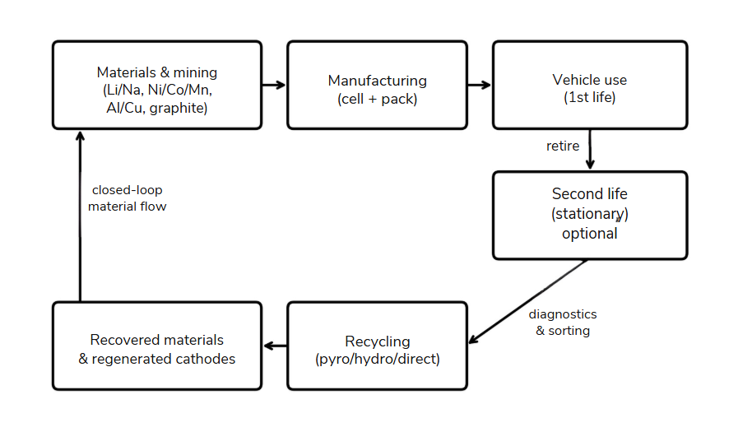
Fig. 5. Conceptual battery life-cycle and circularity pathways including optional second-life use and recycling/regeneration routes (created for this review).

4.11 Emerging battery technologies beyond conventional Li-ion
Beyond conventional liquid-electrolyte Li-ion batteries, two other major research directions are solid-state batteries and sodium-based batteries.
Solid-state batteries are often seen as a safer option because they’re less prone to catching fire. They may also store more energy, largely because many designs can use lithium-metal anodes. However, they still face big hurdles: high resistance at the interfaces between materials, loss of good physical contact as the battery expands and contracts during cycling, and the challenge of manufacturing them reliably at large scale. Wang et al. [97] Stress that bringing solid-state batteries to market will need more than just electrolytes that conduct electricity well—electro-chemo-mechanical interactions and careful interface engineering are also very important.
Sodium-based batteries, on the other hand, use materials that are easier to find and may be cheaper and last longer. Usiskin et al. [98] examine the fundamental science and recent advancements in this field, indicating that although sodium batteries may not achieve the energy density of the most advanced Li-ion cells, they could still be advantageous for short-range vehicles and other economically motivated applications where extended range is not the primary concern.

4.12 Research gaps and future directions for vehicle battery systems
Based on the literature review, the main research needs can be grouped into: (i) fast-charging durability—integrated materials and thermal strategies that suppress plating while keeping high energy density [93], [94], (ii) scalable safety—pack architectures and materials that stop TR initiation and propagation with the least amount of mass/volume loss [88], [91], [92], (iii) trustworthy BMS intelligence—robust SOC/SOH/SOP estimation across temperature extremes and aging, ideally combining physics-informed models with data-driven adaptation [89], [90], (iv) manufacturable next-generation chemistries—solid-state and sodium-based systems that can be made at automotive scale and integrated into safe packs [97], [98], and (v) circularity—design-for-disassembly and direct regeneration processes that reduce environmental impact and supply-chain risk [95]. A common theme is that improvements in any one layer (materials, control, thermal design) don't do much good unless they are designed to work with the rest of the system.

5.Electric Motors & Power Electronics for EVs in Asia (2020–2025)

Summary
This review provides an in-depth analysis of electric-drive technologies for Asian EVs, HEVs, and PHEVs (2020–2025). It covers EV/HEV/PHEV powertrain differences; prioritized motor designs (IPMSM/PMSM, induction, SRM/SynRM, axial-flux, EESM) with detailed metrics (torque/power density, efficiency, NVH, thermal limits, materials); and power electronics (traction inverters, Si/SiC/GaN device physics and losses, multilevel topologies, DC–DC converters, on-board chargers, V2G). Figures compare inverter losses and 400V vs 800V tradeoffs, with system block and timeline diagrams. Tables summarize motor and semiconductor tradeoffs and 400V/800V architectures. We also discuss system integration (e-axles, integrated drive modules), Asia-specific supply-chain & policies (China, Japan, Korea, India), and issues of safety, manufacturability, recycling, and future trends (2025–2035). All claims are backed by recent sources [1–15].

EV/HEV/PHEV Powertrain Background
The ways that propulsion energy is produced, controlled, and transferred to the wheels vary greatly throughout electrified vehicle architectures. Battery electric vehicles (BEVs) need high-power inverters and broad constant-power speed ranges made possible by field-weakening control since they are solely dependent on electric motors for traction. In order to increase overall efficiency, hybrid electric vehicles (HEVs) use smaller motor-generator units that mainly support the internal combustion engine and recover energy during regenerative braking [99], [100]. By utilizing larger batteries and traction motors that can operate partially on electricity while keeping an engine for a longer driving range, plug-in hybrid electric vehicles (PHEVs) combine the advantages of both systems [101]. The choice of motor, inverter rates, and energy management techniques are all significantly impacted by these architectural variations. great-voltage power electronics and permanent magnet synchronous machines with great efficiency are commonly used in BEVs. whereas HEVs and PHEVs adopt more diverse motor configurations depending on cost, performance, and thermal constraints [102], [103].
- Battery EVs (BEVs): Battery EVs (BEVs) are fully electric with no internal combustion engine (ICE). Motors and batteries must provide full propulsion. Typical power: 100-300+ kW motors, battery packs around 50-100 kWh [100]. The emphasis is on great continuous power and range.
- Hybrid EVs (HEVs): An electric motor or motors is attached to an ICE. Low-speed acceleration and regeneration braking are handled by the electric side, while ICE supplies steady power. The usual motor power range is 10–100 kW [101].
- Plug-in Hybrids (PHEVs): HEVs that are grid-charged and have bigger batteries (10–20 kWh). ICE increases overall range, while batteries power short-range EV mode. On-board chargers (OBCs) complicate the system. EV sales in China are the highest in the world (>60% [99]), and the country prefers low cost technologies (such LFP batteries and IPMSMs). Japan prioritizes dependability and NiMH/Li-ion hybrids, Korea makes investments in 800V systems, while India prioritizes affordable e2W/3W.

2. Motor Technologies & Metrics
Efficiency distribution across actual drive cycles is becoming a more important metric for evaluating modern EV traction motors than just peak efficiency. According to recent studies, driving in cities frequently requires low-torque operation, where switching and copper losses predominate in terms of system efficiency. Because their rotor magnet excitation lowers rotor losses and permits high efficiency even under partial load situations, PMSM/IPM machines continue to be appealing [100], [101]. Research developing ferrite-assisted SynRM and EESM substitutes that offer controlled excitation while lowering reliance on rare-earth minerals is being pushed by the supply-chain problems associated with magnet dependency [115].
High-speed motor operation, in which motors run at rates higher than 20,000 rpm, is another new design trend. Although high-speed designs result in smaller and lighter motors, they also increase mechanical stress and necessitate inverter switching. Advanced hairpin windings and oil-spray cooling are being utilized more and more to sustain high torque densities while maintaining thermal constraints. In integrated drive units, inverter cooling and motor cooling must be co-designed because thermal limitations continue to be the principal limit for continuous operation [102].
Prioritized Motors: Table I compares key motor types [100][101]. Metrics include torque density (kW/kg), peak efficiency, NVH, and material use.
- IPMSM/PMSM: Highest torque density (~5–10 kW/kg) and efficiency (peak ~94–96%)[100]. Often interior PM (IPM) for added reluctance torque. Rare-earth NdFeB magnets (with Dy for temp stability) give high performance but supply risk. Example: A 100 kW IPMSM might weigh ~15 kg. Continuous torque is limited by cooling (~150–200°C winding). NVH is smooth, control is mature.
- Induction Motor (IM): Magnet-free, robust; torque density ~3–6 kW/kg motor[101]. Peak efficiency ~90–94%. At light loads efficiency drops (rotor slip). Used in some Chinese EVs/buses and older Tesla models. No permanent magnets needed so good for cost. Thermal limit ~130°C rotor. NVH smooth.
- Switched Reluctance Motor (SRM): Simple rotor (no magnets), potential high torque (4–8 kW/kg). Efficiency ~88–92%. Disadvantages: torque ripple and acoustic noise[113]. Needs sophisticated control to minimize NVH. Rare in mainstream EVs but used in specialized drives (e.g. YASA wedge).
- Synchronous Reluctance Motor (SynRM): No magnets (or small ferrite PM), efficiency ~90–95%, torque ~3–5 kW/kg. Lower NVH than SRM. Toyota/Honda have prototyped SynRMs for HEVs.
- Axial-Flux PM: Pancake geometry yields exceptional torque density (>6 kW/kg[107]). High surface area allows good cooling. Manufacture complexity (disk lamination, double-sided air gaps) and strong axial forces are challenges. Used in in-wheel motors and high-end EVs (e.g., YASA drives in hypercars [107]).
- EESM (Wound-Field): Synchronous motor with rotor winding. Allows flux control, no permanent magnets. Efficiency ~90–95%. Historically used in large motors; automotive use is rare due to brush/transformer losses and complexity [108].
Performance Metrics: Typical torque density ranges (see Table I) and efficiency curves: PMSMs maintain >90% over broad range; IMs start around 90% at high torque but fall off under light load[101]. SRM can match PMSM at peak but only if current optimized. Efficiency maps vary with design; a sample efficiency map (not shown) would have elliptical efficiency contours peaking at ~8000 rpm. Continuous torque is often around 1.5× rated short-term (cooling-limited)[102]. NVH: SRM and axial-flux need careful damping; PMSM/IM/SynRM are inherently smooth. Magnetic material use: NdFeB for PMSM/Axial; ferrite or Nd-lite for SynRM; copper winding for all; no rare-earth in IM/SRM.
Table I. Motor comparison [100][101][113]:
Motor Type | Torque Density (kW/kg) | Peak Efficiency (%) | NVH/Control | Cooling Limit | Materials | Typical EV Use
IPMSM/PMSM | 5–10 | 94–96 | Smooth | ~180 °C stator | NdFeB (Nd/Dy) | Most EVs/HEVs [Q1]
Induction (IM) | 3–6 | 88–94 | Smooth | ~130 °C rotor | Copper, steel | Some EVs, robust apps
SRM | 4–8 | 85–92 | Noisy/ripple | ~150 °C stator | None (steel) | Specialty EVs [Q2]
SynRM | 3–5 | 90–95 | Moderate ripple | ~150 °C | Ferrite/low PM | Emerging HEVs/EVs
Axial-Flux PM | 6–10 | 94–96 | Moderate (disc) | ~1–3 mm gap | NdFeB | In-wheel/supercars [Q1]
EESM (wound) | 5–8 | 90–95 | Low (excited) | ~150 °C rotor | Copper, steel | Niche/large motors
Source: compiled from [100], [101], [113]. Range values are typical for automotive designs.

3. Power Electronics
Inverter Semiconductors: Silicon IGBTs/MOSFETs (600–1200V) have been standard for <400 V systems. Wide-bandgap devices are now prevalent: Silicon Carbide (SiC, 1200–1700V) offers around 10× lower switching loss and ~2× higher thermal conductivity than Si [108]. Gallium Nitride (GaN, 650–900V) switches ultra-fast with very low conduction loss, ideal for 400–800 V converters [108]. Table II contrasts them. For instance, an 800 V SiC MOSFET can handle 25 A with ~50 mΩ at 125 °C, whereas a Si device of similar voltage has >200 mΩ.[104]. Wide-bandgap semiconductor adoption is also reshaping inverter control strategies. Higher switching frequencies enabled by SiC devices allow designers to reduce passive filter size and improve torque ripple performance. Faster switching, however, increases the dv/dt stress on motor insulation systems and presents problems with electromagnetic interference (EMI) [108] . As a result, with high-voltage EV systems, cable design and insulation coordination become crucial factors.
Additionally, recent research shows that increases in inverter efficiency immediately result in benefits at the vehicle level. In long-range EVs, a mere 1-2 percent reduction in inverter loss can increase driving range by several kilometers. As a result, power electronics optimization and battery enhancements are becoming more and more important to automakers [104], [105].
Loss Comparison: Data from [6] shows that in a standard drive cycle, an SiC-based traction inverter may use only ~2% of vehicle energy versus ~6–7% for Si IGBTs. In a test, replacing Si with SiC cut inverter dissipation by ~70%[104]. GaN parts (600V) can reduce auxiliary converter losses by ~50% compared to Si (when used for DC–DC or OBC)[108]. (Quantitative plots: if users have device datasheets, one could chart conduction vs switching losses for each tech.)
Multilevel Inverters: To utilize high-voltage packs, 3-level (NPC, ANPC) and cascaded inverters are used [106]. These reduce voltage stress per device, enabling higher switching frequency. For example, the Toyota Prius Prime uses a 3-level SiC inverter (boosting system voltage to 640 V) [106]. Korea’s Hyundai E-GMP platform uses an ANPC 800 V SiC inverter. Multilevel designs increase component count and control complexity but improve efficiency and EMI performance.
Table II. Si vs SiC vs GaN :
Feature | Silicon (Si IGBT/MOSFET) | SiC MOSFET | GaN HEMT
Typical Voltage | 600–1200 V | 1200–1700 V | 650–900 V
Bandgap | 1.12 eV | 3.26 eV | 3.39 eV
On-Resistance | Moderate | Low | Very low
Switching Loss | High at >20kHz | Moderate at >20kHz | Very low at >100kHz
Thermal Tolerance | ~150–175 °C (SOA) | ~175–200 °C | ~150 °C
Cost | Low | High | High (but falling)
Application | 400V traction (mass) | 800V traction (high perf.) | 400V DC/DC, OBC
Maturity | Mature, abundant | Increasing (Wolfspeed/Toshiba) | Emerging (GaN Systems)
Sample Use | Tesla Model S (Si IGBT) | Audi e-tron GT (SiC) | Prototypes, onboards
Figure 2 is a visual representation for choosing SiC
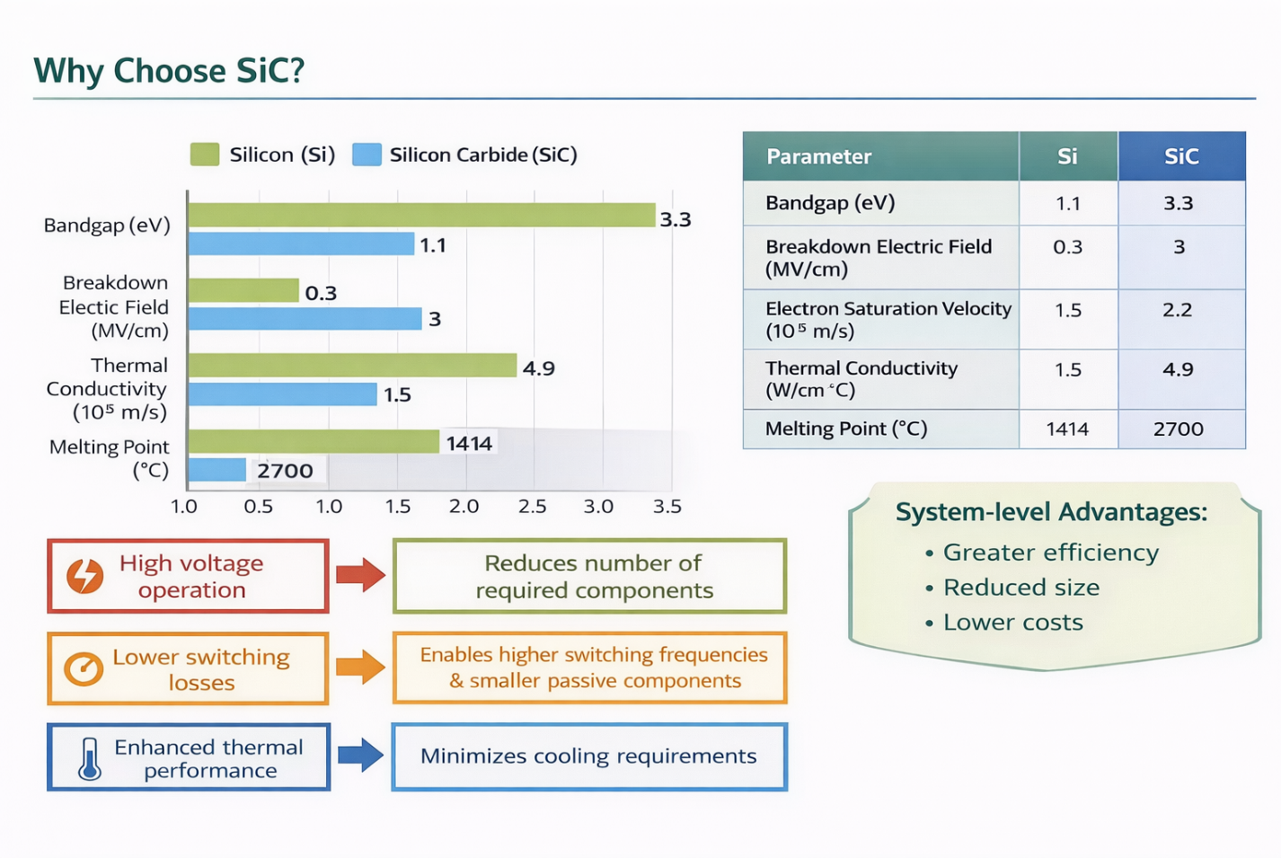
Fig. 2. Sample traction inverter comparison (Si vs SiC)[104].
400V vs 800V Systems: 400 V systems (e.g. Nissan Leaf) use ~600V switches; 800 V (e.g. Porsche Taycan) use 1200–1700V SiC. In a 200 kW charge scenario, 800 V halves current (250 A vs 500 A) and reduces I²R loss to ~25% [103]. 800 V allows faster charging (up to 500 kW) but requires higher isolation and higher-cost semis. Figures 2 and 4 visualize the advantage of SiC inverter and 400/800 V differences (data from published case studies[104][105])
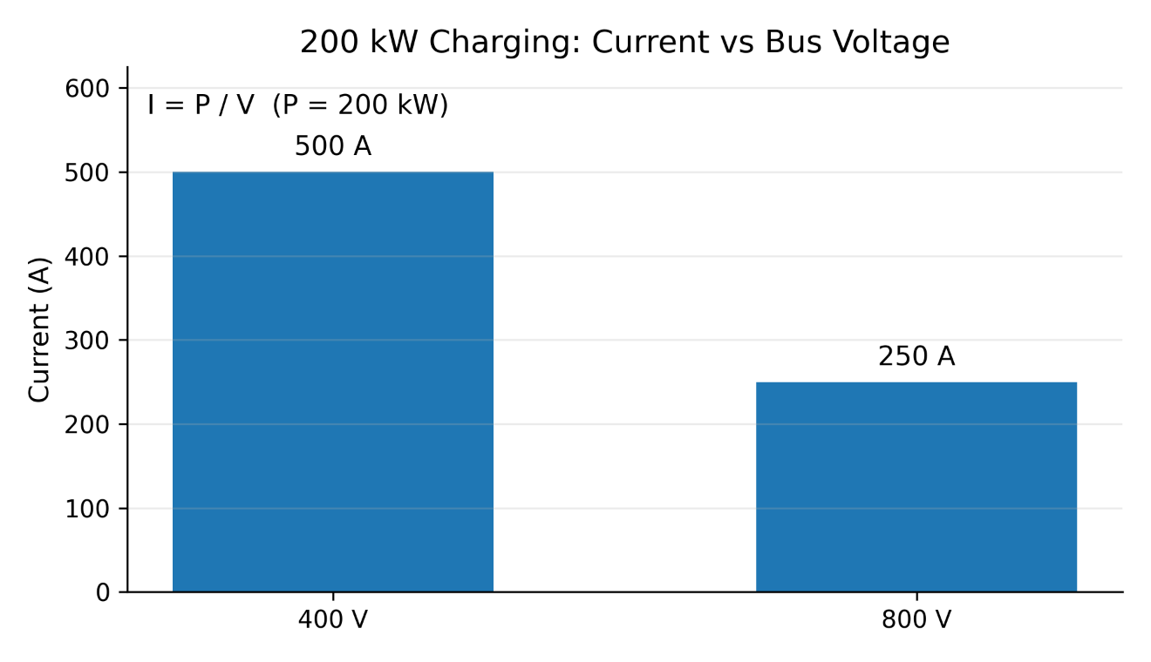
Fig. 4. Charging current and cable loss at 200 kW (400V vs. 800 V) [103]. (Exact values depend on cable specs, user can supply data for precise calculation.)

4. System Integration
- e-Axles: Many Asian EVs use integrated e-axles (motor + inverter + gearbox). For example, Nidec’s 250 kW e-axle (used in Japanese EVs) co-locates a 12,000 rpm IPMSM with SiC inverter in one housing [102]. This saves space and weight.
- X-in-1 Modules: Chinese OEMs (e.g. BYD) are developing single-unit ‘X-in-1’ drives combining motor, inverter, OBC, and DC–DC [105]. This reduces wiring and improves thermal coupling. Figure 1 shows a conceptual block of such integration.
- 800 V architecture : These systems integrate high-voltage batteries, advanced power electronics such as SiC-based inverters, and high-power charging systems to enable ultra-fast charging and improved efficiency [114].
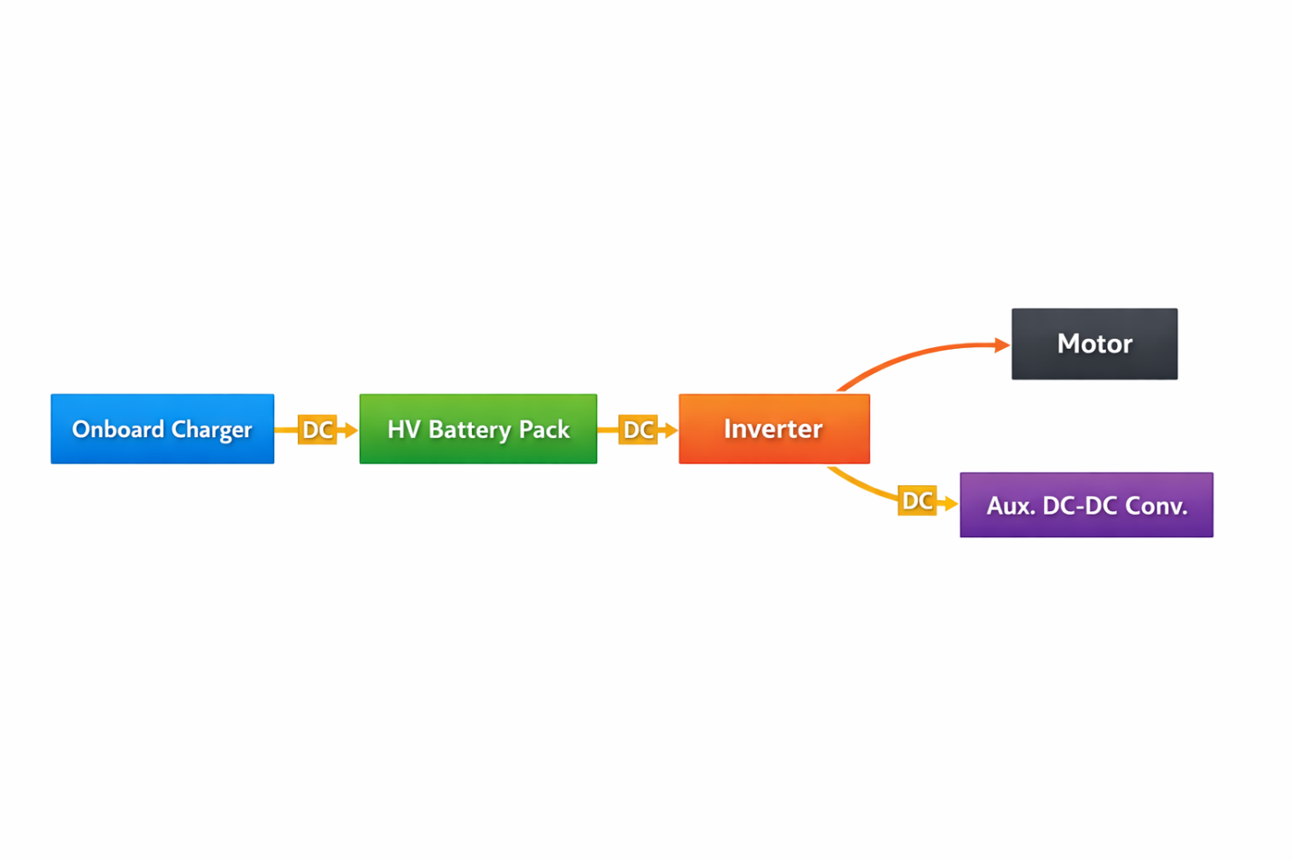
Fig. 1. EV powertrain block diagram with integrated components

5. Supply Chain & Policy
Asia’s leadership in EV manufacturing has accelerated innovation in both motor and inverter technology. With the help of domestic semiconductor supply chains and government incentives, Chinese firms have quickly expanded their manufacturing of SiC inverters. Advanced e-axle systems with optimal thermal performance are the result of Japanese and Korean firms' focus on integration and dependability [1].
The developing EV ecosystem in India shows a steady shift toward higher-voltage systems. Reducing reliance on imported power electronics and permanent magnet materials is the goal of policy initiatives like localized production incentives.
  - China: Leading EV market; 60% of global sales [1]. Strong supply of Li-ion cells (CATL, BYD) and rare-earth magnets (80% global share[112]). NEV subsidies and credit system favor domestic motor and inverter makers. Mandates push towards high efficiency and LFP chemistries. China also leads battery recycling pilot projects [111].
- Japan: Pioneers in motor and battery R&D (Panasonic, Hitachi Metals). Government incentives for EV adoption are smaller (focus was hybrids), but substantial R&D in solid-state batteries and silicon-carbide devices. Strict industrial standards ensure high quality. Japan is also developing next-gen inverters (e.g. GaN-based) [107].
• Korea: Korea’s EV industry benefits from strong battery exports and semiconductor innovation. Hyundai/Kia’s electrification push and partnerships with semiconductor suppliers support the adoption of high-voltage SiC power modules in next-generation EV platforms [115].
• India: Emerging EV policies of india (FAME-II, PLI) fund local manufacturing of motors and batteries. Many two/three-wheelers use cheaper lead-acid or LFP and the transition to Li-ion (48–72V nominal) is ongoing. Usually in India , rare earth minerals are imported, so recycling and alternative magnet R&D are high priorities【112】. The Indian market currently favors simpler 400V drives, but 800V adoption is planned in premium segments.
• India: Local production of motors and batteries is supported by emerging EV legislation (FAME-II, PLI). Cheaper lead-acid or LFP is used in many two- and three-wheelers; the switch to Li-ion (48–72V nominal) is still happening. Due to the importation of rare earth minerals, recycling and alternative magnet research and development are top priorities‐14. Although 800V adoption is anticipated in premium areas, the Indian market now prefers simpler 400V drives.

6. Safety, Manufacturing, Recycling, Trends (2025–2035)
- Safety: Drive systems are governed by EV-specific requirements (ISO 6469) and functional safety (ISO 26262). Higher insulation is needed for 800V systems (e.g. double-fusion interrupts). High currents must be safely managed by regen braking, while overcharge and overtemperature must be avoided by BMS. Pack fuses and active cooling reduce battery thermal runaway.
- Manufacturability: EV drive factories use CNC machining, additive manufacturing for complicated parts, and automated winding (hairpin stators for greater fill factor). Rare-earth magnets are controlled by the motor assembly (usually in glass-fiber reinforced housings to contain fragmentation). Sintered die-attach is used in power module construction to ensure dependability at high cycling [102]. Because of the need for rotor assembly and particular laminations, producing axial-flux or SRM at scale is still expensive [113].
- Recycling: Asian initiatives target >90% material recovery. China now recycles ~60% of Li-ion batteries via hydrometallurgy. NiMH (from hybrids) has a mature recycling stream in Japan[112]. Motor magnet recycling is nascent: techniques (HREPPER, hydrogen decrepitation) can reclaim NdFeB from end-of-life drives. Future EV designs may use recycled NdFeB or shift to ferrite/PMSM hybrids to reduce critical material usage.
Future (2025–2035): Widespread use of SiC inverters and GaN in auxiliaries, which raise system efficiencies above 97%, are anticipated trends. If the supply gets tighter, magnet-free or reduced-RE motors (SynRM, flux-switching) might be used more. AI/ML integration for motor control (adaptive torque control, predictive failure) will progress. As grid services develop, bidirectional V2G and wireless charging pads will be implemented. By 2030, battery-electric vehicles, including 2/3-wheelers, may account for more than 50% of the Asian market. Drive design may be further influenced by the introduction of solid-state batteries (400–500 Wh/kg) in specialty EVs. Future developments in traction motors are anticipated to prioritize digital twin modeling for predictive maintenance, sophisticated cooling systems, and magnet reduction techniques. SiC is expected to rule high-voltage traction inverters in power electronics, while GaN is growing in auxiliary converters than the its counterpart onboard chargers due to its superior switching speed [112].
Integration trends suggest that future EV platforms may combine battery, inverter, and motor assemblies into highly compact modules, reducing system complexity while improving efficiency and manufacturability.
6.Charging Infrastructure & Grid Interaction
6.1
Electric cars (EVs) get all of their power from batteries, so charging infrastructure is very important for getting a lot of people to use EVs. Unlike regular gas-powered cars, electric vehicles need charging stations that are well-placed in homes, businesses, and public places. Having charging stations available makes people less worried about running out of power, boosts public confidence, and helps the overall shift to sustainable transportation. Several studies show that the EV market needs to increase at the same time as the EV charging infrastructure to make sure it is useful. [116], [117]
The power system needs more electricity as more electric vehicles (EVs) are on the road. This makes the way people charge their EVs and the way the grid works work together very well. If charging isn't handled, charging a lot of electric vehicles at once could raise peak load, put stress on distribution transformers, and cause voltage difficulties. So, technological planning and grid reinforcement must support the growth of EV charging infrastructure. [117], [118]
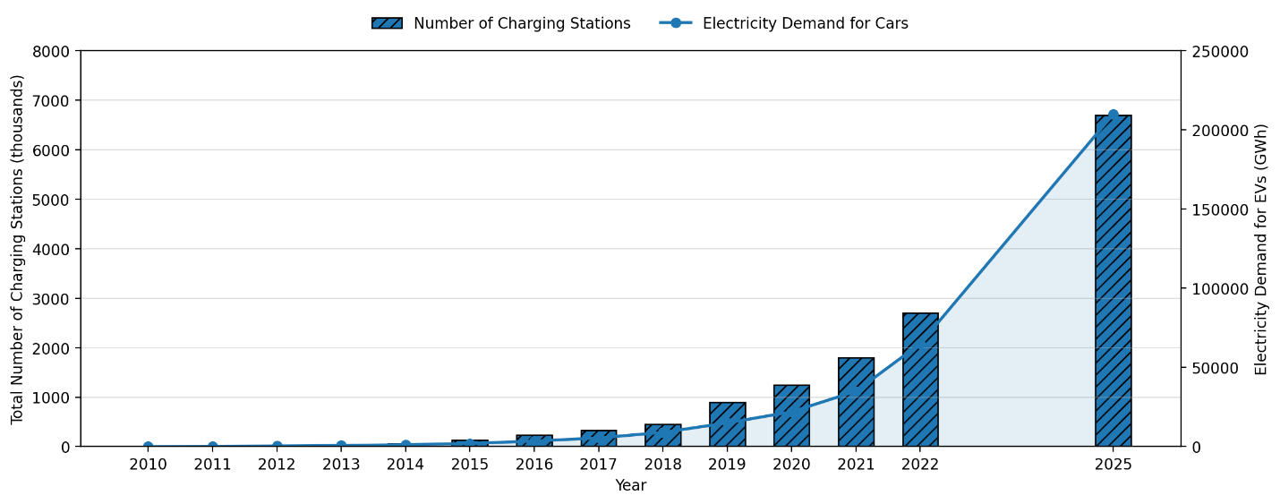
Fig. 1. Growth of charging stations and electricity demand
6.2 Types of Charging Infrastructure
We may group EV charging infrastructure by where the charging happens and what kind of service it is. Home charging, office charging, public charging stations, and highway fast charging stations are the most prevalent varieties. People like charging at home since it's easy and they can do it overnight when the grid isn't as busy. Charging at work assists EV users during the day and makes them less reliant on charging at home. City centers, retail malls, and parking lots all include public charging stations so that drivers who don't have their own charging stations can charge their cars. Fast charging stations are often put up on highways and other key roads to cut down on charging time when traveling large distances. A lot of research and planning goes into EV infrastructure, and these forms of charging are often talked about. [116], [118], [119]
The development of charging infrastructure is not the same in every part of the world. Cities like Shenzhen, Beijing, and Shanghai have a lot more public charging points than cities in Europe and America. This discrepancy is caused by government policy, the rate at which electric vehicles are being adopted, and the amount of money being put into the economy. This kind of uneven distribution shows that we need to design charging stations better and build more infrastructure based on policy. [118], [120]
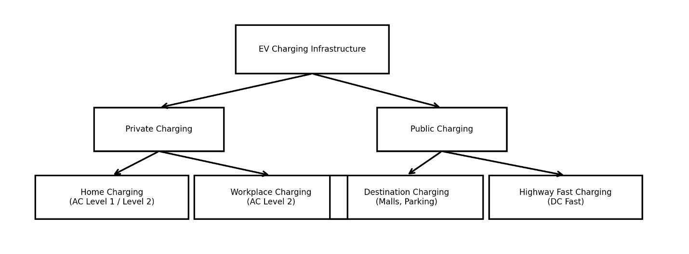
Fig. 2. Classification of charging infrastructure types
6.3 Charging Levels, Standards, and Power Ratings
There are two basic types of EV charging systems: AC charging and DC charging. AC charging takes longer since the car's charger changes AC power into DC power before charging the battery. Most of the time, this technology is employed in charging systems for homes and businesses. DC charging is faster since the charging station changes AC power to DC power and sends it directly to the EV battery. Because of this, DC fast chargers are used in charging stations for businesses and on highways. [117], [119], [122]
There are different charging standards around the world, like SAE J1772, CCS, CHAdeMO, and GB/T. The design of the connectors, the voltage level, and the communication protocols are all different amongst these standards. Standardization is vital for making sure that EVs and charging stations work together, making things easier for users, and making sure that everything works safely. The SAE J1772 standard sets multiple levels for charging, like AC Level 1, AC Level 2, DC Level 1, and DC Level 2. Each level has its own voltage, current, and maximum power ratings. [119], [122], [123]
For instance, AC Level 1 usually works at 120 V and has low charging power, which is good for charging at home. AC Level 2 is utilized in public charging stations since it has a greater voltage and charges faster. DC Level 1 and DC Level 2 give forth a lot more power, which makes charging quick in business settings. [4], [8]
Charging power rating levels:
Charge Method | Volts | Maximum Current  (Amps- continuous) | Maximum Power
AC Level 1 | 120 V AC | 16A | 1.9 kW
AC Level 2 | 120 V AC | 80A | 19.2 kW
DC Level 1 | 200 to 500V DC maximum | 80A | 40 kW
DC Level 2 | 200 to 500V DC maximum | 200A | 100 kW

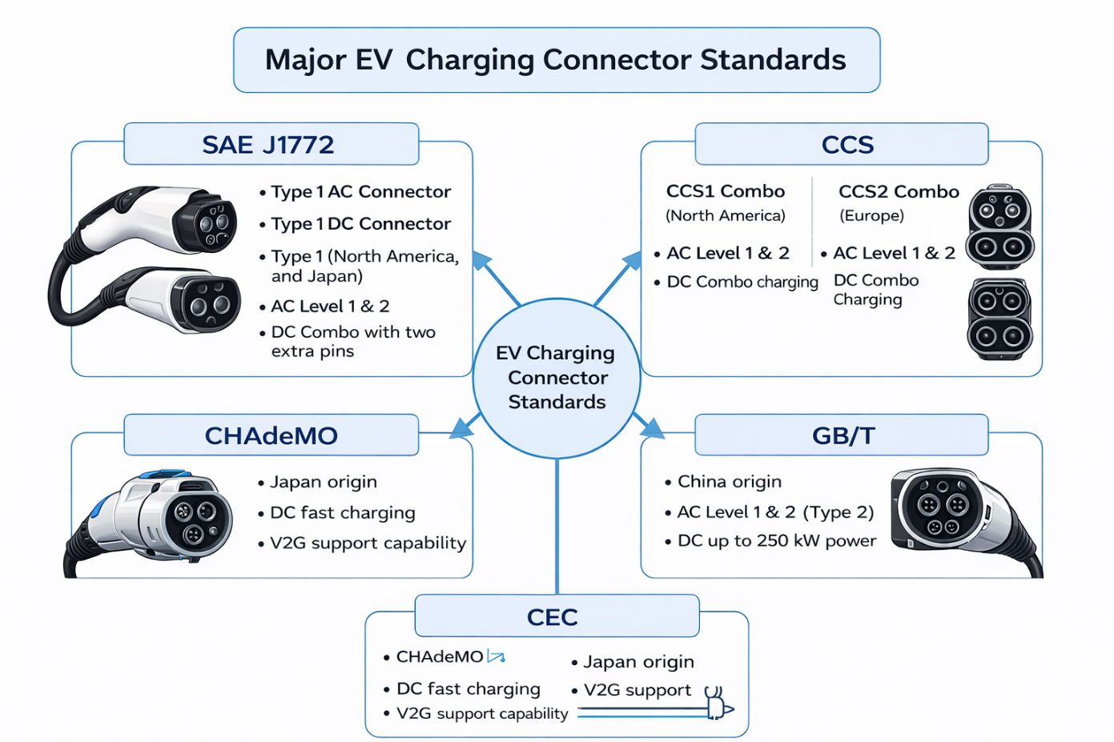
Fig. X. Major EV charging connector standards (based on [3],[6])
6.4 Charging Station Structure and Main Components
A charging station is composed of up of several electrical subsystems, such as circuits for connecting transformers, power converters, protection devices, and control systems. A standard EV charging station has a grid connection, a transformer, a rectifier/inverter, a charging controller, and a charging connector. To keep people safe while they work, there must be safety devices including fuses, circuit breakers, and grounding systems. Because they use a lot of current and create a lot of heat, modern rapid charging stations also need cooling systems. [116], [119]
Also, modern EV charging systems need infrastructure for communication and monitoring. For authentication, payment, defect detection, and smart scheduling, EVs, charging stations, and grid operators need to be able to talk to each other. Technologies like GSM, WiFi, ZigBee, and improved metering infrastructure make it possible to monitor things in real time and manage charging from a distance. These kinds of communication systems make it possible for EV charging to work with smart grids. [117], [119], [122]
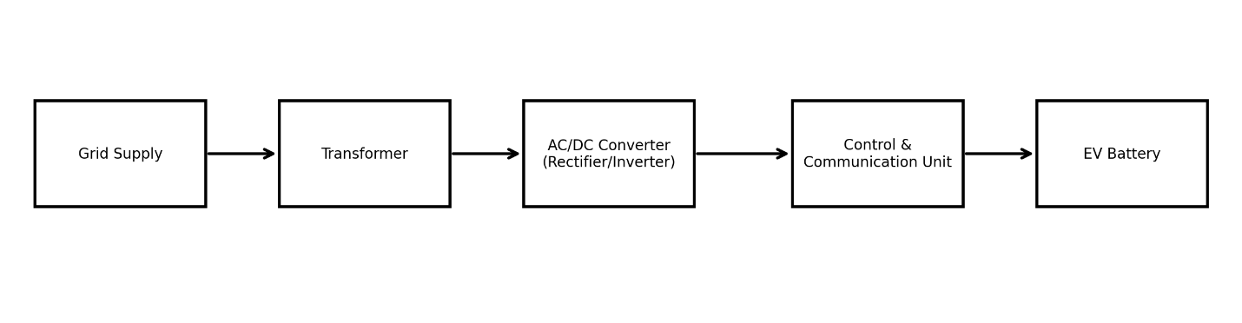
Fig. X. Basic block diagram of an EV charging station
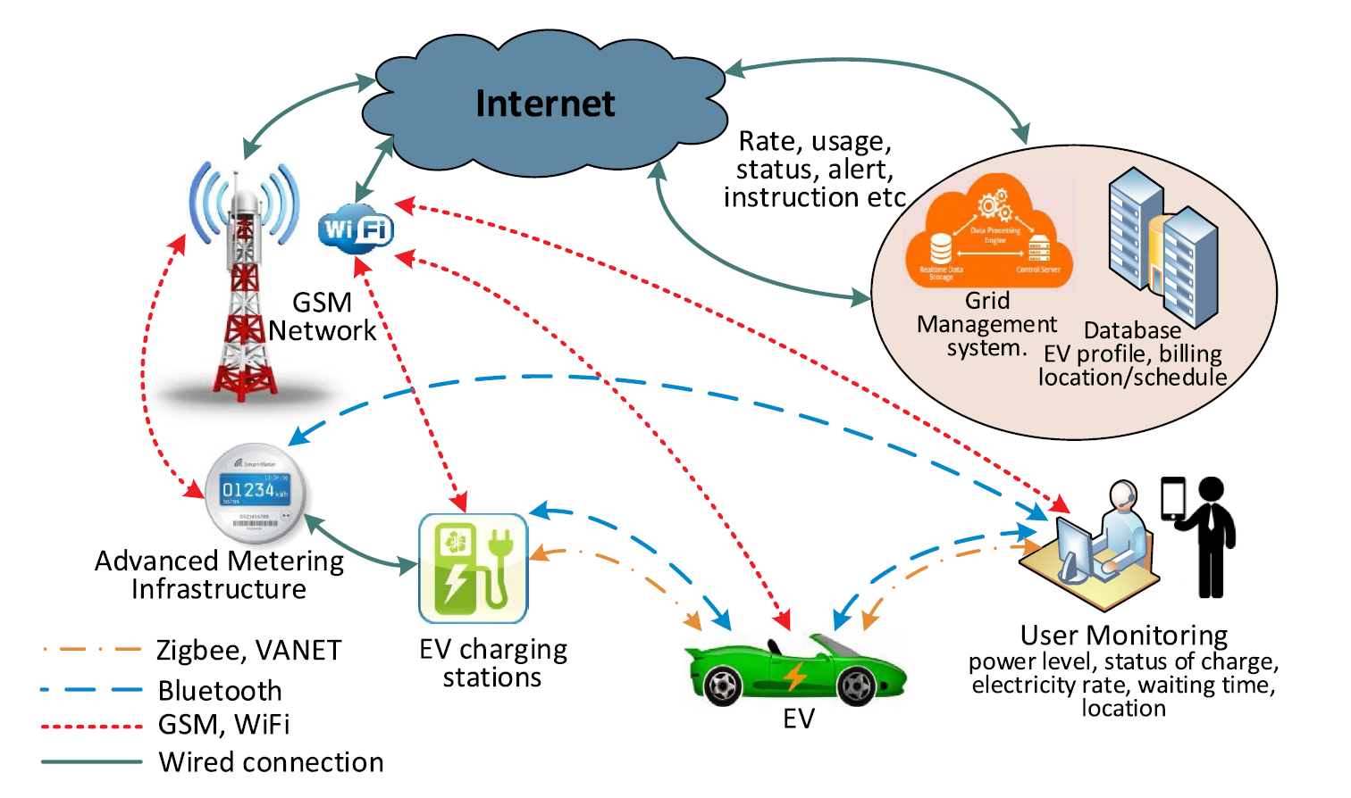
Fig. Communication and monitoring framework for smart EV charging and grid management(adopted from https://doi.org/10.1016/j.rser.2019.109618)
6.5 Grid Interaction and Electricity Demand Increase
When we charge an electric vehicle, it adds more load to the distribution network which means it interacts directly with the power grid. Unlike regular household loads, EV charging uses a lot of power for a long time. When a lot of electric vehicles (EVs) charge at the same time, especially during the evening rush hour, it puts more strain on feeders and increases peak demand. This could cause distribution feeders to become crowded and put more strain on transformers and substations. Studies show that unmanaged EV charging can greatly increase the peak demand on the system and make the grid less reliable. [117], [123], [124]
A smart grid based system describes how EV charging and the grid work together. EV charging stations link to the distribution feeder and are watched over through wired and wireless communication. The kind of charging (AC or DC), the timetable for charging, the location of the charging station, and the level of EV penetration all have a big effect on this grid interaction. So, charging electric vehicles is now seen as a crucial aspect of how new smart grids work. [119], [123]

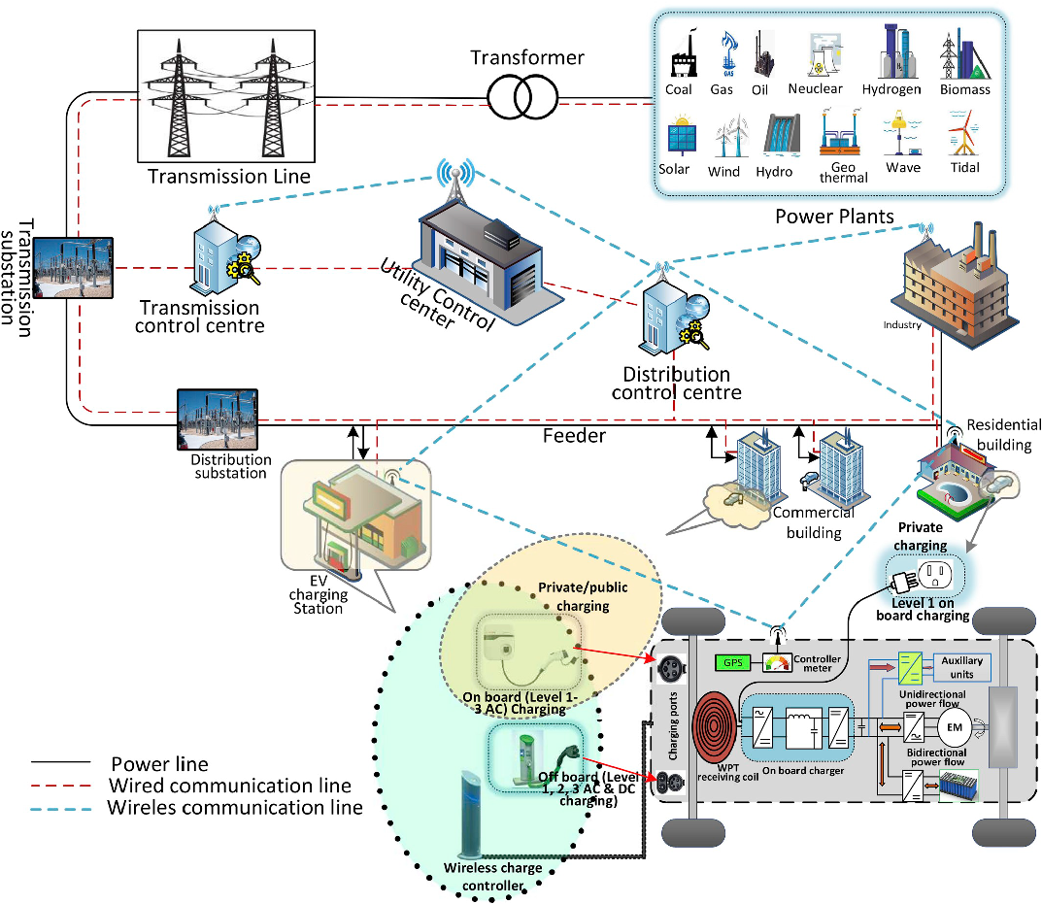
Fig. Smart grid based EV charging interaction with generation, transmission and distribution networks (adopted from https://doi.org/10.1016/j.rser.2019.109618)
6.6 Major Grid Challenges Due to EV Charging
There are many problems with adding large scale EV charging to distribution networks. The biggest problem is that peak load is growing. Charging electric vehicles at different times could increase demand at peak hours in the evening, which means that more capacity is needed to generate and distribute electricity. [2], [8]
Another big problem is that transformers are too full. Distribution transformers are made to handle typical loads, but charging an electric vehicle (EV) puts a constant high current demand on them. This can make them heat up faster and limit their lifespan. [123], [124]
A drop in voltage is also typical, especially for weak distribution feeders. A lot of charging current can lower the voltage at end-user nodes, which can make the grid less stable and less trustworthy for charging. Also, fast chargers use power electronic converters that can cause difficulties with reactive power and harmonic distortion, which can make the power quality not satisfactory. [117], [124]
Building fast charging infrastructure is also quite expensive, and it may require improvements to transformers, feeders, and substations to make the grid stronger. Studies of the economy point out that it costs a lot to create more charging stations when the grid needs to be strengthened. [125], [126]
Table: Summary of EV charging impact on distribution grid
Grid Problem | Cause | Possible Impact
Peak load increase | simultaneous charging | higher electricity cost
Transformer overload | high continuous current | overheating, reduced lifetime
Voltage drop | weak distribution feeder | unstable charging
Harmonics | power electronics | power quality reduction
Upgrade cost | high-power fast chargers | high investment
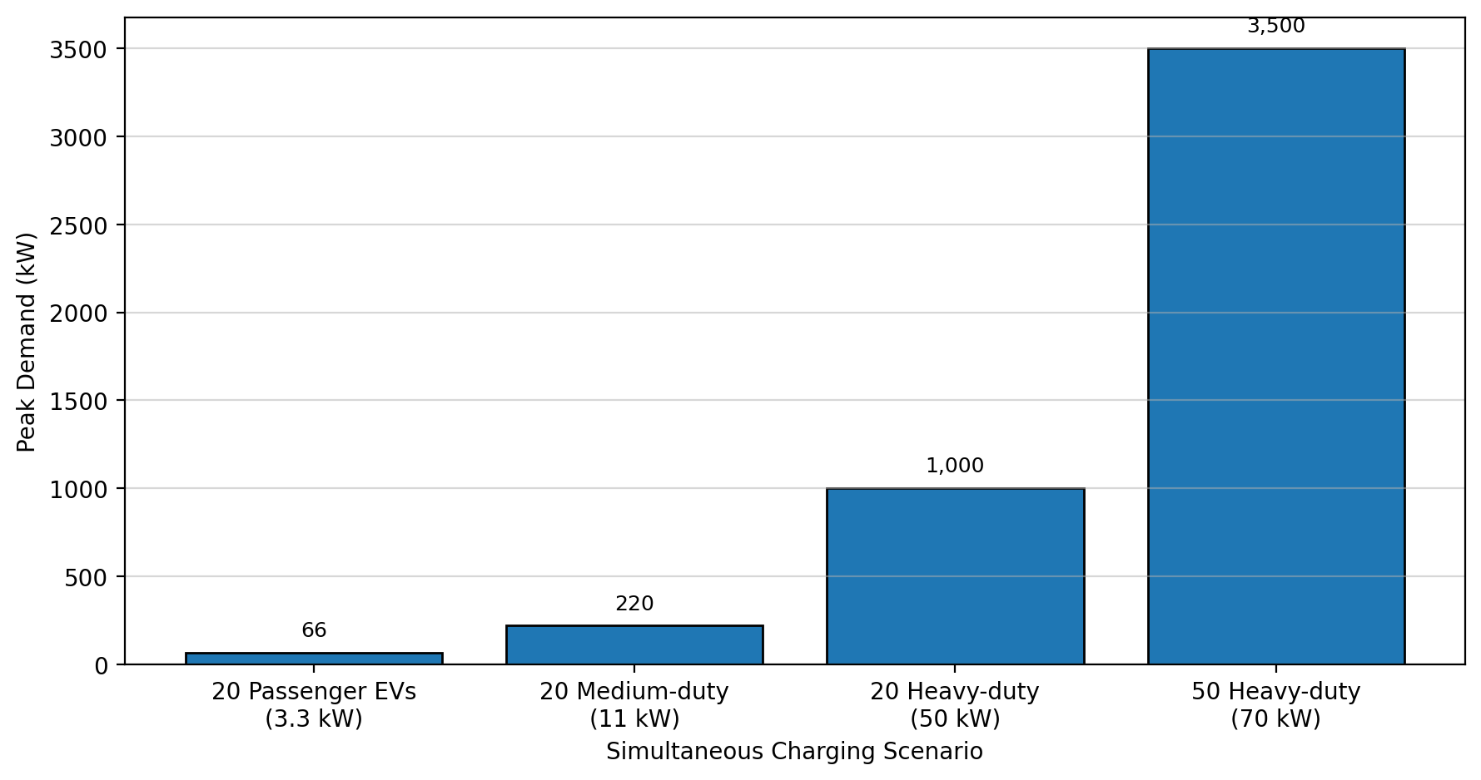
6.7 Smart Charging and Demand Management
Smart charging could help relieve the strain on the grid by permitting us choose the charging time and pace. Smart charging shifts the demand for charging to times when there isn't as much demand, instead of charging right away after plugging in. This minimizes peak demand makes transformer loading more even and maintains the voltage profile consistent. Studies show that combined charging can greatly improve the dependability of the grid and lower the costs of strengthening infrastructure. [117], [123], [127]
We may regulate smart charging by using a centralized, hierarchical, or decentralized system. Centralized control makes it easy to plan things but it needs strong communication and a lot of computational power. Decentralized control makes it easier to grow and not depends as much on communication. These control designs let grid operators deal with EV demand in a rational way. [119], [127]
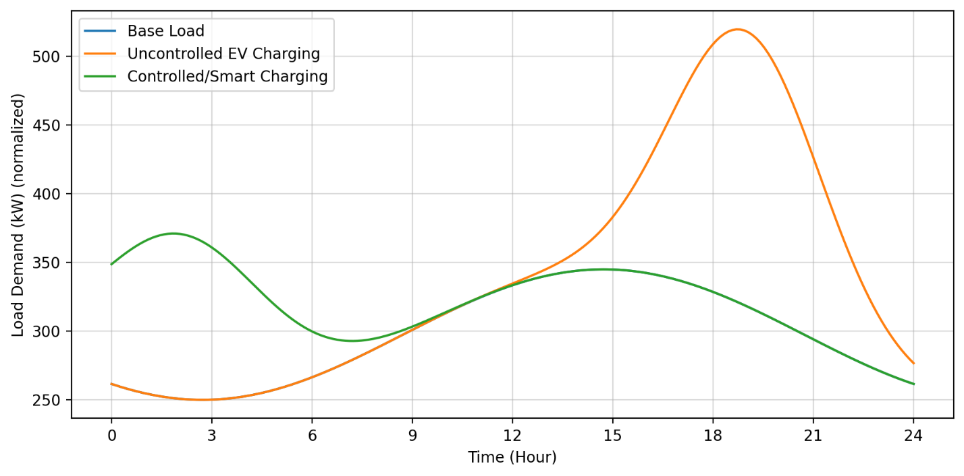
Fig. 15. Uncontrolled vs coordinated charging load profile showing peak demand increase
6.8 Vehicle to Grid (V2G) and Bidirectional Charging
Vehicle to the electrical grid (V2G) is a revolutionary charging system that lets EV batteries send power back to the grid. This lets electric vehicles (EVs) work as distributed energy storage devices, which can help with peak shaving, frequency management, and backup power in case of an emergency. V2G can also help in integrating renewable energy by storing extra energy and giving it to the grid when demand is high. [117], [123], and [124]
But V2G needs chargers that can work in both directions and advanced control and communication systems. The battery wears out quickly because it is charged and discharged often and the charger is very expensive. Also, secure communication is necessary to avoid cyber threats. Even with these problems V2G is thought to be an achievable solution for smart grids in the future. [117], [124]
Table X. Comparison between unidirectional charging and V2G
Feature | Normal Charging | V2G Charging
Power flow | Grid → EV only | Grid ↔ EV both ways
Benefit | simple charging | grid support
Cost | low | higher
Charger type | unidirectional | bidirectional
Battery impact | normal aging | extra degradation risk

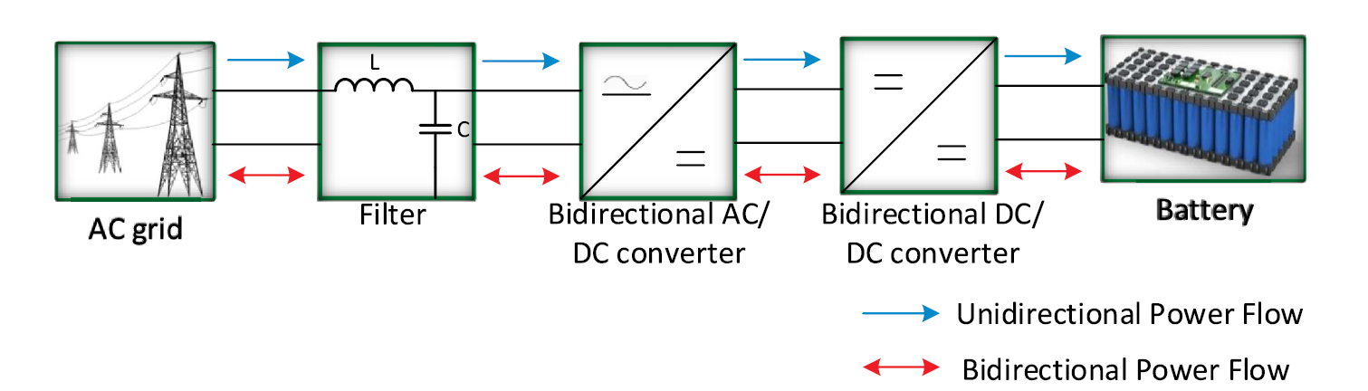
Fig. General topology of unidirectional and bidirectional EV chargers for V2G operation (adopted from https://doi.org/10.1016/j.rser.2019.109618)
6.9 Commercial Fleet Charging and Depot Infrastructure
Commercial electric vehicles, such trucks, buses, and delivery fleets, need a lot of charging stations and a lot of power to charge. Fleet storage facilities charging is a frequent way to charge many vehicles in one place. Fleet charging can cause very high peak demand, though, because many different vehicles can charge at the same time. So, depot charging needs careful planning, load management, and control mechanisms that work through communication. [128], [129]
Most fleet depot charging systems have local distribution networks, monitoring systems, and central control centers. Such infrastructure makes it possible to charge at the same time, lowers peak load, and makes operations more efficient. Charging electric vehicles for business is one of the most difficult things to do because it costs a lot to build the infrastructure and the grid is very important. [129], [130]
6.10 Renewable Energy Integration with EV Charging
Combining electric vehicle charging infrastructure with renewable energy sources like solar and wind can help cut greenhouse gas emissions and reliance on fossil fuels. Renewable integrated charging stations commonly use battery energy storage systems (BESS) to store energy when there isn't much demand and give it back when there is a lot of demand. This makes the main grid less stressed and helps charging stations run in a way that is good for the environment. [117], [131], [132]
But renewable production is not always available, thus energy management measures are needed to make sure that charging service is always available. Future EV charging stations should use hybrid charging systems that combine renewable power, storage, and grid backup. [131], [132]
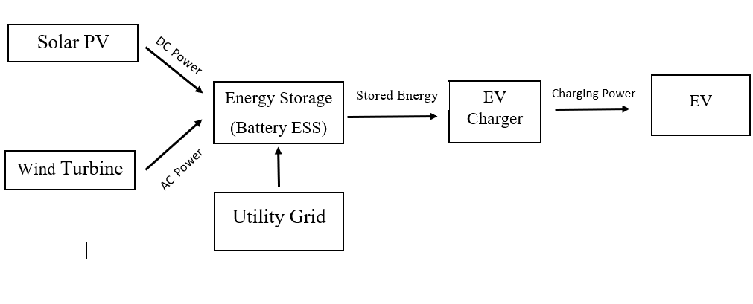
Fig. Renewable Energy Integration with EV Charging
Charging infrastructure is a big part in getting people to use electric vehicles. It includes home charging, office charging, public charging stations, and rapid charging networks on highways. SAE J1772 and other charging standards set different charging levels based on voltage and power ratings. But charging electric vehicles puts a lot of stress on the distribution grid, such as peak demand rise, transformer overloading, voltage deviation, harmonic distortion, and the expensive expense of reinforcing the grid. To keep the grid stable and move charging demand away from peak hours, smart charging solutions are needed. V2G technology also opens up new possibilities for two-way power flow and grid support in the future. Finally, charging stations that use renewable energy and charging networks that use microgrids are promising ways to implement EV charging in a way that is good for the environment. [117], [123], [124], [131]
7.Energy Efficiency & Environmental Impact
Energy Efficiency and Environmental Impact
The transition from stored to usable kinetic energy involves several phases all with their respective entropy content that steadily reduces the effectiveness of the system. In mechanical systems friction/mechanical drag and heat dissipation are the main source of decrement in the obtained output.
The transportation sector around the globe faces challenges in energy consumption and greenhouse gas (GHG) emissions, which works as a motivation for the transition from internal combustion engine vehicles (ICEVs) to more efficient alternatives like Battery Electric Vehicles (BEVs), Hybrid Electric Vehicles (HEVs), and Plug-in Hybrid Electric Vehicles (PHEVs)[133], [134], [135]. This ongoing shift is basically motivated by a drive to be more environmentally conscious and different technological advancements by scientists to minimize the overall energy or carbon footprint and reduce the adverse impacts on environment and biodiversity[134]. A complete and deep understanding of this transition needs us to evaluate both the energy conversion efficiency and its long term environmental impacts across the total vehicular life cycle, using methodologies like Well-to-Wheel (WTW) analysis and Life Cycle Assessment (LCA)[134], [136], [137].
​​7.1 Energy Conversion Efficiency in Electrified Vehicles​​
The process by which stored energy is converted into kinetic motion is made of many stages, each of which has inherent losses of energy and entropy value. Understanding these losses is essential for assessing the overall effectiveness and efficiency of a vehicle[136], [137], [138] .
Internal combustion engines run on power generated by burning fuel, releasing the stored chemical energy to drive the motion of pistons. However, a significant part of this energy is lost as heat [136], [138]. On the other hand Electric vehicles convert electrochemical energy from sources like batteries into electromagnetic force to maneuver the vehicle [137], [138].
Mechanical Losses​​: Parasitic friction in the drivetrain, including due to the meshing of gears, the resistances of mechanical bearing and tire’s resistance during rolling, reduces the net power that is ultimately delivered to the wheels [139]. In ICEVs, additional mechanical drag from pistons, crankshafts, valvetrains and other mechanical components contributes to these losses[139].
Thermal Losses in ICEs​​: A major cause of inefficiency in ICEs is the heat dissipation, generally approximately 60% to 70% of fuel energy is expected to be lost as waste heat through the exhaust system, cooling systems and radiator [136], [139]. This is a limitation of laws of thermodynamics which is illustrated by the Carnot cycle and means that even advanced ICEs struggle to achieve thermal efficiencies above 40% [139].
Electric Motor Efficiency​​: Electric motors have a significantly higher efficiency which is typically in the range of 85% to 95% [138], [139]. They maintain this high efficiency value across a range of rotational speeds (RPMs). The major Energy losses are due to copper losses (resistive heating), iron losses (magnetic hysteresis) and windage [139].
Battery and Inverter Losses​​: Though highly efficient, electric powertrains have energy losses that are not seen in ICs and are entirely unique to them.
Charge-Discharge Losses​​: sometimes referred to as the "round-trip efficiency" energy is lost as heat during the chemical reactions inside battery cells due to internal resistance [140].
Inverter Losses​​: During the conversion from direct current (DC) of the battery to alternating current (AC) used by the motor, high-frequency switching takes place in the inverter which generates a certain amount of heat and results in a 2% to 5% drop in the obtained energy [141].
The superiority electric drivetrains in terms of efficiency is evident when the tank-to-wheel (TTW) efficiencies are compared: ICEVs typically achieve 20-25%, HEVs 30-40%, PHEVs 35-45%, and BEVs 75-90% [138]. This massive differences means that EVs cause much lesser amount of CO and CO2 emissions during operation compared to ICEVs and while not as much as ICEVs, the HEVs and PHEVs also demonstrate a statistically significant amount of reductions [138].
​​7.2 Regenerative Braking​​
One of the main technological advantage of electrified vehicles (HEVs, PHEVs, and EVs) is its regenerative braking system [142], [143]. In the ICEVs kinetic energy during braking is entirely dissipated as wasted heat through friction brakes whereas in the electrified vehicles it is converted back into electrical energy and stored it in the battery for later use[143], [144].
Regenerative braking systems is now a days able to recover 60-70% of the kinetic energy during decelerating motion and thus it significantly improves the overall energy efficiency by 10-25% [140], [142]. This feature is very effective in urban driving practices where frequent stops and starts are expected phenomena [145]. Beyond the energy recovery this process also reduces wear and tear on mechanical brake components of the vehicle causing extension in their total lifespan .
The flow of energy during braking in conventional ICEVs includes the conversion of kinetic energy to heat which gets dissipated to the surroundings. But in electrified vehicles, the electric motor also acts as a generator and converts kinetic energy into electrical energy that recharges the battery [144]. This is a fundamental difference between the two types of vehicles that is a major contributor to the higher energy efficiency of EVs in urban environments.
Table: Energy Recovery Benefits across Vehicle Types.
Feature | ICE | HEV | PHEV | EV
Regenerative braking | No | Yes | Yes | Yes
Energy recovery potential | 0% | Moderate | High | High
Urban efficiency improvement | Low | Medium | High | Very High
​​7.3 Well-to-Wheel (WTW) Energy Analysis​​
To properly analyze the energy consumption and environmental impact of vehicles, a complete WTW analysis is needed [133], [136], [138], [146]. This approach considers all the components of energy chain from the primary energy source ("well") to the vehicle's wheels by dividing them into two main phases: Well-to-Tank (WTT) and Tank-to-Wheel (TTW)[136], [147] .
Well-to-Tank (WTT) Efficiency​​: This phase deals with the energy expended to produce and deliver the fuel or electricity to the vehicle’s engine[136], [147]. For liquid fuels, WTT includes crude oil extraction, refining, and distribution [148]. For electric vehicles, WTT considers the energy consumption and losses associated with electricity generation at power plants (thermal efficiency) and subsequent transmission losses across the electrical grid[136], [147], [149] . This stage highlights the "upstream" energy debt incurred before the vehicle even begins operation[147] .
Tank-to-Wheel (TTW) Efficiency​​: This metric quantifies how efficiently the energy stored onboard (fuel tank or battery pack) is converted into mechanical work at the drive wheels [136], [138], [149]. As previously discussed, electric drivetrains exhibit superior TTW performance due to the high efficiency of electric motors and the absence of idling losses, significantly outperforming conventional engines during this operational phase[138], [150] .
The overall environmental and energetic benefit of electric propulsion is intrinsically linked to the primary energy source of the grid supplying electricity[136], [146], [147], [151] .
7.4 Greenhouse Gas Emissions Comparison
Coal-Based Grid: Using coal for electricity generation in main power plant results in the highest amount of carbon emissions and also results in the lowest system efficiency. Coal driven power plants generally have thermal efficiencies that is belo35% which causes heavy WTT losses that can to some extent negate the TTW advantages of electric motors. Despite this flaw, EVs still maintain a slight advantage in overall CO2 output compared to traditional petrol engines .
Natural Gas Grid: Natural gas is a more efficient alternative fuel source. Combined-cycle gas turbines (CCGT) can deliver thermal efficiencies that exceeds 60% . This hugely reduces WTT energy waste and makes the gas-powered electric charging system a superior option to both coal and direct petroleum combustion in terms of both efficiency and emissions.
Renewable Grid: A grid which is powered entirely and solely by renewable energy sources such as wind, solar or hydropower is the most optimal pathway of energy. By avoiding the thermal combustion entirely, WTT losses are minimized to basic transmission and distribution losses which are much less significant in amount. In this scenario, the "well-to-wheel" lifecycle achieves maximum efficiency and reduces the total greenhouse gas emissions by over 70% compared to the fossil fuel alternative system’s baselines .
Life Cycle Assessment (LCA): The comprehensive life cycle assessment (LCA) is essential for determining the full impact of the different vehicular technologies on the environment, starting from the from raw material extraction to the recycling at the end of its life. This holistic approach covering all the aspects reveals that while EVs offer significant advantages during their operational phase, their overall environmental footprint is most significantly influenced by their manufacturing process and disposal potential .The lifecycle of a typical battery system involves four critical stages:
Raw Material Extraction: This is the initial phase that focuses on acquiring key minerals for vehicle production such as lithium, cobalt, and nickel . These processes often involve processes such as brine evaporation or hard-rock mining for lithium and ore processing for cobalt and nickel which are widely criticized for high amount of water usage and causing harm to local ecology . This is what is called the "upstream" environmental debt .
Manufacturing and Assembly: Battery production is an energy-intensive process, accounting for nearly half of the total greenhouse gas emissions in an EV's pre-operational life . Significant energy is consumed during electrode coating, maintaining ultra-low humidity in dry rooms, and the initial charging cycles (formation and aging) .
Operation Phase: This is the longest phase, where the vehicle's utility is realized . Electric drivetrains convert over 85% of stored energy into movement, far outperforming combustion alternatives . The environmental impact of this phase is directly dependent on the carbon footprint of the local electrical grid system.
End-of-Life (EoL) and Recycling: As batteries reach the end of their usability at typically 70-80% of original capacity and then they are repurposed for second-life applications like stationary grid storage or have to be recycled by the appropriate methods . Recycling using proper methods such as pyrometallurgical or hydrometallurgical processes are a must in order to recover high-value metals which can be recirculated to foster a circular economy and also reduce the need for new material extraction .
Initial Manufacturing Emissions: LCA studies regularly show that EVs have a higher value of initial environmental footprint than ICEVs mainly due to the production of its lithium-ion batteries with high capacity [134]. The manufacturing process of an EV typically causes 30% to 40% more CO2 emissions than a similar petrol or diesel vehicle mainly due to its heat-intensive processes of electrode drying and the extraction of many different critical minerals [134].
Lifetime Operational Offset: even with the high initial manufacturing emissions, the superior efficiency levels of electric vehicles allow them to achieve carbon parity relatively earlier in their life service[134]. On an average estimation, an EV offsets its higher production emissions within 15,000 to 30,000 miles (around 1 to 2 years of typical driving on the road) [134]. Over the lifespan of on average 15 years , total GHG emissions from an EV comes out to be 50% to 70% lower than its ICE counterpart which is a gap that widens as the national grid includes more renewable and cleaner sources of energy [134].
Mitigation via Circular Economy: The implementation of advanced recycling technologies is fundamental for the reduction of the total lifecycle impact of an EV [134]. By using the hydrometallurgical recycling processes manufacturers can end up reclaiming up to 95% of its key materials for battery production[134]. This is an effective closed loop recycling that can ultimately decrease the total lifecycle emissions of a battery system by 20% to 40% and also significantly reduce the need for further mining [134].
Phase | EV Impact | ICE Impact | Net Result
Production | High (Battery debt) | Moderate | EV starts at a carbon deficit
Operation | Near-zero (Grid dep.) | Very High (Tailpipe) | EV achieves parity in < 2 years
End-of-Life | High Recovery (30%+ save) | Low Recovery | Circularity favors EV

Greenhouse Gas Emissions Comparison: A complete comparison of lifecycle emissions across various vehicular platforms shows a significant differences in their "cradle-to-grave" carbon footprint after accounting for all parts ot its life cycle such as manufacturing, fuel/electricity production and also operation.
Vehicle Type | Lifecycle Emissions (gCO₂​/km) | Key Efficiency Bottleneck
ICE (Petrol/Diesel) | 180–250 | Thermodynamic exhaust losses (>60%)
HEV (Hybrid) | 120–180 | Continued reliance on fossil fuel combustion
PHEV (Plug-in Hybrid) | 80–160 | Efficiency highly dependent on charge frequency
EV (Coal-heavy Grid) | 150–200 | High Well-to-Tank (WTT) carbon debt
EV (Renewable Grid) | 20–60 | Manufacturing and battery extraction footprint

7.5 Grid Intensity and Pollutant Displacement
Grid Decarbonization and the Renewable Advantage: The environmental benefit of an EV is not static but heavily depends on the local electricity mix [136]. Amount of green or renewable energy on grid is increasing and it is reducing the lifecycle emissions of EVs significantly [136]. On a renewable energy heavy grid it is estimated that EVs can reduce lifecycle greenhouse gas emission by around 50% to 70% compared to ICEVs [136].
The NOx and N₂O Paradox: Even though EVs eliminate the presence of tailpipe emissions, their total lifecycle carbon footprint for specific pollutants might end up higher if the power grid uses fossil fuels as energy source [133]. On the grids that are heavily reliant on coal, the centralized combustion at power plants can lead to very high lifetime NOx levels than modern ICE vehicles [133]. This means that without a rapid and conscious transition to clean renewable energy, emissions are only displaced from urban areas to the typicalloy more remote power plant sites and not fully eliminated[133]. EVs produce higher NOx and N2O emissions generally more than 70% which points toward a dependence on fossil fuels for the electricity generation [133].
Particulate Matter (PM10) and SOx Elevation: Data collected and analyzed by scientists suggests that air quality related emissions such as Sulfur Oxides (SOx) and PM10 can be significantly higher for EVs in certain scenarios. The higher vehicle weight from battery packs causes rise in the non-exhaust emissions (tire and brake wear) [133]. Also the manufacturing and mining for the battery materials also contribute to higher PM levels [133]. Different industrial processes for refining and extracting nickel and cobalt added with coal fired electricity for battery assembly can cause SOx levels nearly 85% to 90% higher than the standard ICE vehicles [1].
Urban Air Quality and Air Quality Index (AQI): The move to electric vehicles has a huge impact on urban air quality. ICEVs are significant sources of many hazardous pollutants which cannot be removed even with advanced converters. Tailpipe emissions typically contain nitrogen oxides (NOx), carbon monoxide (CO), particulate matter (PM2.5, PM10), burnt lubricant and carbon compound and also unburned hydrocarbons or fuels [133]. These pollutants contribute to ozone at the ground levels,cause acid rain and long and short term respiratory issues [133].
Electric Vehicle (EV) Environmental Impact: Electric drivetrains offers a huge opportunity and trespite by eliminating local exhaust emissions.
Zero Tailpipe Emissions: They remove the primary source of roadside toxin materials by eliminating the combustion cycle completely [133].
Localized Pollution Abatement: Due to the shift to electric fleets the concentration of NO2 and CO in high-traffic areas is reduced to a very low state [133].
7.6 Urban Air Quality and Air Quality Index (AQI)
The Air Quality Index (AQI) is an standard value used by environmental agencies around the world to communicate the cleanliness and purity of the air and associated health impacts on the general public. In densely populated urban areas the EVs provide an immediate reduction in chemical precursors that would otherwise lead to respiratory distress and thus improves the local Air Quality Index (AQI) [133].
The Air Quality Index (AQI) Framework: The AQI is a standardized scale used to communicate air cleanliness and associated health risks to the public. It integrates the measurements of six primary pollutants: fine particulates (PM2.5 & PM10), nitrogen dioxide (NO2), sulfur dioxide (SO2), carbon monoxide (CO), and ground-level ozone (O3) [134]. The relation between transportation and AQI is direct and evident, when vehicle emissions decrease the concentration of these pollutants also drop in the environment which leads to a lower AQI values and also better air quality [133]. This improvement is most easily noticed in metropolitan areas where transport accounts for over 50% of ambient air pollution [133].
Table: Urban Air Pollutant Comparison
Pollutant | Internal Combustion (ICE) | Hybrid (HEV) | Plug-in Hybrid (PHEV) | Electric (EV)
NOx | High | Medium | Low | Zero
PM2.5 | High | Medium | Low | Zero*
CO | High | Medium | Low | Zero
EV adoption significantly improves urban air quality by eliminating tailpipe emissions, even if the electricity grid is fossil-based, because power plants are typically located outside urban centers . This change in emissions location away from populated urban areas leads to direct improvements in the air quality experienced by urban residents.
7.7 Noise Pollution Reduction
Noise pollution is often an overlooked environmental advantage of EV useage. ICE engines produce significant combustion noise, contributing to overall urban noise levels EVs, in contrast, operate very quietly at low speeds due to the absence of an [internal combustion engine . This reduction in urban noise improves public health, reduces stress levels, and enhances sleep quality .The noise reduction is most noticeable at speeds below 50 km/h . Some advanced countries in the world have implemented regulations requiring EVs to emit artificial sounds at low speeds to ensure safety of pedestrian.
The shift to electric vehicles (EVs) offers a significant, yet often underestimated, environmental advantage: the reduction of noise pollution[143]. The acoustic profile of modern transportation, heavily dominated by [internal combustion engine (ICE) vehicles, is a significant contributor to urban environmental health concerns. The fundamental difference in propulsion systems between ICEVs and EVs leads to a transformative reduction in ambient noise[143] .
Comparative Acoustic Profiles
The primary distinction in vehicular noise originates from the method of energy conversion [143].
Internal Combustion Engines (ICE): Conventional vehicles produce consistent "combustion noise" from the controlled explosions within their cylinders, along with mechanical vibrations from the valvetrain and exhaust system [143]. This contributes significantly to overall urban noise levels [143].
Electric Vehicles (EVs): Electric drivetrains operate with near silence at low-to-moderate speeds because they do not have the reciprocating mass or exhaust discharge characteristic of its counterpart the petrol engines [143]. The absence of an internal combustion engine means EVs are very quiet and stealthy especially at lower end of its speed[143] .
Impact on Public Well being
The reduction of urban noise pollution through vehicle electrification ensures measurable improvements in several quality of life indicators:
Public Health: Chronic exposure to elevated noise levels is found to be linked to cardiovascular strain and hypertension which makes noise reduction a public health benefit[143] .
Stress Levels: A quieter environment can help reduce the cognitive load, anxietyand the cortisol levels associated with the constant "background hum" generally considered prevalent in metropolitan areas[143] .
Sleep Quality: Lower nighttime noise levels from nearby roads and transits can hugely improve REM sleep cycles and the overall restfulness for its residents[143] .
Speed-Dependent Noise and Safety Regulations: The acoustic advantage of EVs is most pronounced at lower velocities .
The 50 km/h Threshold: At speeds below 50 km/h noice reduction becomes more noticeable[143]. The sound generated by tire-road interaction and wind resistance at higher speeds becomes one of the most prominent noise source for all vehicle types which is effectively equal for both EVs and ICEVs [143].
Acoustic Vehicle Alerting Systems (AVAS): Due to the quietness of EVs in absence of mechanical engine noises at low speeds, many nations have implemented rules and regulations to include artificial sound generators[143] . These mandatory systems emit a artificial hum to alert the pedestrians specially visually impaired pedestrians and cyclists about an approaching vehicle which balances the benefits of urban quite environment with essential aspecs of public safety[143].
The differences in acoustic profile due to the shift from ICs to EVs ensures a significant reduction in ambient noise pollution which contributes contributing to a healthier urban environment [143].
The environmental impacts of electric vehicle (EV) adoption in developing nations, such as Bangladesh is a complex matter which is also intertwined with the existing energy infrastructure and urban challenges. Even though EVs offer significant benefits in reducing localized emissions more importantly is the carbon intensity of the electricity grid which very heavily influences their overall environmental carbon footprint[134], [136].
Bangladesh's electricity generation is still heavily reliant on fossil fuels which leads to a high grid carbon intensity with a range of approximately 500 to 600 g CO₂/kWh[133] . This reliance also means that while EVs produce zero tailpipe emissions its upstream emissions from electricity generation for their charging is more than substantial. Asa result the well-to-wheel (WTW) emissions of an EV operating on such a grid might not be as low as those in regions with a higher percentages of renewable energy sources[133] . For example EV charged on a coal-heavy grid can have lifecycle CO₂ emissions ranging from 150–200 g CO₂/km which although potentially lower than an ICE vehicle (180–250 g CO₂/km) is much higher than an EV charged on a renewable grid (20–60 g CO₂/km)[1] .
Severe air pollution in urban areas like in cities of Dhaka is a critical concern which is caused by high levels of particulate matter (PM2.5) and also significant traffic congestion with ill health IC vehicles[134] . ICE vehicles are major contributors to this pollution which emits nitrogen oxides (NOx), carbon monoxide (CO), particulate matter (PM2.5, PM10), burned particles and unburned hydrocarbons[134] . So EVs offer a not only a direct and immediate benefit by eliminating tailpipe emissions at the point of use it also causes reduction in the urban NOx and PM2.5 exposure which might lead to improved local air quality and public health outcomes even if the electricity generation is fossil-fuel dependent since power plants are typically located outside urban centers which displaces emissions away from densely populated areas[134] .
However, the high carbon intensity of Bangladesh's grid is a hard challenge for achieving the full climate benefits of EVs. Even though EVs can significantly reduce urban air pollutants like NOx, PM2.5 and CO its lifecycle footprint for specific pollutants like SOx and PM10 can be higher if the power grid relies mostly on fossil fuels, especially coal[1]. For example the industrial processes for refining battery materials and the electricity used for assmembly of battery parts particularly from coal powered power plants can and will lead to SOx levels nearly 85% to 90% higher than those of standard ICE vehicles [133]. Moreover, the increased vehicle weight of EVs due to battery packs can cause high non exhaust emissions from tire and brake wear which contributes to PM10 levels[133] . This means that without a rapid transition to cleaner energy sources for electricity generation at power plans supplying the grids the burden of emissions is only transferred from urban areas to more remote power plant sites and are not fully eliminated[133] .
Therefore, for developing nations like Bangladesh, the environmental efficacy of EVs is two-fold. Firstly, they provide a crucial solution for mitigating urban air pollution and improving the Air Quality Index (AQI) in densely populated areas by eliminating tailpipe emissions[134] . Secondly, to fully realize the climate benefits and reduce overall lifecycle GHG emissions, substantial investment in and transition to renewable energy sources for electricity generation are imperative[133], [134] . Without such grid decarbonization, the potential for EVs to contribute to climate change mitigation remains constrained by the upstream emissions associated with their power supply[136] .
In the context of Bangladesh, electrified vehicles offer significant potential for improving urban air quality and reducing traffic-related pollution. However, the environmental benefits in terms of greenhouse gas mitigation are closely linked to the carbon intensity of the national electricity grid. Therefore, simultaneous development of renewable energy infrastructure and EV adoption is essential to ensure long-term sustainability.
Ultimately, HEVs present the most balanced combination of selling price, emission cost, and maintenance cost, making them an appealing option for the future market[134].
8.Economic Analysis and Marketing Trends

8.1
Electric Vehicles (EVs) have gotten extremely popular over the past two decades. The primary causes that have aroused this popularity are low operational costs, reduced greenhouse emissions and improved fuel economy [152]. But several limitations of the manufacturing cost of EV have consistently discouraged the consumers to purchase EVs over ICEVs (Internal Combustion Engine Vehicles). However, there is massive scope to surge the EV market to a much larger scale since the correct marketing policies have not been implemented well enough to encourage the consumers to purchase EVs. In this section, we will elaborately discuss the marketing trends for EVs and analyze the economy concerning Electrical Vehicles.

8.2 Total Cost of Ownership
The total cost of ownership (TCO) can be categorized into two main types: (a) One Time Cost (OTC) and (b) Recurring Cost (RC). One time cost includes purchase price and resale values. On the other hand, RC includes fuel cost, maintenance cost, insurance cost, taxes etc [158].
The prices of electric machines depend on the nominal power.
Table-8.a: Price of Electric Machines[153]
Machine Type | Price (€/kW)
PSM (Permanent Magnet Synchronous Machine) | 10
IM (Induction Motor) | 8

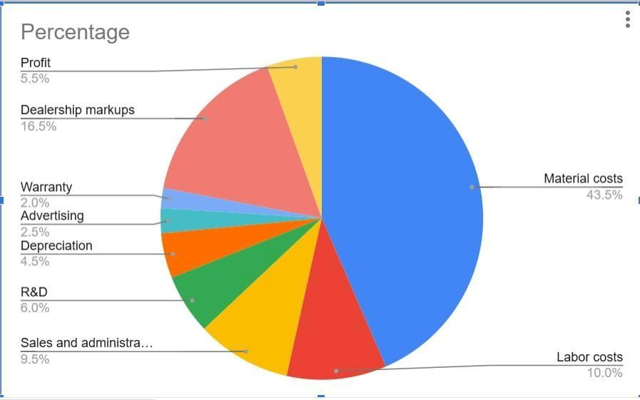
Figure-8.a) Cost breakdown of a new car [153]
For a glider, the production cost is presumably calculated from the selling price and surcharge factor. In table 8.b, we list down the costs of standard equipment for a glider and a medium size car.
Table-8.b) Costs of components in a vehicle[153]
Components | Costs (€)
Windows | 75
Window Lifter | 12
Exterior Lights | 140
Low voltage electronics | 520
Wiring harmless | 210
ESP | 160
Airbag | 20
HVAC | 80
Seat Warmer | 10
Wind shield wiper | 30
Front Seat | 100

The costs of different kinds of materials used in the construction of the car also contributes to the TCO.
Table-8.c) Cost of materials[153]
Material | Cost (€/kg)
Aluminium | 2.5-4
High strength steel | 0.6-1
Plastic PP | 1.6-2
Plastic ABS | 2.5-3.5
Apart from the infrastructure costs and energy costs, there are external costs to an electric vehicle because of climate, air pollution, accidents, traffic jams, noise control and so on.
Table 8.d) External costs for different vehicles [153]
Vehicle | Cost (€/km)
Cars | 0.12
Motorcycle | 0.25
Public Transport | 0.04
The general cost factors affecting the TCO calculation are acquisition, depreciation, energy consumption, insurance, tax, inspection and repair, tires, vehicle care, parking etcetera.

8.3 Current Global Market of EVs
Electric vehicles have taken the world by a storm throughout the past decade with its massive success as Light Duty Vehicles (LDVs) like 3-wheelers, mopeds, kick scooters and e-bikes. By the year 2020, 140 billion US dollars have been invested globally for the electrification of vehicles. 50 LDV models were proposed in 2020 and 130 EV models were estimated to be proposed in 2023. At present, approximately 2% of the global electricity demand is required by transports, which is expected to rise to 10% by 2050. By the end of 2019, the global EV market had escalated by more than 40% than that of 2018, rising to 7.3 million units in that year [152].
For medium duty vehicles, the market is calculated to be rising at nearly 9% rate per year. In 2020, the global industry value for medium duty vehicles was found out to be $343 [152]. However, for heavy duty vehicles (HDVs), battery buses are much more expensive than the fossil fuel based alternative vehicles. So, HDV and MDV are generally less popular than LDVs because of technical and economic factors.
8.4 Battery Prices and Its Affordability
The prices of batteries used in electric vehicles play a significant role in the marketing of EVs. In 2019, the price of lithium ion batteries declined by more than 80%, creating a large shift from $1000 kW/h to $156 kW/h [152]. Along with the major reduction of battery prices, a battery becomes more preferable when its specific energy is amplified and the battery weight is reduced. One way of removing this weight from the lithium ion battery can be done by removing the cobalt belt off the battery. Apart from lithium ion batteries, other types of batteries that are typically used in electric vehicles are lead acid batteries, LiCoO₂ and lithium phosphate batteries. The price of a battery primarily depends on the material used in its construction.
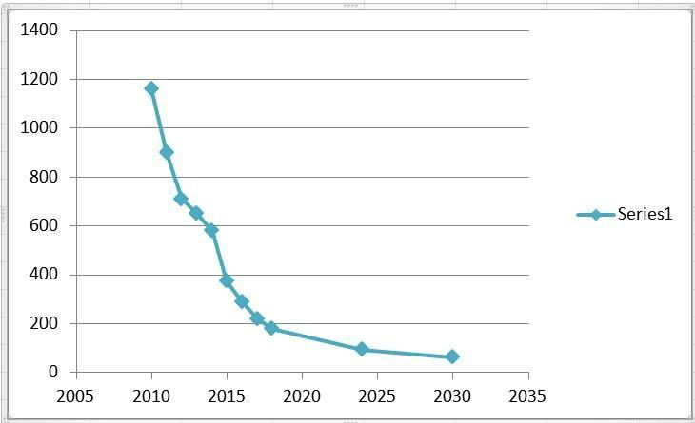
Figure-8.b) The graph showing the reduced price of lithium ion battery over the years [152]
Table-8.e) Cost of different materials in a battery[152]
Type of Chemistry Cathode/Anode | Approximate cost ($kW/h)
LCO/Gr | 250
NMC111/Gr | 145
NMC622/G | 135
NMC622/Gr | 120
NCA/Gr | 130

The market of batteries for electric vehicles has been growing sharply over the past few years. The global battery industry commanded a market value of $21.95 billion in the year 2020 [155]. This value escalated to $27.3 billion the very next year, 2021 [155]. And it has been estimated to stand at $154.9 billion by the year 2028 [155].
The leading obstacles of the BEVs (Battery Electric Vehicles) are the high prices of batteries, especially for HDVs, lack of standardization and obsolete marketing policy.[155]
For the BEVs, the primary costs include the vehicle price, initial registration fees, annual operating costs, repair cost and tax fees. The operational costs of BEV is low but the vehicle price of BEV is so high that people still prefer ICEVs instead for its lower price, especially in under developed and developing countries [156] [157].
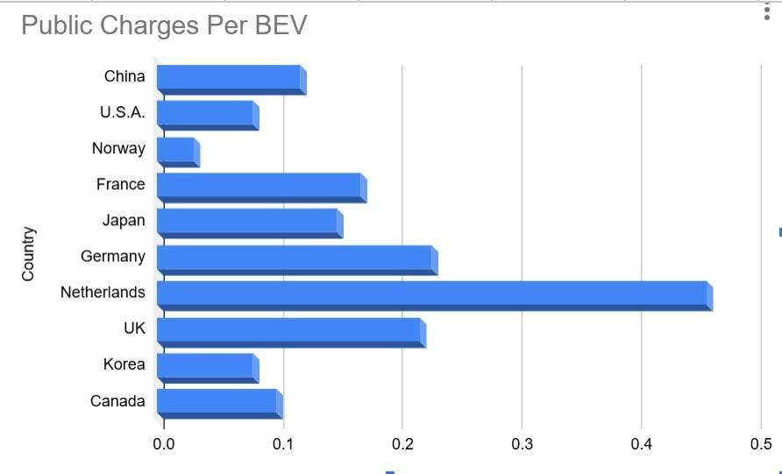
Figure-8.c) Public charges per BEV in developed countries [157]
Observing the figure 8.c, even in developed countries the numbers vary significantly. BEVs are yet not into the mainstream because of their high cost and less available infrastructure required for its maintenance. Therefore, there are huge scopes to improving the market policy of EVs.
8.5 Improving the economy of EVs against limitations
Grid integration is one of the most essential methods to boost the economy concerning Electric Vehicles. It has multi-dimensional economic benefits. For DSO (Distribution System Operator), minimization of loss and maximum power transfer are ensured. For Aggregators, revenue from utility and end user create significant economic profits. Again, the demands of the end users also dominate with minimum charging cost and mitigated total cost of ownership. In this way, additional generation units and current network infrastructure become the essentials for a successful economy of electric vehicles [160].
Vehicle to Grid (V2G), Vehicle to Home (V2H) and Vehicle to Building (V2B) remain instrumental for the expansion of the number of electric vehicles, assurance of better balance between energy generation and consumption, reduced peak demand and energy costs, and improved profitability [159].

8.6 Marketing Trends for EVs
The most common feature of the economic status of an electric vehicle is its high purchase price and low operational cost. The high purchase price along with the extended infrastructure for EV maintenance (for example, charging) and the unavailability of the EVs compared to ICEVs are the primary limitations on the way to the widespread dominance of electric vehicles. To defeat these challenges, awareness is a vital tool. ICEVs use fossil fuels and burn non-renewable energy making not only its operational cost high, but also mounting the Greenhouse Gas (GHG) emissions. The government must raise public awareness about the detriments of choosing ICEVs over EVs for the sake of the climate. But this method might not work promptly in under-developed and developing countries. Studying the statistics and government policies of China and India, the most effective government policies to promote the purchase of EVs are: exemption from registration tax, ban of two-wheelers ICEVs (in China), improving infrastructure for EV maintenance and its higher availability.
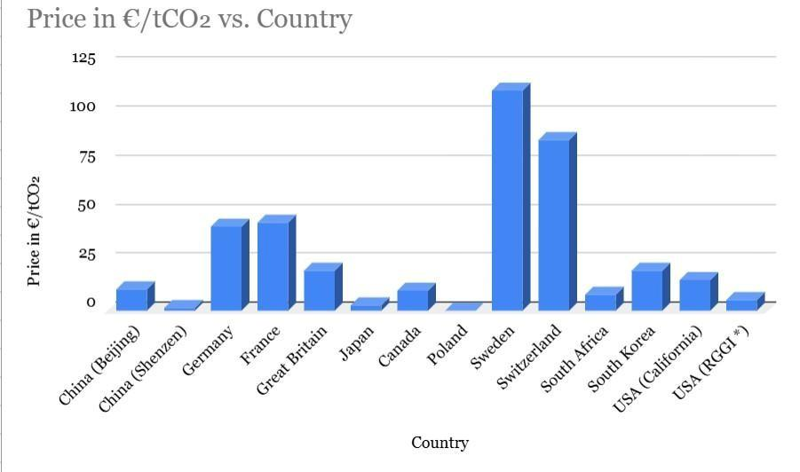
Figure:8.d) Monetary cost applied to GHG emissions [154]
The figure 8.d suggests an effective concept that can be implemented to influence the consumers to choose EV. The concept is about a carbon tax that is charged from the consumer for GHG emission from the owned vehicle. So, consumers switch to cleaner energy machineries instead, like electric vehicles.
Another important marketing policy for EVs are relative innovativeness and relative product advantage. This is basically the comparison of EVs with traditional vehicles to measure what new advantage the newly introduced product brings for the consumers [161]. Electric vehicles have higher efficiency, better performance (with less noise and comfortable and smooth user experience), convenient maintenance and positive impact on the environment. Comparing the TCOs, EVs turn out to be more advantageous in the long run. At the same time, newer models of EVs must be introduced to make it more available and customer-friendly due to technological improvements. Similarly, the battery prices must be reduced to make the purchase price more reasonable for the users, specially for medium duty and heavy duty vehicles where ICEVs are still more popular.

8.7
Hence, with the appropriate marketing policies EVs are expected to take over traditional fossil fuel-run vehicles. The overall economy of EVs are on the verge of consecutive improvement and evolution in the upcoming years. The industry of electric vehicles is full of potential if its features are customized according to the demand of the consumers. Again, most economic analyses of EV are mostly centred around the markets of Europe, the USA, China or other developed countries which leaves a significant gap of study of the emerging economies of EV in developing countries, especially in southeast Asia or South America.
9. Policies, Regulation, and Global Adoption of Electric
Vehicles

Executive summary
The world has observed the adoption of electric vehicles (EV) across various countries at a fast speed during the past several years. Statistically, the global market reached 17 million vehicle sales in 2024, which represented more than 20 percent of all new passenger vehicle registrations, although various regions showed different patterns of growth. The nation wide adoption depends on various factors which mainly are - The differences in policy designs and charging network development and various affordability parameters and laws which mainly indicates regulatory conditions established by governments (International Energy Agency [IEA], 2025).[162]
Factually, the early market generally is benefited from demand-side incentives such as purchase subsidies or tax benefits. But it is a matter of fact that when a market matured it leads us to various mixed results. “The establishment of emissions standards and zero-emission vehicle” mandates and “The implementation of coordinated charging infrastructure” policies create more sustainable pathways for long-term adoption when organizations are on the way to develop clear executional guidelines (Anilan & Vij, 2024; Martins et al., 2024; Zhao et al., 2024). [163]
Studies of the most significant markets tells us that many policy patterns keep appearing throughout the study. Firstly, jurisdictions which mixes regulatory targets with infrastructure investment and targeted fiscal incentives which maintain stronger adoption momentum, as observed in recent European Union and United Kingdom policy frameworks infrastructures. [164] The strictness of supply chain of critical minerals will improve through — Local Manufacturing Requirements and Critical-minerals Sourcing rules, which are now becoming customary in policy strategies which ties industrial goals with trade objectives. Organizations now have to deal with additional compliance obligations and equality challenges brought forth by recent U.S. legislation. [165] Norway shows through its permanent fiscal policies and user perks, which encourage user benefits, that public policy helps consumers to modify their spending patterns. The current regulations require approval. [166]
The research includes a structured scoping method to investigate the advancements made from 2015 until 2025 using two investigative methods which are – 1) Comparative policy assessment and 2) A standardized evaluation system. The analysis bonds measurable adoption parameters with qualitative invigilation of regulatory design, considering ethical, legal, and compliance (ELC) dimensions which are related to global EV policy development.

9.1 Introduction and background
Electric mobility policy is visualized as a multi-layered governance regime in which the use of regulations,instruments and system rules are combined together to shape the market. These policies are mainly focused on mechanical features of a vehicle such as— including emissions, standardized cybersecurity software as well as market challenges like tax breaks, mandates and feebates that directly involve consumer demand and manufacturer behavior. That's why, system-enabling policies, such as charging deployment, interoperability with other technologies or consumer information and data reporting, facilitate a wider connection within energy and transport systems.The International Energy Agency describes EV diffusion as a globally transitioning shape through coordinated policy packages that affect factors like affordability, availability of vehicles, infrastructure flexibility, and overall energy-system output (IEA, 2024; IEA, 2025). [167][168]
In some places, the use of electric vehicles (EVs) has gone from being a small market to a more common one. The sales report tells us that, a total of 14 million units of EVs were sold in 2023, which is approximately 18 percent of all the new cars sold. Again, total EV stock reached to about 40 million cars which are contained mostly within major international markets (IEA, 2024). [168] Worldwide sales increased by 3 million units by one year, which portrays an annual developmental rate of above 25 percent from the previous year. But most importantly, the sales also increased outside the three largest markets which tells us that adoption is increasing day by day and is turning into one of a wider range of economies (IEA, 2025). [162]
As more people buy electric vehicles (EVs), regulatory frameworks are becoming more important because they help manufacturers, utilities, charging operators, and battery supply chains complying with the rules and regulations. The European Union's [169] fleet-wide CO₂ standards from Regulation (EU) 2019/631 set progressively stricter limits on emissions from cars and vans. It is estimated that there will be a total ban on emissions by 2035. Consequently, The Alternative Fuels Infrastructure Regulation (AFIR) imposes more rules such as charging stations must offer customers seamless interoperability and payment options which will make it easier for the customers to charge their electric vehicles seamlessly and non-hesitently (European Commission, 2024; IEA, 2025).[164]
In this context, the present study utilizes a structured scoping review and comparative policy analysis covering the years 2015 to 2025 to examine the impact of regulatory design on electric vehicle adoption outcomes in significant global markets.

9.2 Methodology for evidence synthesis

9.2.1 Searching strategies for peer‑reviewed literatures and authoritative policy sources
This study utilizes a structured scoping review system involving the period from 2015 to 2025 which is supported by analysis of primary legal texts and major institutional databases.
- Definition of scope and unit of analysis
Focused on: Policies and regulations affecting the EV adoption for light-duty vehicles (LDVs), charging stations, batteries and compliance frameworks. The unit of analysis is typically a jurisdiction–policy instrument–time period (e.g., “EU AFIR charging obligations, 2023–2030”). [167]
- Databases (literature) and portals (policy/data)
Peer‑reviewed databases: Scopus, Web of Science, ScienceDirect, IEEE Xplore (for infrastructure/standards), Transport Research International Documentation (TRID).
Authoritative policy/data portals: IEA Global EV Outlook series and tools (EV Data Explorer, EV Policy Explorer). [170]
- Keyword families and example Boolean strings (2015–2025 filter) Use two search layers: (a) broad recall, (b) precise filterable strings.
For researching electric vehicle policy and regulation between 2015 and 2025, it is effective to use a two-layered search strategy consisting of broad recall queries and more precise, filterable Boolean strings. At the broad level, general keyword phrases such as “electric vehicle adoption policy effectiveness,” “ZEV mandate compliance,” and “charging interoperability regulation” can help capture a wide range of relevant literature and reports. These initial searches are useful for identifying key themes, authors, and terminology.
To refine results, more structured Boolean search strings can then be applied. For example, one precise query could be: (“electric vehicle” OR “battery electric” OR BEV) AND (subsid* OR “tax credit” OR “purchase incentive” OR feebate) AND (adoption OR uptake OR diffusion) AND (2015:2025). Another useful string is: (“charging infrastructure” OR EVSE) AND (interoperability OR “payment methods” OR “uptime” OR standards) AND (regulation OR “minimum requirements”) AND (2015:2025). A third example focuses on regulatory compliance: (mandate OR “emissions standard” OR “CO2 standard”) AND (fleet-wide OR “zero emission”) AND (compliance OR enforcement) AND (2015:2025). Together, these layered approaches improve both the breadth and precision of search results.
- Screening workflow (PRISMA-compatible)
Study selection followed a PRISMA-compatible screening workflow. Titles and abstracts were first analyzed with predefined inclusion criteria with full-text evaluation of potentially connected sources. When potential adoption outcomes were absent and focused solely on commentary, or fell outside the defined time boundary unless they are considered foundational policy references, studies were eliminated. This approach helped to create a transparent and methodical leniency throughout the reviewing process. [163]

9.2.2 Inclusion/exclusion criteria
Inclusion (preferred): - Empirical evaluations (DiD, panel models, IV strategies, quasi-experiments) linking policy instruments to adoption outcomes. [169]
- Systematic reviews/meta-reviews of EV policy effectiveness. [163]
- Primary legal/regulatory texts and official agency summaries (EU CO₂ rules; AFIR; US
IRS and Federal Register regulations; national schemes like India’s FAME II). [164]
- Institution based reports with clear dataset (IEA Global EV Outlook 2024/2025). [168]
Exclusion: - Non-English sources when an English primary/official equivalent exists (unless the policy has no English text).
- Purely technical battery papers without policy/regulatory linkage.
- Studies lacking enough methodological detail to assess causal claims. Data sources for quantitative and qualitative collection
For a comprehensive analysis of electric vehicle policies, both quantitative and qualitative data sources should be incorporated. On the quantitative side, datasets such as the IEA EV Data and Policy tools and the Global EV Outlook databases provide valuable statistical information on vehicle sales, fleet stock, charging infrastructure, and future projections. Additionally, official market and vehicle registration datasets, such as those published by the European Automobile Manufacturers’ Association (ACEA), offer region-specific insights into EV adoption trends. Administrative sources are also important, particularly for understanding policy compliance; for instance, reporting requirements outlined in frameworks like the NEVI program in the Federal Register provide structured data on implementation and enforcement.
On the qualitative side, legal and regulatory texts play a central role in understanding how policies are formulated and applied in practice. These include formal regulations such as European Union directives, Federal Register rules in the United States, and national policies like the UK’s ZEV mandate law. Supporting documents that explain policy design and implementation—such as guidance issued by institutions like the U.S. Treasury or IRS regarding eligibility for EV tax credits—offer further clarity on how these policies function. Finally, stakeholder-based evidence, including parliamentary inquiries, regulatory consultations, and audit office reports, provides practical insights into real-world challenges, effectiveness, and responses to EV policy measures.

9.2.3 Key attributes to evaluate policy instruments
The table below provides an explicit evaluation framework suitable for coding, scoring, and cross-case comparison.
Dimension | What to code | Why it matters for adoption outcomes
Instrument type | Mandate/standard; subsidy/tax credit;  feebate; infrastructure obligation; | Determines depth of market signal and  durability (regulatory vs fiscal). [163]

Dimension | What to code | Why it matters for adoption outcomes
procurement;
zoning/LEZ;
information/labeling
Target segment | LDV, vans, buses,  2/3-wheelers, charging, manufacturing | Adoption and  elasticities differ by  segment (e.g., e‑2W  vs passenger cars). [171]
Magnitude & duration | Incentive amount; % mandate trajectory; timeline (start/end); phase-down rules | Short “stop–start” incentives can  destabilize demand;  mandates depend on clear timelines. [169]
Fiscal cost & sustainability | Budget outlays; tax expenditure; foregone  revenue; long-run cost  curve | Determines political feasibility and rollback  risk. [166]
Adoption impact metrics | Sales share; registrations; stock;  charger-to-EV ratios; equity metrics | Enables comparable evaluation across jurisdictions. [162]
Infrastructure readiness | Public charging density/capacity; interoperability;  uptime; payment access | Infrastructure is a binding constraint in many regions. [174]
Equity & access | Distribution by income/tenure (renters vs homeowners); urban/rural; affordability | Policies can widen adoption gaps if not  designed for access. [167]
Enforcement & compliance | Monitoring, penalties, verification (e.g.,  supply chain eligibility  rules) | Weak enforcement undermines mandates  and credit systems. [173]
Dimension | What to code | Why it matters for adoption outcomes
Coherence with energy system | Grid capacity, low‑GHG electricity, smart charging integration | Adoption benefits depend partly on decarbonized electricity and  managed charging. [175]

9.2.4 Analysis techniques
The analysis technique utilizes a unique comparison based policy framework to divide regulatory instruments and invigilate the correlation between various policy designs and frameworks and EV adoption outputs nationwide. This method lets us study the look at policies which are mixed with coherence by looking at how rules, standards, and infrastructure quantifies the work together instead of quantifying separately.
Quantitative trend analysis is another sub-technique which is used to look at how the share of EV sales, the number of EVs in a fleet, and the positioning of charging infrastructure have changed over time. These indicators generally help find the possible changes in the adoption patterns around important regulatory targets.
To complement the quantitative assessment, qualitative arrangements of legal and proof-based texts, policy examinations, and regulatory reports are undertaken to identify repeating genres such as interoperability, equity considerations, enforcement mechanisms, trade implications, and data-governance issues. Insights from this thematic analysis are then compared with quantitative adoption parameters to support a balanced wording of policy effectiveness. Reference management follows standard academic practices to maintain consistent APA formatting and accurate DOI documentation.

9.3 Results
Peer-reviewed research conveys the message that the effects of EV policies differ significantly nationwide and within phases of market development. The shelf life of these policies seem to be closely related to factors like income levels, the blend of electricity sources, the availability of infrastructures, and the overall maturity of the market which implies that policies that are same across the board, don't often lead to the same results.
A multi-period difference-in-differences (DID) analysis of 30 European countries from 2012 to 2021 indicates that purchase incentives are related to increased registrations of battery electric and plug-in hybrid vehicles, while ownership incentives justify negligible measurable effects. The study also portrays that the output results are different based on the level of income in each country and amount of renewable energy is used. [169] These outcomes indicate that immediate price reductions can be more effective than long-term ownership advantages in markets where electric vehicles still possess a hefty cost.
Complementary cross-country panel analysis were done among 20 major EV markets 2015 to 2019 which portrays that lessening of taxes, installation of charging-station, and household income significantly influence EV penetration rates. This shows us how significant the alignment of affordable measures with infrastructure expansion is.(Xue et al., 2021). [176]
A methodical “review of reviews” concentrated on battery EV adoption. It tells us that even though subsidies and tax concessions can start market growth, their effectiveness may reduce over time. Nonetheless, policies which supports public charging infrastructure remain important even as financial concessions are reduced, and supply-side regulations such as emissions standards or zero-emission vehicle (ZEV) mandates often need to set the way for demand-side measures to prevent supply bottlenecks (Anilan & Vij, 2024). [163]
It is evident in China that policy results evolve as markets mature. A study was conducted on 61 pilot cities between 2009 and 2018 which shows us that subsidies were useful in promoting electric bus deployment within the public, whereas private adoption was more strongly influenced by convenience and luxury measures such as charging-station development and purchase-restriction exemptions (Liu et al., 2021). [177] A panel data which was recently conducted upon 275 cities from the period of 2016 to 2022 suggests that purchase subsidies alone may have a declining boundary effect. But if they are somehow combined without coordination, they can lead to saturation of policy outcomes (Zhao et al., 2024). [178]
Lastly, behavioural research indicates that adoption decisions last up to economic considerations. A summary of 211 studies highlights the importance of contextual and psychological factors such as— perceived utility, charging accessibility, and user experience. It suggests that effective policy design must tackle both financial barriers and everyday concerning usage (Singh et al., 2020). [178]

9.3.1 Global adoption baseline and infrastructure constraints
According to a statistical report of 2024, global electric car sales crossed 17 million and accounted for more than 20% of new car sales (IEA, 2025). [162] In the United States[179], electric car sales increased to 1.6 million in 2024 and the sales share grew to more than 10%, while growth slowed compared with 2023 (IEA, 2025). [162] Charging infrastructure is now a central constraint: the IEA reports public charging stations doubled over the past two years, with China and the EU broadly keeping pace, while the US and UK saw public charging lag relative to EV deployment (IEA, 2025). [174]
The growth of the rapid charging industry suggests both progress and concentration. In China, about 80% of global growth is seen in the fast charging sector. Statistically fast chargers increased from 1.2 million (2023) to 1.6 million (2024) (IEA, 2025). [180] This saturation has policy relevance because it connects adoption trajectories to industrial capacity, grid upgrades, and interoperability rules.

9.3.2 Regional cases
European Union: standards plus infrastructure obligations
Within the European Union,[181] EV policy is shaped by a combination of binding emissions standards and coordinated infrastructure regulation. Fleet-wide CO₂ targets require progressive reductions in emissions, with a transition toward a zero-emissions benchmark for new cars and vans by 2035, supported by interim milestones for the period between 2025 and 2034 (European Commission, 2024). [164]
These regulatory targets are complemented by infrastructure measures under the Alternative Fuels Infrastructure Regulation (AFIR), which came into force in April 2024 and introduces requirements related to charging coverage, interoperability, and transparent payment options for users (European Commission, 2024). [167]
Policy analysis suggests that infrastructure deployment becomes a limiting factor once EV adoption begins to scale. The International Energy Agency highlights corridor-based charging targets—such as high-power fast chargers along the core TEN-T network—as well as the need for sustained annual installation rates to meet projected demand (IEA policy database, 2025; IEA, 2025).[182] [162] Together, these measures illustrate how regulatory standards and infrastructure obligations function as complementary components of the EU policy framework.
United States: demand incentives with supply-chain conditionality, plus charging standards
US policy has combined tax incentives with manufacturing/supply-chain requirements. The Internal Revenue Service[173] outlines that to qualify for the clean vehicle credit, vehicles must undergo final assembly in North America and meet critical mineral and battery component requirements (IRS, 2025). [165] The U.S. Department of the
Treasury[179] describes the credit’s split incentive logic (e.g., partial credits tied to battery component requirements), illustrating how industrial policy is embedded into adoption incentives (U.S. Treasury, 2023). [183] A Congressional Research Service summary provides an example of how eligibility thresholds can be structured over time for critical minerals content, underscoring compliance complexity (CRS, 2024). [184]
Infrastructure policy has also been formalized through the National Electric Vehicle Infrastructure (NEVI) program, which establishes minimum technical and operational standards for publicly funded chargers, including interoperability, payment accessibility, and data-sharing provisions. These requirements aim to support the development of a reliable and equitable national charging network (Federal Register, 2023).[173]
China: mandate-style supply policy plus evolving fiscal support
China’s[57]EV strategy has relied heavily on manufacturer obligations combined with shifting fiscal incentives. The New Energy Vehicle (NEV) mandate, implemented in 2018, integrates credit targets with fuel-consumption regulations, encouraging manufacturers to increase zero-emission vehicle production (ICCT, 2018). [186]
Fiscal support has gradually evolved, with purchase-tax exemptions extended through 2025 and partial incentives continuing into later years as part of a phased policy transition (Gov.cn/Xinhua, 2023). [187]
Market dynamics increasingly reflect internal competition and affordability. The
International Energy Agency notes that, by 2024, many small battery-electric models in China were priced below comparable internal combustion vehicles, contributing to high electrification rates in certain market segments (IEA, 2025). [162] This shift suggests that policy emphasis may move away from broad purchase subsidies toward infrastructure development and regulatory standardization as markets mature.
United Kingdom: mandated adoption trajectory
The United Kingdom[163] has established a clear regulatory pathway through a Zero Emission Vehicle (ZEV) mandate. The Department for Transport[177] requires a rising share of zero-emission car and van sales through 2030 and beyond, culminating in a fully zero-emission new-vehicle market by 2035. Policymakers frame this approach as providing long-term certainty for industry investment while aligning with broader emissions targets (GOV.UK, 2024). [188] Such supply-side mandates reflect wider research findings that regulatory certainty can help stabilize market expectations and reduce investment risk (Anilan & Vij, 2024). [163]
India: targeted segment strategy and demand incentives
In India[178], EV diffusion is strongly tied to two- and three-wheelers and targeted demand incentives. The Ministry of Heavy Industries[181] The FAME II program directs substantial funding toward demand incentives and fleet deployment targets for buses, three-wheelers, and other priority vehicle classes (Government of India, n.d.). [189]
Although passenger-car adoption remains comparatively modest, rapid growth in other segments demonstrates how tailored incentives can accelerate electrification where cost and usage patterns differ from traditional car markets (IEA, 2025). [162] This highlights the importance of designing policies that reflect local mobility structures rather than applying uniform adoption strategies.
Norway: sustained fiscal incentives and near-total new‑car electrification
Norway[166] represents one of the most advanced EV markets globally. The OECD[169] notes that Norway used long-standing fiscal incentives—including exemptions from registration taxes and value-added tax which have significantly reduced purchase costs and contributed to a high share of zero-emission vehicles in the national fleet (OECD, 2021). [166] Market outcomes illustrate the cumulative effect of sustained policy support: battery-electric vehicles accounted for more than 95.9% of new car registrations in 2025, demonstrating how consistent incentives can reshape consumer behaviour over time (Reuters, 2026). [190]

9.3.3 Summary comparison table
Jurisdiction | Anchor regulation | Key demand-side  tools | Infrastructure rules | Illustrative adoption indicator
EU | Fleet CO₂ targets; 0 g  CO₂/km from  2035 | National purchase/  ownership measures vary | AFIR:  interoperability, payment info, corridor targets | BEV share  ~17.4% in EU registrations  (2025)
US | Federal emissions  standards +  tax credit rules | 30D credit with assembly/miner al constraints | NEVI: minimum standards,  interoperability  & data reporting | EV sales  1.6M; share  >10% (2024)
China | NEV mandate  (dual credit) | Purchase tax exemptions/pha  se-down; earlier subsidies | Large fast-charger  build-out; policy mix | Global leader; segment  electrification  (small cars  ~95% in  2024)
UK | ZEV mandate:  80% by 2030;  100% by  2035 | Complementary incentives | National charging  investments + mandate trajectory | Policy certainty  mechanism
Jurisdiction | Anchor regulation | Key demand-side  tools | Infrastructure rules | Illustrative adoption indicator
India | Programmati c adoption support | FAME II demand  incentives | Developing infrastructure frameworks | Electric car share ~2%  (2024); strong  2/3W focus
Norway | Long-term tax incentives | VAT/registration tax treatment; user benefits | Complementary charging + local policy | BEV share  95.9% of new cars (2025)
EU BEV share from ACEA (2026); US and China stats from IEA (2025); Norway share from Reuters (2026). [172]

9.3.4 Suggested figures and mermaid charts
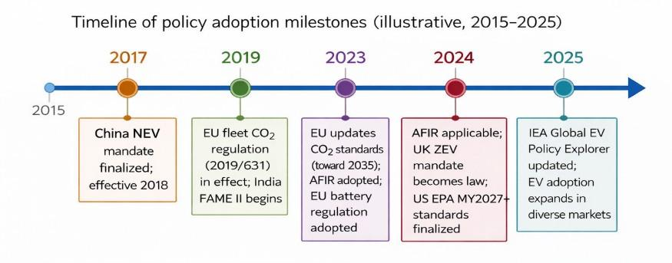
Figure 1: Policy adoption milestones (2015–2025). (Sources: ICCT (2018); European Commission; GOV.UK; EPA.)

China NEV mandate details: ICCT (2018). [186] EU CO₂ targets: European Commission
(cars and vans page). [164] AFIR applicability/objectives: European Commission. [167] UK
ZEV mandate law: GOV.UK. [188] EPA rule final: EPA. [191]
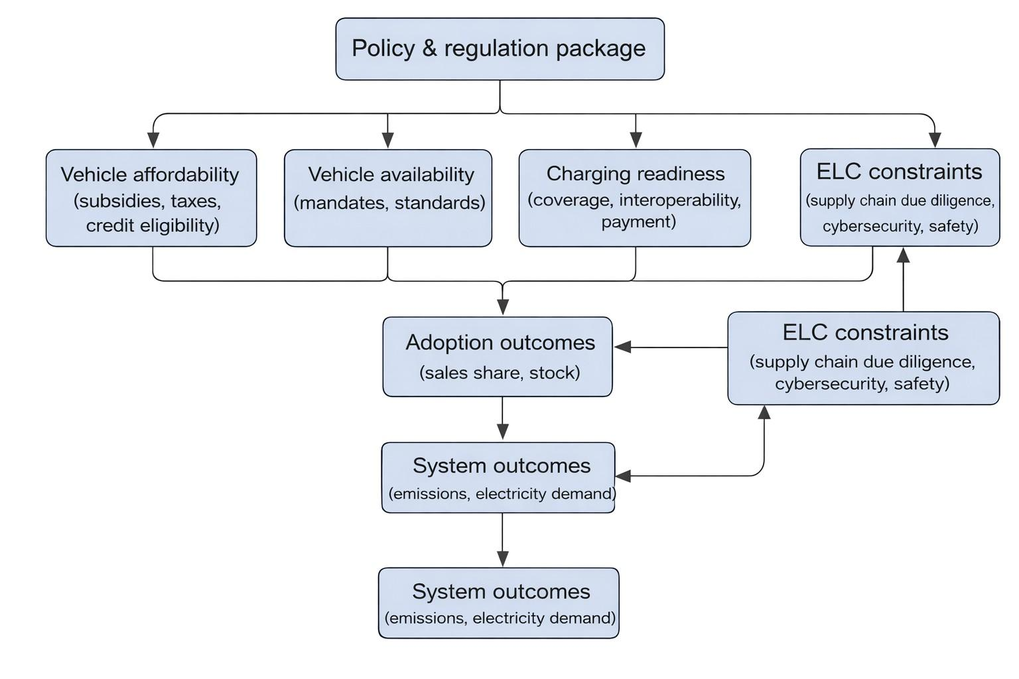
Figure 2: Policy impact pathway (conceptual)
This pathway aligns with IEA’s emphasis on charging coverage and policy frameworks. [174]
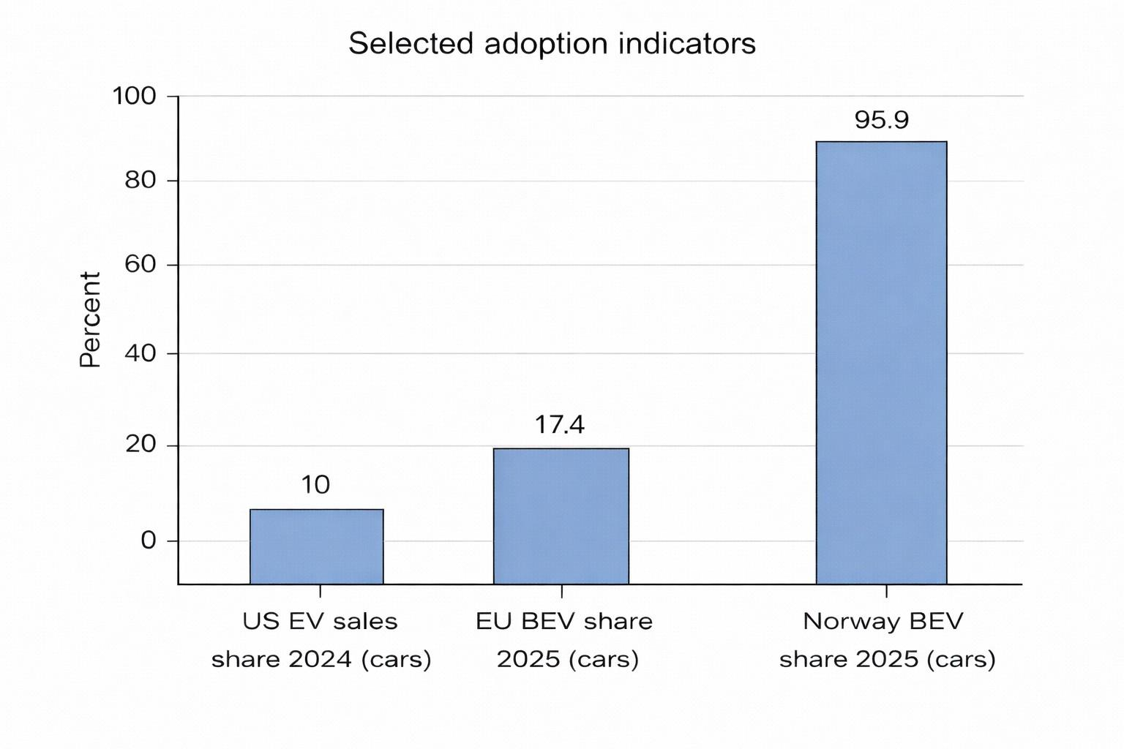
Figure 3: Selected adoption indicators
Values: US “more than 10%” (IEA 2025), EU 17.4% (ACEA 2026), Norway 95.9% (Reuters 2026). [162]

9.4 Ethical, legal, and compliance considerations

9.4.1 Ethical and social considerations: equity, access, and distributional impacts
Policy packages can sometimes produce uneven outcomes, particularly when benefits are concentrated among higher-income households that have access to private charging or among early adopters who face fewer cost and infrastructure barriers. Recent European Union guidance under AFIR places emphasis on user information, payment transparency, and interoperability, reflecting growing recognition that convenience and transaction friction influence accessibility and user confidence (European Commission, 2024). [167] Equity considerations are also becoming more embedded in regulatory design. For example, California’s Advanced Clean Cars II (ACC II) framework incorporates equity-focused governance mechanisms, including dedicated advisory structures and monitoring provisions aimed at ensuring broader participation in zero-emission vehicle markets (CARB, 2022–2025 program materials). [192]
From an ethical, legal, and compliance perspective, policy evaluation frameworks increasingly consider distributional impacts alongside adoption metrics. This includes examining adoption patterns across income groups and housing types, assessing cost differences between home and public charging, and analysing geographic disparities between urban and rural regions. Such measures are not peripheral social considerations; rather, they influence long-term policy legitimacy and the durability of regulatory mandates.

9.4.2 Legal and compliance: safety, cybersecurity, and software update governance
As road vehicles become increasingly software-defined and connected, electric mobility policy is expanding beyond traditional transport regulation into cybersecurity and digital governance. United Nations Regulation No. 155 introduces cybersecurity requirements through a Cyber Security Management System (CSMS) framework for vehicle type approval, while also clarifying that such measures operate alongside existing privacy and personal-data protection rules (UN Regulation No. 155, consolidated to 2025). [179] Complementing this, UN Regulation No. 156 establishes provisions for Software Update Management Systems (SUMS), defining approval pathways for vehicles that rely on over-the-air software updates and continuous digital maintenance (UN Regulation No.
156, 2021). [193]
Electrical safety remains another critical regulatory pillar. UN Regulation No. 100 sets requirements for electric powertrain systems and rechargeable energy storage safety, including protections against electrical shock and unintended contact (UN Regulation No. 100, 2021). [181] Together, these frameworks shape certification pathways, compliance costs, and the conditions for cross-border vehicle trade, illustrating how technical regulation increasingly influences global adoption dynamics.
Infrastructure governance is also evolving to address consumer data responsibilities. Under the U.S. National Electric Vehicle Infrastructure (NEVI) program, minimum standards for federally funded chargers include provisions on payment accessibility, interoperability, and customer data privacy. These rules require that personal information be collected only when necessary and protected through appropriate safeguards, reflecting a broader shift toward privacy-by-design principles within charging policy (Federal Register, 2023). [173]

9.4.3 Environmental and circular-economy compliance: batteries and supply chains
The EU Battery Regulation (Regulation (EU) 2023/1542) explicitly aims to reduce environmental impacts and ensure a sustainable battery value chain, considering carbon footprint, ethical sourcing, and facilitating reuse/repurposing/recycling—making battery due diligence and circularity part of regulatory compliance, not voluntary ESG (Regulation (EU) 2023/1542). [185] This is directly relevant to global adoption because battery sustainability requirements can (a) raise near-term compliance costs, (b) reduce long-term supply chain risk, and (c) influence where battery manufacturing locates.

9.5 Conclusions and policy recommendations

9.5.1 Synthesis of findings
Evidence across 2015–2025 indicates that EV adoption scales fastest when three policy layers align: (1) a credible regulatory trajectory (CO₂ standards/ZEV mandates), (2) consumer-facing affordability measures that are stable and well targeted, and (3) infrastructure rules that guarantee interoperability, price transparency, and adequate charging coverage. [163]
The literature also shows that “more incentives” is not automatically better: effects vary by context, and policy mixes can crowd out effectiveness when layered without coherence (e.g., mature-market evidence from China; heterogeneity in Europe). [178]

9.5.2 Policy recommendations grounded in the evidence
- Use mandates/standards as the anchor; align timelines with implementation capacity
Fleet standards and ZEV mandates provide long-term certainty (EU CO₂ targets; UK ZEV mandate; California ACC II). The key is to pair them with measurable infrastructure obligations and compliance monitoring to avoid “mandate without means.” [164]
- Prioritize charging coverage, interoperability, and payment simplicity as adoption multipliers
AFIR’s focus on interoperability and payment options and the NEVI rule’s requirements on payment methods, uptime, and data reporting reflect a best-practice model: regulators should standardize user experience to reduce perceived risk and transaction costs. [167] IEA evidence suggests charging buildout must keep pace with vehicle deployment to avoid rising EV-per-public-charger ratios (IEA, 2025). [174]
- Shift from broad purchase subsidies to targeted affordability and high-leverage segments as markets mature
Meta-review evidence suggests subsidies are most effective early, but later-stage markets can sustain adoption with infrastructure support and supply-side policies while rationalizing fiscal exposure (Anilan & Vij, 2024). [163] Empirical studies show purchase incentives can work (Europe) but may become less effective or heterogeneous, implying the need for targeting by income, vehicle segment, and market maturity (Martins et al., 2024; Zhao et al., 2024). [169]
- Design industrial-policy conditionality to minimize equity and compliance burdens Credits tied to assembly and mineral content can stimulate domestic supply chains but increase consumer confusion and administrative complexity (IRS; Treasury; CRS). [165] Recommended practice is to publish machine-readable eligibility lists, adopt clear transitional rules, and monitor distributional outcomes (who can actually claim credits).
- Embed ELC as a first-class dimension of adoption policy
Adoption policy should be co-designed with battery sustainability and due diligence requirements (EU Battery Regulation), vehicle cybersecurity and software update governance (UN R155/R156), and safety/type approval rules (UN R100). [185] This reduces systemic risk, supports consumer trust, and promotes cross-border interoperability.

9.5.3 Limitations and future research directions
This report is a structured scoping synthesis, not a full PRISMA systematic review with exhaustive database export, de-duplication logs, and meta-analysis. Evidence quality varies across study designs (DiD vs correlational), and cross-country comparisons are complicated by differing definitions (BEV vs PHEV; car sales vs all vehicle types) and by policy bundling that makes single-instrument attribution difficult. [163]
Future research priorities include (a) causal evaluation of infrastructure mandates (not only incentive programs), (b) distributional and spatial equity analysis at neighborhood scale, (c) policy–trade interactions (tariffs, local content) and their net adoption effects, and (d) compliance cost quantification for cybersecurity and battery due diligence regimes. [167]
10.Challenges, Future Trends:

10.1 Technical Challenges

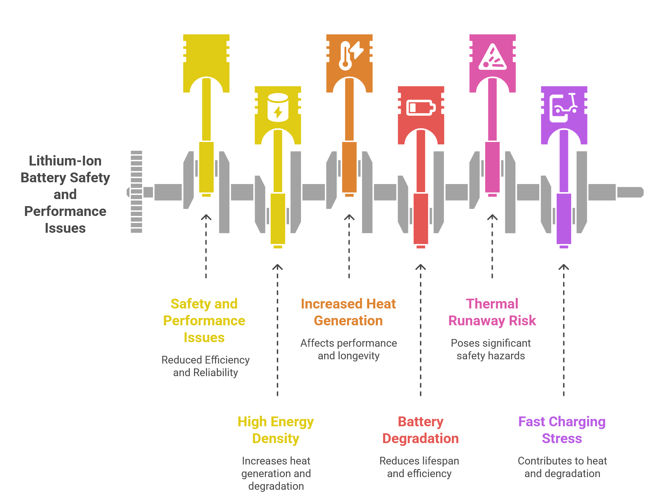
Figure 1: Overview of Technical Challenges in Lithium-Ion Batteries for Electric Vehicles (created by the author)
10.1.1 Energy Density vs Safety Trade-offs
Lithium-ion batteries are now used in practically all electric vehicles because they can store great quantities of energy in small forms, therefore enabling longer distances between charges. Although little, these units are progressively under pressure since engineers seek packing in more charge heat builds quicker if something fails. Fully loaded, they release more heat during operation or refill, so forcing cooling systems to go over their usual duty just to keep equilibrium. Stretching materials too far brings greater risks: tiny metal threads may develop within, cutting durability and unexpectedly increasing fire risk. Although recent blends claim more output, shortcomings of this kind presently preclude actual usage. Trade-offs are evident in a quick look across modern battery designs. NCA–graphite units they provide high energy relative to mass but ignite faster when heated, implying lower safety margins [194]. The electrodes lie close together with dense interior packing, therefore increasing breakdown hazards during temperature rises particularly when immersed in combustible liquid electrolytes [195].The interrelationship between the major technical challenges in lithium-ion batteries is illustrated in Figure 1.
Beginning with battery development, advancement mimics processes found in living cells. Motor systems face comparable obstacles. High-voltage circuits, perhaps 800 volts, or rotors with fast spin rates provide benefits but need better thermal management and thicker insulation materials [196]. Rather than harmony, conflicting requirements between material constraints and system goals complicate safety when raising capacity. Experts look for more energy inside tighter risk margins by means of changes in cell architecture and pack coordination [197]. Shifting fluid electrolytes to solid forms removes certain combustion dangers; such solid matrices support lithium-metal anodes, providing greater storage while fostering even current flow to lower damaging peaks [195], [198]. Approaches like this point toward solutions not perfect, yet closer to balanced outcomes where durability rises alongside protection.
10.1.2 Battery Degradation & Cycle Life
Beginning with usage patterns helps one see why lithium-ion batteries lose capacity over time. Important roles are played by elements including operating temperature, discharge depth, and filling rate. With chill, ion flow slows, internal pushback rises, and minute metallic particles fall on the negative side; excessive heat quickens unwanted reactions, so damaging core structures and diminishing conductive liquids [199], [194]. Much as fast refills do they strip active compounds faster, decreasing efficiency [194], remaining near maximum or minimum levels accelerates damage. Wear reveals itself slowly: trapped ions disappear, external films thicken, sections split open, current channels rust, internal friction rises [200], [201] . Often breaking sooner, high-capacity materials one case demonstrates silicon expanding swiftly till pressure splits it; sulfur types battle weak positive sides and early drop in output [200]. Although converting such resistance into real life span remains unclear [194], changes in how a battery resists flow provide hints about its years. Though many lithium-ion cells maintain great performance throughout over a thousand charging cycles covering almost ten years, their drop toward eighty percent capacity signals a turning point; early detection of decline lets for improved energy use control and longer function [202].
Though worn-out batteries cannot drive vehicles, remaining capacity permits repurpose in less demanding uses before disassembly. Understanding degradation patterns guides better recycling methods especially those conserving components yet in good condition. Solid-state designs have trouble at interior contacts even if they have great chemical and thermal stability. Surface resistance develops at layer connections; solid structures impede consistent bonding under ongoing strain. Gradual loss of efficiency results in a fall in total performance over time as well as in power delivery rate. With every swell and contraction of the electrode, stress accumulates inside the structure, progressively loosening bonds and thereby speeding deterioration most obvious in alloy or lithium-metal anodes expanding considerably when charged [198]. Although solid electrolytes decrease dendrite development more than liquids do, hazards remain; resolving interfacial instability will probably determine if future solid-state batteries achieve longevity and consistent performance [195], [198].
10.1.3 Thermal Runaway & Safety Risks
Carrying an intrinsic thermal runaway risk a chain reaction triggered by overheating, lithium-ion batteries have the capacity to cause internal shorts, fire, or perhaps explosions [199], [200]. High temperature hastens exothermic reactions within the cell because organic electrolytes burn readily, made worse by oxygen escaping from metal oxide cathodes along with carbon-based components such graphite and silicon that readily catch flame [200]. Electrodes touch directly as these reactions erode the separator layer, producing more warmth; leaked electrolyte and gas buildup increase likelihood of burning and physical collapse [200]. Cold environments generate their own hazards: lithium forms needle-like structures capable of cutting through separators, hence producing inner defects when charging is done too chilly [199]. Some battery types that store a lot of energy, like those using nickel cobalt aluminum with graphite, start failing at lower temperatures, making them more likely to overheat when exposed to heat or physical damage This highlights the need of temperature monitoring [194]. If workers do not handle them carefully while moving, disposing of, or dismantling outdated equipment, flames could start, explosions might happen, and hazardous chemicals might contaminate the air or come in contact with skin [201], [202]. These power cells also contain dangerous compounds that burn readily and poison people.
Heat-related hazards impact connected parts like motors and electronics in addition to battery units since insufficient heat dissipation together with great heat output jeopardizes constant performance. Hotspots sometimes result from materials resisting heat flow, sensitive capacitors, or magnetic imperfections in quick spinning devices, increasing opportunities for abrupt temperature spikes or part failure [196]. New methods including solid-electrolyte batteries replace unstable liquids for stable solids, hence lowering fire risk while keeping utility under greater thermal needs [195]. Such changes lessen tendencies toward breakdown or ignition when heated, therefore demonstrating how advancements in materials, cooling techniques, and shielding designs contribute to a safer next-gen energy storage.
10.1.4 Fast Charging Limitations
Faster charging generates more heat inside the battery unit even if it requires more electrical current. In larger or more dense cells, warmer temperatures from fast charge cycles may compromise general thermal balance. Applying external heat to hasten charging can cause hotspots to develop, which results in erratic internal temperatures across the cell structure. Such inconsistent warming increases hazards connected to both function and safety, therefore strong current-based heating is difficult to use safely in daily electric cars. Keeping consistent heat levels during quick recharge is difficult under real driving circumstances as driver behavior influences the quantity of energy an EV consumes at any given moment [199].
Getting ultra-fast charging ranging from 200 to 300 miles in under a quarter-hour requires systems producing more than 350 kilowatts at over 400 volts. Lithium-ion batteries heat up dramatically when strained this much; temperatures exceed the safe range of 50 to 60 degrees Celsius without adequate cooling. Since most mass-market cells were not meant to handle such high loads, pushing for rapid recharging sometimes causes lithium metal to build up on graphite-based negative electrodes. During several quick sessions, this unwelcome plating becomes worse when silicon mixes with those same anodes, which shortens shelf life even more quickly. Behind every charge pulse is a delicate balance: raw power, what materials the cell is made of, and how well heat is taken away all affect how long something will last and how likely it is to catch fire [200].
Though these challenges require solutions to enable consistent grid operation together with increasing EV usage [197], a growing number of rapid charging stations raises issues including peak load spikes and changing voltages.
Relying too much on ultra-fast charging over time usually degrades battery life. Higher charge speeds drive more current, which causes more internal stress and makes cells break down faster because they make them get hotter. This slow deterioration frequently causes less usable capacity for daily use. Though fast recharging initially saves time, frequent exposure could compromise endurance unless properly balanced [194].
Using new types of batteries addresses issues that arise while operating electric cars, improves their performance, lifespan, and consistency, therefore assisting to solve them. Charging systems have to adapt effectively to various conditions like extremely hot or cold surroundings in order to maximize these developments, hence influencing both cost and performance. The technique mostly determines how long it takes to recharge: older, simple stations could require two entire days; modern home style models often complete between four and ten hours; and high-speed direct current variants may reach eighty percent charge in less than an hour, sometimes even in as little as twenty minutes [202].
Small changes in electrode thickness can lower ion mobility, which restricts the amount of energy that these flat, layered batteries can hold. Designers aiming for more capacity usually find that a longer time is required to charge completely. Such trade-offs expose basic limitations in particular solid-state arrangements when size increases and speed of recharge decreases. Improvements in one area usually bring with them costs in other parts of the system.
10.1.5 Manufacturing & Scalability Barriers
Making batteries on a large scale causes major issues when sophisticated heat management methods are put to use in them. Adding phase-change materials, heat pipes, or spray cooling starts stacking more pieces to denote more volume and tougher assembly lines. Although liquid approaches transfer heat effectively, they raise concerns about leaks and demand rigorous design criteria for fluid pathways that function consistently. Extra layers stack on when heaters composed of PTC devices warm cells themselves, therefore boosting mass and confusing designs. Taken together, these difficulties make it difficult to produce slim, lightweight packs quickly enough for millions of electric vehicles [199].
Energy-intensive steps, include initial charging, resting stages, then assembling components in procedures often failing to increase relevant weakening market strength and deepen ecological stress. Manufacturing's thirst for electricity is strong, and every kilowatt-hour produces a significant amount of carbon. Increasing production enough to meet goals for cleaner energy requires careful management of resource draw and planet-level impacts as global output nears thousands of gigawatt-hours before decade's end [197].
Scaling battery reuse presents challenges despite the techniques at hand because of dispersed sources and fractured systems. Though current capacity can manage more volume, infrastructure development trails. As technological complexity slows down recovery procedures, economic hurdles impede progress. Handling discarded power units from transport calls for supply chain consolidation. There is still limited impetus without organized funding or clear paths ahead [201].
Direct regeneration has promise but is hard to scale since it's hard to rebuild the exact same material structures. Getting the clean, well-arranged crystals required by battery manufacturers is still not always possible. These practical hurdles cast question on widespread use. Meeting strict criteria for quality gets more difficult under such circumstances [203].
Especially in stages like drying air in regulated chambers or removing solvents, manufacturing batteries calls for a lot of energy, which has a big influence on a plant's total energy consumption. Researchers' definition of systems, choice of different metrics, dependence on different datasets, or use of different approaches explains the wide variations in numbers on energy consumption across studies. A factory's size also counts; larger facilities operating near their maximum capacity sometimes consume less energy per battery manufactured. The way a plant runs also influences results: local grids using coal versus solar significantly change emissions. Upcoming lifecycle assessments include numerous standard-sized facilities when estimating production effects, which makes comparing results simpler [194].
Electric cars are initially costly, which slows the rate at which people convert, despite their higher efficiency. Building an EV early on often releases more climate-warming gases than producing gasoline-powered cars since batteries use a lot of energy. Meeting future demand like hitting 35% of car sales worldwide by 2030 is tough when factories must quickly grow output while managing raw material flows and environmental impact, especially in key regions such China, the U.S., and areas of Western Europe.
Punching, stamping, or pushing on core materials sometimes changes how they behave, which can make FEA estimates about how much energy is lost wrong. Though sealing the ends improves heat control, doing it frequently in large electric motors causes actual construction difficulties. Although high-silicon steel is great at preventing energy loss, it breaks too easily when shaped, which makes it difficult to work with in large quantities. Expensive GaN base layers keep vertical power units from becoming common in markets, even though they have a lot of potential [196].
Because they react quickly when exposed to ambient air, certain solid electrolytes are challenging to manufacture and utilize. These substances have to be handled in an oxygen-free environment since exposure to air causes undesired chemical reactions brought on by moisture or gases. Working in sealed, oxygen-free chambers becomes crucial since it complicates and delays experimentations. Such limitations hamper initiatives to reliably grow production. These difficulties directly cause delays in getting more widely used sophisticated solid-state batteries [195].
Making solid-state batteries has problems because it takes a lot of steps to make perfect, very thin films of electrolyte and also make sure the interfaces between the electrodes are stable. Though promising, some sophisticated solid electrolytes are costly or challenging to create in big quantities, such as garnet compounds needing very high heat or LiPON thin films made via delicate processes. Since they are brittle, ceramic electrolytes present difficulties during assembly and degrade more quickly when exposed to repeated physical tension. Keeping consistency among millions of units without compromising performance remains the main hurdle in launching them to market; But advances in coating technology, firing techniques, patterning techniques, and bulk preparation using liquid-phase reactions or ball-milling routes point to possible future solutions for practical large-scale production [198]. A simplified representation of the electric vehicle battery system architecture is shown in Figure 3.
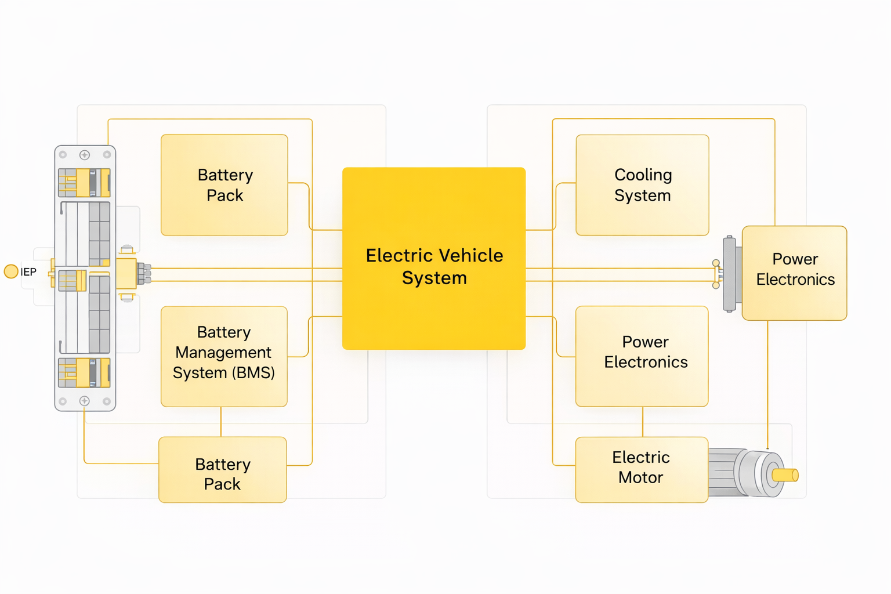
Figure 3: Simplified Architecture of an Electric Vehicle Battery System (created by the author)
A consolidated overview of the major technical challenges discussed in this section is presented in Table 1.
Table 1. Summary of key technical challenges in lithium-ion batteries for electric vehicles (created by the author).
Subsection | Key Challenge | Core Issue | Impact on EV Performance
10.1.1 Energy Density vs Safety | High energy storage | Thermal instability increases with energy density | Safety risks, overheating
10.1.2 Battery Degradation | Temperature & cycling stress | Capacity fade and internal damage | Reduced lifespan
10.1.3 Thermal Runaway | Heat-triggered reactions | Chain reactions leading to fire/explosion | Critical safety hazard
10.1.4 Fast Charging | High current input | Excessive heat and lithium plating | Faster degradation
10.1.1 Manufacturing | Complex systems | High cost and design difficulty | Limits scalability
10.2 Environmental Implications
The overall lifecycle of lithium-ion batteries and its associated environmental impacts are presented in Figure 2.
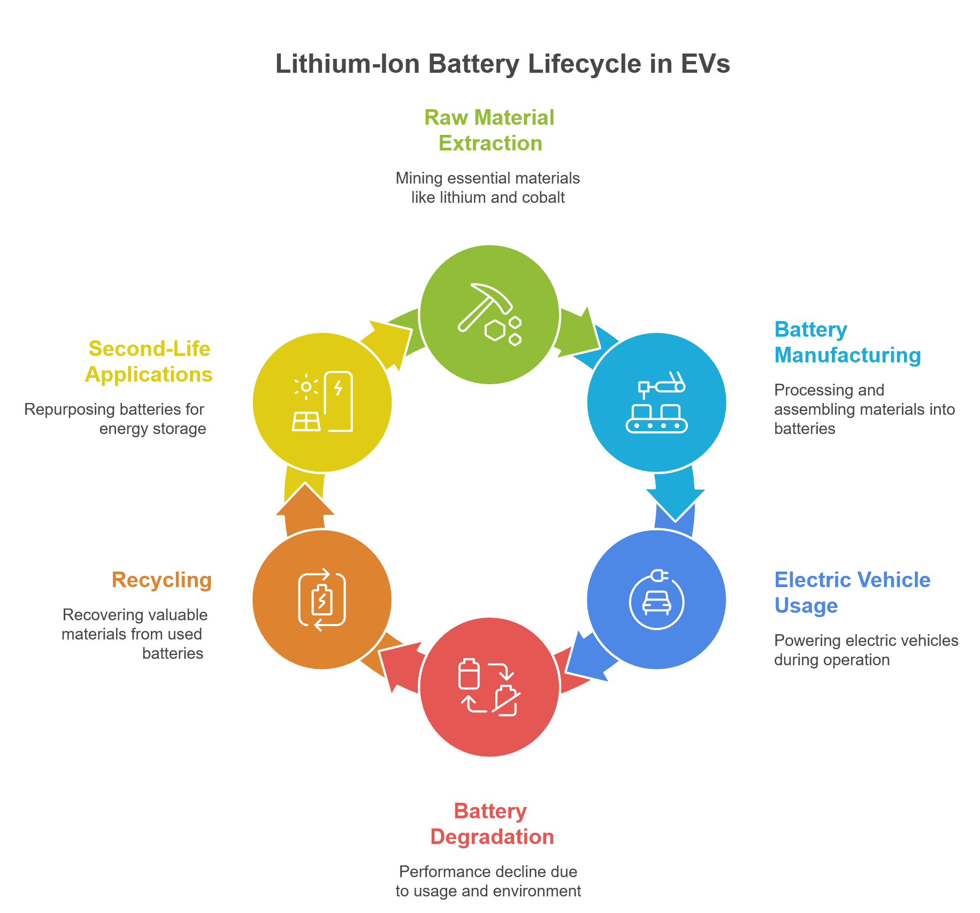
Figure 2: Lifecycle of Lithium-Ion Batteries in Electric Vehicles (created by the author)
10.2.1 Raw Material Extraction Impacts
Gathering resources for batteries raises difficult moral and environmental issues. Key component lithium increases significantly in water usage during retrieval. In Congo, cobalt comes at great human cost since it is often linked to juvenile workers and bad working circumstances. America needs more graphite, lithium, nickel, and cobalt among other crucial minerals. That gap makes one rely more on outside vendors, especially China, which produces most electrodes. Overlapping demands access to resources, care for the environment, and fairness in labor now put strain on supply networks all around as each shapes the others [200].
Though attempts to fulfill net-zero targets are speeding, lithium, cobalt, nickel, and graphite are projected to see fast increased reliance in the next years. Getting enough raw materials is now a big problem since electric cars and renewable technologies rely a lot on them. Where governance is poor, mining operations frequently cause community damage together with environmental damage. Lithium should be extracted from the ground because doing so often contaminates nearby water supplies. Large volumes of water are also needed for this process, it uses a lot of energy, and it creates a lot of waste that reflects more serious problems in how these resources are acquired [197].
Lithium-ion battery production mostly relies on lithium, cobalt, and nickel. However, concerns rise about the environmental impact of mining and refining these resources. Moving toward recycled sources, often known as urban mining, can help to alleviate some of the damage while also using resources more sustainably [201].
Contrary to popular belief, electric vehicles' power sources need a lot of certain raw materials, which raises questions about material usage and health risks when compared to conventional fuel-powered models. Making important parts like positive electrodes and lightweight structural parts is how emissions mostly come from, especially in places where fossil fuels are the main source of electricity. Rather than consistent results, local mining techniques and how cleanly industrial plants run their equipment determine the ecological effects. Processes requiring a lot of heat or a lot of power, like refining ores or getting rid of moisture from coating layers, put extra strain on a lot of different environmental indicators. Though mining lithium and cobalt hurts communities and ecosystems, all-solid-state designs lower the amount of harmful chemicals found in batteries. These modern systems offer better environmental performance by eliminating dangerous compounds included in conventional varieties. Still, some depend on lanthanum, a rare element confined to a small number of areas, therefore raising fresh concerns about accessibility and long-term viability [198].
Lithium-ion battery manufacturing is challenged by limited raw materials, raising concerns about long-term availability. Key elements like cobalt and lithium are sourced from a few regions, creating supply vulnerabilities that are often overlooked in standard life-cycle analyses. Cobalt mining in places like the Democratic Republic of Congo leads to ecological damage and human rights issues, including the use of child labor and toxic metal poisoning. The processes of refining aluminum and extracting lithium also produce significant carbon emissions, particularly when reliant on coal power. Future life cycle assessments should incorporate a variety of resource draw models and examine responses to changes. Furthermore, electric cars generate more waste than traditional vehicles due to the rare minerals required for batteries, highlighting the importance of recycling old batteries to reduce mining pressure. Despite their advantages, rare-earth elements in magnets increase production costs and supply chain risks, prompting scientists to seek alternatives that minimize these components for greater stability.
10.2.2 Carbon Footprint & Life Cycle Assessment
Although battery production adds much to greenhouse gases, how that power is made shapes its full climate effect. Where mines pull materials matters, because dirty grids boost pollution during early steps. Cell building stands out as especially emission-heavy across the entire timeline. Charging habits later on play a role too, yet origins of the electricity supply weigh heavily at every stage. Factories placed where renewables dominate tend to lower harm more than those tied to coal-heavy networks [197].
Built during production, batteries tie closely to high greenhouse gas outputs, especially where power grids rely on fossil fuels mining raw minerals adds heavily to this burden. Instead of new digging, reprocessing old units might slash climate impacts nearly 50 percent. Still, breaking down used batteries demands considerable power, sometimes releasing harmful fumes, dirtying water supplies, leaving behind stubborn waste. Even so, recycled pathways must stay cleaner overall compared to fresh resource extraction. Lasting gains depend on balancing these trade-offs without shifting harm elsewhere Fewer harmful materials show up in all-solid-state batteries because solids tend to stay put, behave predictably, mostly avoid dangerous reactions unlike the easily vaporized organics inside conventional cells. Since these units last longer under regular use, swapping them out happens far less often, which slowly cuts down on waste tied to power storage [198]. Few realize how much battery making affects Earth electric cars often carry heavier ecological footprints early on compared to gasoline models. That footprint comes mostly from crafting their large storage units, responsible for most carbon released up front. Once driving begins, pollution levels usually drop off, yet the actual gain hinges critically on whether local grids burn coal or harness cleaner sources instead. If power plants rely heavily on fossil fuels, any edge electric machines seemed to have may vanish entirely or worse, disappear upside down. Beyond climate metrics, mining materials and assembling packs intensifies risks tied to poisoning people and overloading water with nutrients. Even so, when stacked against outdated types like lead-acid or nickel-cadmium designs, today's lithium cells still come out ahead across major sustainability checks [203].
Though Life Cycle Assessment helps gauge how lithium-ion batteries affect the environment, ways of measuring and sharing results still lack uniformity. Because studies define system limits differently alongside mismatched functional units, databases, and selected impact types it becomes tough to line up findings. One paper might count twice as much manufacturing energy as another, simply due to methodological choices. Emissions tied to global warming over a century mostly stem from fossil-fuel-based carbon dioxide released when making cells. Progress hinges on separating effects caused by power demand from those linked to material extraction or transport. When analysts split these factors apart, updates reflecting cleaner grids become easier to integrate. Clarity grows if assumptions shift away from averaged inputs toward transparent source tracing [194].
Despite cleaner operation, electric cars carry an initial climate cost due to battery production. Their total footprint hinges on how local power grids generate electricity. Where wind or solar dominate supply, these vehicles emit less CO₂ over time. In contrast, areas burning large amounts of coal might see electric models outpace gasoline counterparts in emissions. Lifecycle advantages shift sharply based on energy sources used during both manufacturing and driving.
10.2.3 Recycling & End-of-Life Challenges
Although electric vehicles gain popularity, used batteries pile up fast creating pressure to find smart ways forward. When cars retire, their power packs still hold close to 70% function, making reuse a practical option. Grid support or emergency energy supply can give them new purpose, cutting down trash and sparing raw materials at once. Still, moving many of these units into fresh roles hits snags notably money demands across handling, checking, rebuilding, linking systems, certifying safety, setting up operations, storing parts, shifting locations, and putting pieces together again. Each step adds complexity; none fit neatly into today’s infrastructure without effort. Value stays locked unless both innovation and investment rise hand in hand. Sustainability gains remain partial so long as hurdles block smooth transitions from car to next phase . Using recycled materials from old lithium-ion batteries helps ease demand on raw resources while lowering ecological harm. Though common, traditional smelting approaches require large amounts of power and release harmful fumes problems likely to grow as discarded batteries pile up. Chemical-based extraction methods recover more material efficiently; however, they bring complicated steps alongside steep expenses for reagents and cleaning polluted water. Newer ideas like restoring damaged parts directly struggle with measuring real-world feasibility when factoring in energy use, manpower needs, and broader ecosystem effects across wide deployment. Physical laws limit total reuse, meaning complete recycling loops cannot exist under current understanding. Often, the worth of reclaimed substances fails to balance out the energy invested and environmental toll taken during recovery [197].
Sometimes buried away, used lithium-ion cells can leak harmful substances into dirt and water supplies. Even though they harm nature, a large number end up thrown out instead of recovered, because gathering them is still rare especially tiny ones from personal gadgets, since their small scale plus minimal financial return makes reuse hard [201].
Battery recycling might lower harm to nature along with cutting down on raw resource needs yet it's unclear whether it cancels pollution tied to making new batteries. When recovering and rebuilding materials takes too much power, gains shrink fast. High-heat techniques already in use demand heavy energy, release dangerous fumes, and often miss extracting vital components entirely; water-based alternatives bring tangled operations plus messy waste streams to manage. Newer ideas like restoring battery parts directly or using microbes to extract metals still struggle with growing beyond lab size, speed issues, or being simply too fresh to rely upon. Profitability also wobbles under real-world pressures: moving used units around, worker pay, how products are built for disassembly, and just how well current tech handles sorting and refining [203].
Most used ways to recycle lithium-ion batteries rely on closed systems using high-heat methods, liquid-based extraction, or rebuilding parts directly. High-temperature treatments tend to pull out metals like cobalt, nickel, and copper more easily. Liquid-driven reactions along with direct reuse strategies can capture extra elements lithium, for example, plus aluminum. Still, nearly all spent units, around 95 percent worldwide, never enter any recycling path. Regional differences shape how often or thoroughly these steps happen. Evaluating total environmental impact runs into problems when assuming recycled inputs match new ones exactly. Hard data confirming such parity remains sparse. Benefits tied to reprocessing might vanish should reclaimed components shorten battery lifespan or weaken energy return during charge cycles [194].
Waste from standard lithium-ion batteries often harms ecosystems when discarded or processed. Even though solid-state versions perform cleaner while operating, questions remain about how they will be handled once retired [198].
Getting lithium back from used batteries takes serious effort different battery types mean extra steps, plus pulling out metals like cobalt demands precision. Though burning them brings money, it also burns through fuel and releases large amounts of carbon dioxide into the air. Soaking parts in chemicals uses less power yet leaves behind dangerous byproducts that pose risks. Skipping heat altogether could cut pollution sharply; however, most trials stay inside labs for now. Today's approaches often fall short, wasting resources while harming nature, which keeps pushing scientists toward smarter, cleaner ways to reuse what we already have [202].The key environmental impacts associated with lithium-ion batteries across their lifecycle are summarized in Table 2.

Table 2. Environmental implications associated with lithium-ion battery lifecycle (created by the author).
Subsection | Environmental Issue | Description | Impact
10.2.1 Raw Materials | Resource extraction | Mining of lithium, cobalt, nickel | Environmental & ethical concerns
10.2.2 Carbon Footprint | Manufacturing emissions | High CO₂ during production | Climate impact
10.2.3 Recycling | Waste management | Low recycling rates, complex processes | Resource loss, pollution
10.3 Economic & Supply Chain Barriers
10.3.1 Cost Reduction Challenges
Despite facing soaring costs, lithium, ion batteries are still the main factor preventing the electric car market from expanding, therefore, researchers are trying to find ways to reduce the cost of both the production and the buying of raw materials [199]. What is more, the reuse of old batteries may result in a cost reduction, primarily for the application of energy storage. However, at the moment, the use of second, life batteries has not become popular. Thus, even if saving money with second, life batteries is possible, individuals who prefer purchasing new ones would do so if the price difference is not significant [203].
It is true that electric vehicles (EVs) represent a step forward concerning the environment and have the potential to save users money in the long run. Nonetheless, the fact that their initial price is so high is a major barrier for their widespread adoption. Concurrently, the already heavy handling cost of raw materials, like the spent lithium, ion batteries, is getting more and more burdened with additional expenses caused by their processing. If these types of vehicles are to become more widely available and viable for large, scale use, the various problems at both manufacturing and end, of, life stages need to be addressed [202].
Li, ion battery pack prices have plunged significantly over the last few years thus resulting in solid, state batteries becoming one of the most promising technologies in terms of energy density and safety. Nevertheless, it is still not easy to make them cost, effective, especially when it comes to the manufacturing processes. On top of that, the part price has increased even more due to the use of very fine powders. As a result, the performance advantage of solid, state batteries is currently limited by the cost of the materials and the complexity of manufacturing. Therefore, the future of battery technology is likely to be heavily influenced by the constant juggling of demands: the need to innovate while still minimizing costs [T7] .
Ore features determine how easily battery materials can be removed or reused. They influence the sorting and treatment steps. When lithium occurs with other minerals, separating them becomes more difficult. This sometimes leads to useful substances being discarded as waste. Transforming used materials back into usable forms requires a lot of energy. These processes often harm ecosystems and are more expensive than the value of the recycled output. Without better economics, full-cycle reuse is hard to maintain financially [197]. One significant cost factor in lithium-ion batteries is raw materials. Using recycled inputs could significantly lower overall pack prices. However, costly reprocessing and uncertain performance after reuse make widespread adoption hard. Concerns about the lifespan of old batteries add to the complexity. Sometimes, processing scrap materials is more expensive than mining new resources. Price fluctuations in global markets also create pressure on whether recycling is financially practical [201].
Though solid electrolytes show potential, producing them affordably is challenging due to high component costs. The costs come not only from raw materials like ionic liquids but also from the assembly process. Even with performance improvements, thin-film versions require expensive fabrication steps. These obstacles keep broad use unattainable for now [198].
Reducing costs in electric traction systems drives innovation, especially through lower motor and inverter prices without sacrificing performance. Since interior permanent magnet motors depend heavily on rare-earth elements, their prices remain high, prompting researchers to explore new magnet combinations with less or no heavy rare-earth materials. Even materials like Hyperco 50, known for their strong magnetic properties, have not gained much market acceptance because of their high cost. Meanwhile, vertical gallium nitride power devices face challenges in reaching mass markets due to expensive GaN base layers. Progress requires smarter approaches to materials and manufacturing methods for broad implementation to become possible [196].
10.3.2 Critical Material Supply Risks
Not far behind rising electric vehicle numbers sits a growing need for stable supplies of lithium, cobalt, and nickel, in addition to related elements such as manganese, copper, and aluminum. Supply chains waver where mines exist in areas prone to governance issues or unrest. Even when material exists underground, climbing local demand often means less leaves the country. Without clear backup plans, nations like the United States could face tightening constraints on production down the line. Should materials prove unstable, momentum in electric vehicle uptake may falter, even amid significant technological breakthroughs. The pace of technological spread now hinges on steady access to raw inputs, which remains an unspoken force behind real-world deployment.
Pressure mounts on raw materials needed for batteries, stirring concerns about ethical supply chains and environmental costs among shifting geopolitical currents. While lithium flows largely from Australia, Chile, and China, the broader mix, including cobalt, copper, manganese, nickel, tin, and graphite, reveals tighter constraints. These are shaped by limited output, dependence on mined co-products, or control concentrated in a single country. Should diplomatic strains emerge, rules shift, or lead times extend between discovery and production, scarcities will loom larger. In the absence of resilient systems ready to absorb disruption, momentum behind electrified transit and renewable grids may stall without warning [197]. Furthermore, garnet-type solid electrolytes lean on lanthanum; this represents a weak spot, since the availability of this element varies sharply across geographies, leaving few alternatives [198].
Electric cars depend on specific raw elements, namely cobalt, lithium, nickel, and manganese, for which demand is expected to climb sharply by 2034. With shocks like pandemics still affecting trade, turning to nearby sources has become more practical. Recovering old batteries offers a path to reduce reliance on distant suppliers. When outbreaks occurred, delivery routes faltered, exposing weak points in overseas procurement systems. Starting with steady sources cuts risk from volatile areas. One reason certain countries lead extraction is light oversight or tough environments; instead of relying on these locations, recycling outdated parts helps reduce dependence. Past disruptions demonstrated that independence in supply chains supports lasting resilience.
Depending on certain raw materials for rechargeable batteries raises serious environmental issues, along with challenges in sourcing, because early-stage production leaves a heavy footprint. With major deposits controlled by just a few nations like cobalt mostly mined in the Democratic Republic of Congo and lithium largely drawn from Australia, Chile, and Argentina access becomes fragile. Standard ways of evaluating product lifespans often fail to reflect these weaknesses, especially when sudden shortages or market swings occur. Meeting rising needs through faster lithium extraction could slow things down instead, revealing how crucial smart planning and broader supplier networks really are [194].
Cobalt and lithium recovery matters because these elements support ongoing battery manufacturing while reducing dependency on scarce raw supplies [202].
Despite their role in NdFeB magnets, dysprosium and terbium face unstable availability and shifting costs, creating challenges for makers of electric vehicles. Because prices swing unpredictably and sourcing remains uncertain, work has shifted toward developing magnets without heavy rare-earths. Researchers now explore substitute materials, aiming to ease pressure on limited supplies while strengthening long-term material access [196].A summary of the major economic and supply chain challenges is provided in Table 3.
Table 3. Economic and supply chain challenges affecting EV battery deployment (created by the author).
Subsection | Barrier | Description | Consequence
10.3.1 Cost | High battery cost | Expensive materials and manufacturing | Limits adoption
10.3.2 Supply Risk | Critical materials | Geographical concentration | Supply instability
10.4 Policy & Regulatory Landscape
10.4.1 Government Incentives & Support
Starting in 2030, some nations and American states begin phasing out new petrol and diesel car sales this shift speeds up electric vehicle uptake. Funding flows into battery-related activities: study, raw material handling, production, along with logistics networks not just from governments but also firms. Backed by laws passed in 2021 and 2022, Washington channels large amounts of money toward extracting critical minerals and refining components like cathodes and anodes. Support from state programs becomes a key force behind industrial expansion [197].
Despite differing national approaches, efforts to boost battery electric vehicle uptake often center on homegrown manufacturing alongside broader supply chain adjustments. Shifting supplier bases occurs while nations simultaneously upgrade safety protocols and refine raw material processing. Recycling systems grow more robust at the same time innovation receives steady support through targeted funding streams. Ethical procurement practices emerge as a priority, with attention paid to reducing harm across ecosystems and communities. Regulatory improvements proceed hand-in-hand with tighter oversight structures meant to ensure accountability. Economic levers like Europe's carbon-linked import fees and America’s sweeping climate-related spending law encourage cleaner industrial output. Local assembly of emission-free transport benefits from financial perks embedded within these policy designs. Facing growth pressures, officials also shape how land gets used aiming to reduce friction while guiding tech rollout and handling local effects. Questions remain about hidden costs or side outcomes, making continuous study essential [197].
Without strong financial rewards and clear rules, building reliable systems for reusing electric car batteries stays out of reach. Support from public authorities helps spark regional growth, drive new ideas, fuel trial programs, while shaping fair markets and regulations at once. Efforts focused on gathering used units must go hand-in-hand with better treatment methods, stronger facilities, lower expenses across the cycle.
Across nations, officials push transport electrification using tailored rules and schemes meant to boost electric vehicle uptake. Because cleaner mobility depends on structural change, many administrations back charger networks alongside fiscal perks like rebates or tax reductions. Shifts away from fossil-powered cars gain speed when laws nudge buyers toward EVs instead. While technology evolves, steady public intervention helps lower expenses linked to switching fleets. Only with consistent guidance can large-scale adoption clear hurdles tied to cost and access. Goals around emissions and energy use rely heavily on these moves within urban and rural corridors alike [203].
Starting off differently each time helps clarify how rules and money-related pushes influence electric car use. Where one area sets tough fuel targets, another might force sellers to move more EVs both build trust slowly among buyers and makers alike. These tools work better in some places than others, depending on what the market can handle right now. Looking at nations such as Brazil shows that mixing cash rewards with practical benefits often leads to longer-term success. A blend of supports tends to stick when shaped around real local needs [202].
Support from public institutions shapes how electric cars evolve, mainly by setting goals around efficiency and pricing. By working together, the U.S. Department of Energy and the automotive research council outlined key benchmarks for passenger EVs expected by 2025 these shape expectations across companies and push progress tied to regulations. When agencies coordinate on milestones like these, science projects, production plans, and market rollouts tend to follow broader aims related to travel systems and power usage nationwide [196].
10.4.2 Safety Standards & Regulations
Getting rid of old batteries the right way protects people's health, which pushes governments to build strong rules. In places like China, companies that make or bring in batteries must handle how they are collected, reused, or recycled. Clear labels on each unit along with a digital record showing what it’s made of, where it came from, its condition, and who owned it help manage them safely once their life ends. This kind of system improves sorting accuracy while boosting recovery rates during recycling processes [201].
Nowhere is change more evident than in how electric car makers adjust to shifting rules that redefine their daily operations. Because policies evolve, company plans shift often in ways unanticipated just years before. One clear case emerges from Europe, where a rule about batteries forces firms to recycle old units. This directive sets exact goals: certain metals must be pulled back from used cells. As a result, manufacturing choices now tie closely to what happens when vehicles retire. How things begin links firmly to how they end
Rules and safety rules shape how safely electric car power parts and chargers work. Instead of just listing tests, groups like JEDEC, AEC-Q101, and AQG 324 set clear checks for tough silicon carbide parts used in vehicles. Because SiC MOSFETs react quickly under stress, they need quicker safeguards along with better resistance to interference. Under SAE J1772, limits on certain magnetic and storage elements in DC circuits affect both layout choices and signal clarity during charge cycles. For boards handling high voltage, meeting UL-796 and IPC-2221a isn’t optional it keeps insulation strong and risks low [196].Table 4 summarizes the key policy measures and regulatory frameworks influencing EV development.
Table 4. Policy and regulatory frameworks influencing electric vehicle development (created by the author).
Subsection | Policy Area | Description | Role
7.1 Incentives | Government support | Subsidies, investments, laws | Boost EV adoption
7.2 Regulations | Safety standards | Battery handling & certification | Ensure safety
10.5 Future Research Directions & Emerging Solutions
The challenges discussed across technical, environmental, economic, and regulatory domains are highly interconnected rather than isolated. For instance, efforts to increase energy density directly influence safety risks, thermal behavior, and lifecycle degradation, while also impacting manufacturing complexity and cost. Similarly, supply chain constraints and environmental concerns are closely linked to raw material extraction and recycling limitations. These interdependencies highlight that advancements in electric vehicle battery technology cannot rely on single-dimensional improvements, but instead require integrated solutions that simultaneously address performance, safety, sustainability, and scalability.
Although future work targets steady temperatures across lithium packs, progress depends heavily on how well heating integrates with a car’s existing climate system. Instead of standalone units, shared cooling loops may cut energy waste especially if tailored to each pack's layout. Electrolyte tweaks might handle winter conditions better, yet questions remain about long-term wear under repeated warming cycles. When batteries warm themselves in bursts, timing matters just as much as total heat delivered. Combining AC and DC currents heats faster but risks plating metal where it shouldn’t form. Peltier devices offer solid-state control, though they often lose more heat than desired. Airflow paths grow uneven when packs scale up, demanding smarter ducting designs. Liquid channels face leaks and pressure drops that reduce reliability over time. Pairing cold plates with materials that absorb excess warmth during melting shows potential not only smoothing hot spots, but supporting longer function without failure [199].
Scientists keep working on better battery materials, trying out new kinds of electrodes like silicon mixed with graphene, cathodes rich in nickel, or anodes made from lithium titanate meanwhile, LFP batteries last longer over time and repeated uses. To store more lithium, researchers shape silicon into tiny structures, wrap it in carbon layers, mix it carefully, yet still face swelling issues during charging cycles. Reaching 350 to 450 watt-hours per kilogram is the goal for nickel-heavy cathodes, pushing how much power fits in a given weight. Some teams explore lithium-sulfur setups instead, drawn by sulfur's low cost and massive energy promise, even though the chemistry tends to break down too fast. Progress comes slowly by binding sulfur to carbon scaffolds or adjusting liquid components inside the cell. Solid-state versions could run safer, hold more charge, live longer, recharge faster but making solids that conduct ions well without cracking or costing too much remains tough. Behind every pack, smart controls track voltage, balance loads, prevent overheating, adjust flow based on real-time feedback. These systems adapt quietly, helping each unit perform steadily under changing conditions. Focusing on recovery, new methods now combine high temperature processing with liquid based extraction and full component reuse, while innovations like machine guided breakdown, sound wave sorting, targeted contaminant breakdown, and metal layer transfer enter testing phases. Together, progress across these areas responds to demands for safer, longer lasting, affordable, and environmentally responsible power storage solutions [200].
Though often overlooked, transport decarbonization demands more than single solutions it thrives on layered strategies. A resilient battery supply system hinges not only on technology but also smarter use of renewables alongside steady funding flows. Instead of relying solely on breakthroughs, progress comes through blending better materials, cleaner power sources, and forward-looking planning. Lightweight parts made from fiber composites help cut fuel needs; so do trucks built for efficiency rather than speed. Biobased gases now power some fleets, showing promise where electrification lags behind. Rules set by governments like those introduced in recent U.S. legislation shape much of what becomes possible down the road. Evaluating the Inflation Reduction Act requires care when aligning cleaner transportation goals with reliable power access. Battery passports offer one path forward making sourcing clearer through better tracking and ethical manufacturing oversight. Instead of just expanding mining, gaining needed materials may come from novel recycling methods or tapping into alternative deposits. Charging innovations such as vehicle-linked grids help stabilize electricity networks, especially where solar and wind play larger roles. Shifting toward long-term solutions means blending smarter technology use, updated policies, and tighter control over resources. Together, progress hinges on how well engineering advances, rules, and supply chains work at once [197].
Moving forward with better recycling methods means looking at every step from gathering old batteries to how they’re stored since these stages often get overlooked even though they affect safety, performance, and expenses. Instead of just focusing on major parts, innovation ought to aim at full reuse cycles, targeting materials once ignored: things like lithium, graphite, aluminum, and liquid components inside cells. One path worth exploring involves pulling lithium selectively out of LFP units; doing so keeps valuable tiny structures intact rather than dissolving everything away. Building batteries with future breakdown in mind through choices like simpler layouts or easier-to-recover substances can turn into an edge over competitors. Testing real-world trials that bring together car makers, scientists, rule setters, recyclers, and producers helps confirm what works financially and technically, fills missing pieces, and uses large batches of used electric vehicle power packs effectively [201].
Solid electrolytes need strong mechanical traits so all-solid-state batteries can progress fluoride-rich halides show promise, while mixtures blending solid and liquid elements help reduce resistance at junctions. Materials like silicon or tin go under scrutiny for anodes since they handle swelling better during cycling, though problems remain around layer instability and spike-like metal formations; running cells cooler tends to calm these issues when using pure lithium anodes. Improving contact zones between components plays a big role not just cutting down blockages to ion flow but holding performance steady over time, where computer models reveal how particles move and interact right down to single atoms. Making these batteries widely available demands upgrades in fabrication too: milder heat conditions, faster processing steps, alongside newer methods that fit large-scale output without sacrificing quality [198].
Focused work ahead on electric vehicles centers on refining energy systems, pushing forward battery design, because better reuse methods matter for wide usage and lasting ecological balance. Looking closely at how clean EVs really are over their entire lifespan when set against gas-powered cars is still key, especially as grids add more wind and solar power while building stronger markets for old batteries through second-life roles and recovery networks. New kinds of cells, like those packed with extra lithium, sulfur-based types, or oxygen-driven models, try to deliver longer function without harming nature; meanwhile researchers test tiny silicon threads and hollow carbon tubes as parts that hold more charge yet swell less during charging, although making them widely stays hard. Handling used units well demands complete plans: giving worn-out packs new jobs first, then pulling out valuable elements safely before final discard, so pollution drops sharply. Progress hinges on steady investigation that shapes truly responsible growth in transport powered by electrons [203].
Looking ahead, work on lithium-ion batteries needs clearer life-cycle evaluations that match real-world changes in how energy and raw materials are sourced especially when mining strays from standard methods, like small-scale cobalt digging. Instead of broad assumptions, studies ought to compare factories of different sizes, since output volume and physical scale shape environmental footprints in distinct ways. Measuring impact per unit of stored energy or total delivered electricity makes more sense than using battery weight alone. Location matters too: where minerals come from affects both ecological strain and community well-being, especially near unofficial or loosely regulated sites. Breaking down harm caused by power use versus damage from chemical waste helps clarify true costs. Exploring various conditions through adjusted inputs or modeled futures allows room to test new techniques, supply limits, and likely transformations in how these systems operate over time. A single set of testing rules covering how batteries are charged, how hot they run, and how full they stay helps measure wear, performance, and lifespan clearly. To compare results fairly between research efforts, shared frameworks must emerge; these would confirm findings independently while guiding stronger conclusions for long-term battery progress [194].
Looking ahead, life-cycle assessments must come first; these help measure how battery making and throwing away affects nature over time. Smart grids linking up with electric cars plus clean power sources could make energy use far smarter. Work that weighs costs against gains, especially over decades, shapes better rules and company plans. Recycling methods need sharper focus so valuable stuff inside batteries does not go to waste. Human behavior plays a role too; learning how people react helps organizations shift smoothly. Policies already in place? They require regular checkups. New regulations ought to grow from solid data, tested across countries. One puzzle still looms large: what happens to electricity networks when millions plug in at once. Answers won’t come fast but the search matters just the same [202].
Looking ahead, work centers on new materials and redesigned components to boost how well electric drives and power electronics operate, last longer, and scale up. Instead of traditional paths, researchers explore ultra-conductive copper coils, magnets treated by grain boundary diffusion, along with thinner steel layers that cut down energy waste in cores. Some alloys, Hyperco 50 among them, bring together strong magnetism and durability under stress. On another front, semiconductors like silicon carbide, gallium nitride, diamond, and beta-gallium oxide open doors to devices that handle more power without losing efficiency vertical GaN stands out where voltage demands rise. Packaging advances also matter: embedded modules now feature better substrates, flat bonding methods, plus ways to pull heat straight from the base, cutting unwanted electrical noise while moving warmth away faster. Efforts now focus on refining inverter layouts through split configurations, reducing electrical noise pairs with tighter packaging and lower energy waste. While some approaches adjust circuit segmentation, others target consistent operation under load shifts. At the same time, faster rotating machines rely on novel heat control such as tiny internal channels, directed fluid bursts, or 3D-printed dissipaters to sustain strength output and temperature management. These paths, though different, share a goal: longer service life without bulk [196].
Getting better ion movement in solid electrolytes on par with liquids is still a hurdle, even though some oxide and sulfide options show promise. What stands out: cutting down resistance where materials meet inside the battery directly affects how well it charges, delivers power, and lasts over time. Stabilizing these solids using chemistry and electrical methods helps, just as tweaking physical interactions does, alongside adjusting surfaces at both ends to stop unwanted reactions while keeping tight connections. New types of solid conductors need to emerge, matched by suitable positive and negative electrodes such as nickel-heavy oxides, metallic lithium, or versions without lithium altogether. Focus must land on how stable these junctions stay, how they break, and how they handle stress during operation. To move from lab experiments to real-world use, blending multi-level testing, design refinements, and manufacturing approaches that work beyond small batches becomes unavoidable. To provide a holistic perspective, Table 5 presents a cross-domain comparison of key challenges, emphasizing their interactions and the inherent trade-offs affecting performance, sustainability, and scalability.
Table 5. Interconnection between major challenges affecting electric vehicle battery systems (created by the author).
Challenge Domain | Key Issue | Affected Areas | Trade-off
Technical | High energy density | Safety, degradation | Performance vs safety
Environmental | Resource extraction | Sustainability, ethics | Growth vs impact
Economic | High cost | Market adoption | Innovation vs affordability
Supply Chain | Material concentration | Production stability | Efficiency vs dependency
Policy | Regulation & incentives | Market growth | Control vs flexibility

10.2 Conclusion
This review has shown that BEVs, PHEVs, and HEVs represent a continuum of electrified mobility solutions rather than competing end states. BEVs offer the largest pathway for direct tailpipe‑emissions elimination, but their performance and acceptance depend strongly on battery capability and accessible charging networks. HEVs and PHEVs provide transitional value in markets where charging coverage is limited or where specific duty cycles (highway‑dominant use, cold climates, or long‑distance travel) make full electrification more challenging in the near term. Across this spectrum, powertrain architecture choices (series, parallel, power‑split, and multi‑mode) can be understood as trade‑offs between mechanical complexity, efficiency across real‑world drive cycles, and control requirements.
At the component level, progress in batteries, motors, and power electronics is enabling higher efficiency and power density, but the most important advances occur when these subsystems are engineered together. Batteries cannot be evaluated only by headline energy density; real‑world performance is constrained by thermal behavior, fast‑charge limits, aging trajectories, and safety margins. Likewise, the benefits of high‑efficiency machines and modern inverters are realized most fully when paired with optimized voltage architectures, robust thermal design, and control strategies that balance performance against lifetime. Charging infrastructure closes the loop between vehicles and the energy system: deployment scale, reliability, interoperability, and smart‑charging capability determine whether electrified mobility is convenient and equitable, and whether grid impacts are manageable.
Economics and policy are therefore inseparable from the engineering roadmap. Total cost of ownership improves as battery costs decline, energy efficiency rises, and maintenance needs fall, but market growth is highly sensitive to how incentives, mandates, infrastructure obligations, and industrial policies are combined and enforced. The strongest long‑run outcomes will come from integrated strategies that (i) accelerate clean electricity and managed charging, (ii) strengthen safety and cybersecurity governance, (iii) reduce supply‑chain risk through recycling and sustainable sourcing, and (iv) protect equity by ensuring that charging access and financial benefits are reachable for a broad set of users. In summary, the transition to electrified transport is best understood as a coordinated socio‑technical system change: sustained adoption will require concurrent advances in materials and manufacturing, battery intelligence and thermal safety, grid‑aware infrastructure, and coherent regulation that aligns climate objectives with affordability and public trust.
References:
[1] S. Aggarwal and A. K. Singh, “Electric vehicles the future of transportation sector: a review,” Energy Sources, Part A: Recovery, Utilization, and Environmental Effects, vol. 47, no. 1, pp. 11126–11146, Jun. 2025, doi: 10.1080/15567036.2021.1976322.
​[2] I. Kusuma, Ruliyanta, R. A. S. Kusumoputro, and A. Iswadi, “Electric Vehicle Review: BEV, PHEV, HEV, or FCEV?,” Jurnal Konversi Energi dan Manufaktur, pp. 70–83, Jan. 2025, doi: 10.21009/JKEM.10.1.8.
​[3] A. A. Ghani, N. Abdullah, K. B, R. Saidur, and A. K. Pandey, “Assessing technological-driven challenges and policies associated with electric vehicle (EV) adoption,” Transp. Policy (Oxf)., vol. 169, pp. 167–177, Aug. 2025, doi: 10.1016/j.tranpol.2025.04.030.
​[4] S. Slouma, M. Ben Said, and S. Skander, “Current State, Challenges, Recommendations and Prospects of Machine Learning Application in Fuel Cell Based Hybrid Electric Cars: A Comprehensive Overview,” Journal of Sustainable Development of Energy, Water and Environment Systems, vol. N/A, no. N/A, pp. 0–0, Dec. 2025, doi: 10.13044/j.sdewes.d13.0641.
​[5] F. Jung, M. Schröder, and M. Timme, “Exponential adoption of battery electric cars,” PLoS One, vol. 18, no. 12, p. e0295692, Dec. 2023, doi: 10.1371/journal.pone.0295692.
​[6] N. P. Hariram, A. Megalingam, and K. Sudhakar, “Flying cars and hyperloops: A glimpse into the future sustainable vehicles,” Sustainable Energy Technologies and Assessments, vol. 75, p. 104196, Mar. 2025, doi: 10.1016/j.seta.2025.104196.
​[7] Z. Chen, H. Gu, S. Shen, and J. Shen, “Energy management strategy for power-split plug-in hybrid electric vehicle based on MPC and double Q-learning,” Energy, vol. 245, p. 123182, Apr. 2022, doi: 10.1016/j.energy.2022.123182.
​[8] M. S. Koroma et al., “Life cycle assessment of battery electric vehicles: Implications of future electricity mix and different battery end-of-life management,” Science of The Total Environment, vol. 831, p. 154859, Jul. 2022, doi: 10.1016/j.scitotenv.2022.154859.
​[9] M. S. Mastoi et al., “An in-depth analysis of electric vehicle charging station infrastructure, policy implications, and future trends,” Energy Reports, vol. 8, pp. 11504–11529, Nov. 2022, doi: 10.1016/j.egyr.2022.09.011.
​[10] X. Li, Y. Liu, Y. Qu, L. Ding, and X. Yan, “Effect of electric vehicles and renewable electricity on future life cycle air emissions from China’s road transport fleet,” Energy, vol. 318, p. 134969, Mar. 2025, doi: 10.1016/j.energy.2025.134969.
​[11] O. Sadeghian, A. Oshnoei, B. Mohammadi-ivatloo, V. Vahidinasab, and A. Anvari-Moghaddam, “A comprehensive review on electric vehicles smart charging: Solutions, strategies, technologies, and challenges,” J. Energy Storage, vol. 54, p. 105241, Oct. 2022, doi: 10.1016/j.est.2022.105241.
​[12] Md. R. H. Mojumder, F. Ahmed Antara, Md. Hasanuzzaman, B. Alamri, and M. Alsharef, “Electric Vehicle-to-Grid (V2G) Technologies: Impact on the Power Grid and Battery,” Sustainability, vol. 14, no. 21, p. 13856, Oct. 2022, doi: 10.3390/su142113856.
​[13] K. Gholami, S. Karimi, and A. Rastgou, “Fuzzy risk-based framework for scheduling of energy storage systems in photovoltaic-rich networks,” J. Energy Storage, vol. 52, p. 104902, Aug. 2022, doi: 10.1016/j.est.2022.104902.
​[14] D. Menchaca Santos, P. Thüne, J. M. Zepter, and M. Marinelli, “Business cases for degradation-aware bidirectional charging of residential users and heavy-duty vehicle fleets,” eTransportation, vol. 23, p. 100389, Jan. 2025, doi: 10.1016/j.etran.2024.100389.
​[15] K. Balu and V. Mukherjee, “Optimal allocation of electric vehicle charging stations and renewable distributed generation with battery energy storage in radial distribution system considering time sequence characteristics of generation and load demand,” J. Energy Storage, vol. 59, p. 106533, Mar. 2023, doi: 10.1016/j.est.2022.106533.
​[16] N. Uribe-Pérez et al., “Communications and Data Science for the Success of Vehicle-to-Grid Technologies: Current State and Future Trends,” Electronics (Basel)., vol. 13, no. 10, p. 1940, May 2024, doi: 10.3390/electronics13101940.
​[17] Z. Xing et al., “AGV charging scheduling with capacitated charging stations at automated ports,” Transp. Res. E Logist. Transp. Rev., vol. 197, p. 104080, May 2025, doi: 10.1016/j.tre.2025.104080.
​[18] Dr. V. B. Kumar, “Advancing Sustainable Transport: A Comparative Review of Battery and Fuel Cell Electric Vehicles in Automotive Industry,” Jan. 2026. doi: 10.4271/2026-26-0164.
​[19] K. Gholami, S. Karimi, and A. Rastgou, “Fuzzy risk-based framework for scheduling of energy storage systems in photovoltaic-rich networks,” J. Energy Storage, vol. 52, p. 104902, Aug. 2022, doi: 10.1016/j.est.2022.104902.
​[20] F. Gunes and M. A. Zehir, “Development of a Vehicle-to-Grid (V2G) Energy Management System to Mitigate Local Operational Challenges in Low Voltage Distribution Networks with Photovoltaics,” in 2022 4th Global Power, Energy and Communication Conference (GPECOM), IEEE, Jun. 2022, pp. 389–394. doi: 10.1109/GPECOM55404.2022.9815823.
​[21] N. Uribe-Pérez et al., “Communications and Data Science for the Success of Vehicle-to-Grid Technologies: Current State and Future Trends,” Electronics (Basel)., vol. 13, no. 10, p. 1940, May 2024, doi: 10.3390/electronics13101940.
​[22] A. A. Ghani, N. Abdullah, K. B, R. Saidur, and A. K. Pandey, “Assessing technological-driven challenges and policies associated with electric vehicle (EV) adoption,” Transp. Policy (Oxf)., vol. 169, pp. 167–177, Aug. 2025, doi: 10.1016/j.tranpol.2025.04.030.
[23] R. A. Akpinar, S. Achanta, A. Fotouhi, H. Zhang, and D. J. Auger, “Battery temperature prediction in electric vehicles using Bayesian regularization,” in Proc. 20th Int. Conf. Synthesis, Modeling, Analysis and Simulation Methods and Applications to Circuit Design (SMACD), Volos, Greece, Jul. 2024, pp. 1–4, doi: 10.1109/SMACD61181.2024.10745411.
[24] R. Zhi-yong, “Research on influence factors affecting driving range of flame-proof battery electric vehicles,” in Proc. IEEE 4th Adv. Inf. Technol., Electron. Autom. Control Conf. (IAEAC), Chengdu, China, Dec. 2019, pp. 1982–1986, doi: 10.1109/IAEAC47372.2019.8997686.
[25] B. Frieske, M. Kloetzke, and F. Mauser, “Trends in vehicle concept and key technology development for hybrid and battery electric vehicles,” in Proc. World Electric Vehicle Symp. and Exhibition (EVS27), Barcelona, Spain, Nov. 2013, pp. 1–12, doi: 10.1109/EVS.2013.6914783.
[26] L. Timilsina, P. R. Badr, P. H. Hoang, G. Ozkan, B. Papari, and C. S. Edrington, “Battery degradation in electric and hybrid electric vehicles: A survey study,” IEEE Access, vol. 11, pp. 42431–42462, 2023, doi: 10.1109/ACCESS.2023.3271287.
[27] B. Price, E. Dietz, and J. Richardson, “Life cycle costs of electric and hybrid electric vehicle batteries and end-of-life uses,” in Proc. IEEE Int. Conf. Electro/Information Technol. (EIT), Indianapolis, IN, USA, May 2012, pp. 1–7, doi: 10.1109/EIT.2012.6220712.
[28] B. Ban, M. Vrazic, and I. Bahun, “Electric vehicle model with driving cycle based algorithm for battery and motor minimization,” in Proc. Int. Conf. Electrical Drives and Power Electronics (EDPE), Tatranska Lomnica, Slovakia, Sep. 2015, pp. 220–226, doi: 10.1109/EDPE.2015.7325297.
[29] A. V. Grishin, A. R. Asoyan, A. A. Solntsev, V. V. Guly, and O. V. Fediushkina, “Ensuring the operation of electric bus batteries in the optimal temperature range,” in Proc. Intell. Technol. Electron. Devices Vehicle Road Transp. Complex (TIRVED), Moscow, Russia, Nov. 2022, pp. 1–4, doi: 10.1109/TIRVED56496.2022.9965484.
[30] A. Rezaei, J. B. Burl, M. Rezaei, and B. Zhou, “Catch energy saving opportunity in charge-depletion mode, a real-time controller for plug-in hybrid electric vehicles,” IEEE Trans. Veh. Technol., vol. 67, no. 11, pp. 11234–11237, Nov. 2018, doi: 10.1109/TVT.2018.2866569.
[31] M. Yilmaz and P. T. Krein, “Review of battery charger topologies, charging power levels, and infrastructure for plug-in electric and hybrid vehicles,” IEEE Trans. Power Electron., vol. 28, no. 5, pp. 2151–2169, May 2013, doi: 10.1109/TPEL.2012.2212917.
[32] K. Clement-Nyns, E. Haesen, and J. Driesen, “The impact of charging plug-in hybrid electric vehicles on a residential distribution grid,” IEEE Trans. Power Syst., vol. 25, no. 1, pp. 371–380, Feb. 2010, doi: 10.1109/TPWRS.2009.2036481.
[33] A. Emadi, Y. J. Lee, and K. Rajashekara, “Power electronics and motor drives in electric, hybrid electric, and plug-in hybrid electric vehicles,” IEEE Trans. Ind. Electron., vol. 55, no. 6, pp. 2237–2245, Jun. 2008, doi: 10.1109/TIE.2008.922768.
[34] SAE International, SAE Electric Vehicle and Plug-In Hybrid Electric Vehicle Conductive Charge Coupler, SAE Standard J1772_201210, Warrendale, PA, USA, 2012.
[35] F. Berthold, A. Ravey, B. Blunier, D. Bouquain, S. Williamson, and A. Miraoui, “Design and development of a smart control strategy for plug-in hybrid vehicles including vehicle-to-home functionality,” IEEE Trans. Transp. Electrification, vol. 1, no. 2, pp. 168–177, Aug. 2015, doi: 10.1109/TTE.2015.2426508.
[36] U.S. Department of Energy, Hybrid and Plug-In Electric Vehicles. Washington, DC, USA: Alternative Fuels Data Center, 2021.
[37] F. Noor et al., “Design and validation of adaptive barrier function sliding mode controller for a novel multisource hybrid energy storage system based electric vehicle,” IEEE Access, vol. 12, pp. 145270–145285, 2024, doi: 10.1109/ACCESS.2024.3471893.
[38] C. U. Kim et al., “Optimization of device design for low cost and high efficiency planar monolithic perovskite/silicon tandem solar cells,” Nano Energy, vol. 60, pp. 213–221, Jun. 2019, doi: 10.1016/j.nanoen.2019.03.056.
[39] H. Maghfiroh, O. Wahyunggoro, and A. I. Cahyadi, “Energy management in hybrid electric and hybrid energy storage system vehicles: A fuzzy logic controller review,” IEEE Access, vol. 12, pp. 56097–56109, 2024, doi: 10.1109/ACCESS.2024.3390436.
[40] Z. Zhao and X. Tang, “Control of e-CVT to EV mode transition on braking deceleration condition for a compound power-split hybrid electrical vehicle,” IEEE Access, vol. 7, pp. 111954–111967, 2019, doi: 10.1109/ACCESS.2019.2935039.
[41] M. A. Masrur, “Hybrid and electric vehicle (HEV/EV) technologies for off-road applications,” Proc. IEEE, vol. 109, no. 6, pp. 1077–1093, Jun. 2021, doi: 10.1109/JPROC.2020.3045721.
[42] C. H. T. Lee et al., “A critical review of emerging technologies for electric and hybrid vehicles,” IEEE Open J. Veh. Technol., vol. 2, pp. 471–485, 2021, doi: 10.1109/OJVT.2021.3138894.
[43] A. U. Rehman et al., “A critical review of recent industrial developments, trends, and future perspectives of power electronic systems: Fuel cell electric vehicles,” IEEE Trans. Ind. Inform., vol. 20, no. 4, pp. 6060–6074, Apr. 2024, doi: 10.1109/TII.2023.3347736.
[44] L. Schmitt, J. Beerwerth, M. Bahr, and D. Abel, “Data-driven predictive control with online adaption: Application to a fuel cell system,” IEEE Trans. Control Syst. Technol., vol. 32, no. 1, pp. 61–72, Jan. 2024, doi: 10.1109/TCST.2023.3293790.
[45] Y. Tao, J. Qiu, S. Lai, X. Zhang, and G. Wang, “Collaborative planning for electricity distribution network and transportation system considering hydrogen fuel cell vehicles,” IEEE Trans. Transp. Electrification, vol. 6, no. 3, pp. 1211–1225, Sep. 2020, doi: 10.1109/TTE.2020.2996755.
[46] S. Luo et al., “Microconformal electrode-dielectric integration for flexible ultrasensitive robotic tactile sensing,” Nano Energy, vol. 80, p. 105580, Feb. 2021, doi: 10.1016/j.nanoen.2020.105580.
[47] M. H. Sarwar et al., “Fuzzy logic-based novel hybrid fuel framework for modern vehicles,” IEEE Access, vol. 8, pp. 160596–160606, 2020, doi: 10.1109/ACCESS.2020.3010067.
[48] S. A. Q. Mohammed et al., “Critical review on powertrain technologies for electric vehicles: Classification, broadly adopted topologies, and future challenges,” IEEE Access, vol. 13, pp. 71755–71772, 2025, doi: 10.1109/ACCESS.2025.3561577.
[49] NITI Aayog, “Types of electric vehicles,” e-AMRIT Portal, 2023.
[50] G. Gutmann, Encyclopedia of Electrochemical Power Sources. Amsterdam, Netherlands: Elsevier, 2009.
[51] Aptiv, “BEV, PHEV, or HEV: The differences affect the architecture,” Aptiv Technical Insight, 2021.
[52] U.S. Department of Energy, “Fuel cell electric vehicles,” Alternative Fuels Data Center, 2023.
[53] U.S. Department of Energy, “Emissions from electric vehicles,” Alternative Fuels Data Center, 2023.
[54] Y. Pan et al., “A review of hybrid vehicles classification and their energy management strategies: An exploration of the advantages of genetic algorithms,” Algorithms, vol. 18, no. 6, p. 354, Jun. 2025, doi: 10.3390/a18060354.
[55] T. Hofman, S. Ebbesen, and L. Guzzella, “Topology optimization for hybrid electric vehicles with automated transmissions,” IEEE Trans. Veh. Technol., vol. 61, no. 6, pp. 2442–2451, Jul. 2012.
[56] H. Pointner and W.-D. Steinmann, “Experimental demonstration of an active latent heat storage concept,” Appl. Energy, vol. 168, pp. 661–671, Apr. 2016.
[57] C.-L. Wang, C.-L. Yin, T. Zhang, and L. Zhu, “Powertrain design and experiment research of a parallel hybrid electric vehicle,” Int. J. Automot. Technol., vol. 10, no. 5, pp. 589–596, Oct. 2009.
[58] C. Liu, K. T. Chau, and J. Z. Jiang, “A permanent-magnet hybrid brushless integrated starter–generator for hybrid electric vehicles,” IEEE Trans. Ind. Electron., vol. 57, no. 12, pp. 4055–4064, Dec. 2010.
[59] W. Zhuang et al., “A survey of powertrain configuration studies on hybrid electric vehicles,” Appl. Energy, vol. 262, p. 114553, Mar. 2020.
[60] A. Rezaei et al., “Catch energy saving opportunity (CESO), an instantaneous optimal energy management strategy for series hybrid electric vehicles,” Appl. Energy, vol. 208, pp. 655–665, Dec. 2017.
[61] J. Liu and H. Peng, “Modeling and control of a power-split hybrid vehicle,” IEEE Trans. Control Syst. Technol., vol. 16, no. 6, pp. 1242–1251, Nov. 2008.
[62] H. Pei et al., “Configuration optimization for improving fuel efficiency of power split hybrid powertrains with a single planetary gear,” Appl. Energy, vol. 214, pp. 103–116, Mar. 2018.
[63] J. M. Miller, “Hybrid electric vehicle propulsion system architectures of the e-CVT type,” IEEE Trans. Power Electron., vol. 21, no. 3, pp. 756–767, May 2006.
[64] X. Zhang, H. Peng, and J. Sun, “A near-optimal power management strategy for rapid component sizing of multimode power split hybrid vehicles,” IEEE Trans. Control Syst. Technol., vol. 23, no. 2, pp. 609–618, Mar. 2015.
[65] T. Matsubara et al., “Development of new hybrid system for compact class vehicles,” SAE World Congress & Exhibition, 2009.
[66] G. S. Vasilash, “A Lexus like no other but like the rest: Introducing the RX 400h—luxury, not economy,” 2005.
[67] A. N. Duhon et al., “Chevrolet Volt electric utilization,” SAE Int. J. Altern. Powertrains, vol. 4, no. 2, pp. 269–276, Apr. 2015.
[68] A. G. Holmes and M. R. Schmidt, “Hybrid electric powertrain including a two-mode electrically variable transmission,” US Patent 6,478,705, 2002.
[69] H.-T. Ngo and H.-S. Yan, “Novel configurations for hybrid transmissions using a simple planetary gear train,” J. Mech. Robot., vol. 8, no. 2, 2016.
[70] J. Liu and H. Peng, “A systematic design approach for two planetary gear split hybrid vehicles,” Veh. Syst. Dyn., vol. 48, no. 11, pp. 1395–1412, 2010.
[71] A. E. Bayrak, N. Kang, and P. Y. Papalambros, “Decomposition-based design optimization of hybrid electric powertrain architectures,” J. Mech. Des., vol. 138, no. 7, 2016.
[72] M. Kang, H. Kim, and D. Kum, “Systematic configuration selection methodology of power-split hybrid electric vehicles with a single planetary gear,” ASME Dyn. Syst. Control Conf., 2014.
[73] H. Kim and D. Kum, “Comprehensive design methodology of input- and output-split hybrid electric vehicles,” IEEE/ASME Trans. Mechatronics, vol. 21, no. 6, pp. 2912–2923, 2016.
[74] R. Finesso, E. Spessa, and M. Venditti, “Cost-optimized design of a dual-mode diesel parallel hybrid electric vehicle,” Appl. Energy, vol. 177, pp. 366–383, 2016.
[75] M. Adachi et al., “Development of a new hybrid transmission for RWD car,” SAE World Congress, 2006.
[76] K. Kamichi et al., “Hybrid system development for a high-performance rear drive vehicle,” SAE Technical Paper, 2006.
[77] S. Kato et al., “Development of multi-stage hybrid system for new Lexus coupe,” SAE Int. J. Altern. Powertrains, vol. 6, no. 1, pp. 136–144, 2017.
[78] T. Zhang et al., “Brake clutch assisted mode transition control for compound power-split vehicle,” SAE Int. J. Altern. Powertrains, vol. 6, no. 1, pp. 113–121, 2017.
[79] F. Zhu, L. Chen, and C. Yin, “Design and analysis of a novel multimode transmission for a HEV using a single electric machine,” IEEE Trans. Veh. Technol., vol. 62, no. 3, pp. 1097–1110, 2013.
[80] S. Tomura et al., “Development of vibration reduction motor control for series-parallel hybrid system,” SAE Technical Paper, 2006.
[81] C. Yang et al., “Economical launching and accelerating control strategy for a single-shaft parallel hybrid electric bus,” Mech. Syst. Signal Process., vol. 76–77, pp. 649–664, 2016.
[82] H.-Y. Hwang, “Minimizing seat track vibration that is caused by the automatic start/stop of an engine in a power-split hybrid electric vehicle,” J. Vib. Acoust., vol. 135, no. 6, 2013.
[83] D. Kum, H. Peng, and N. K. Bucknor, “Control of engine-starts for optimal drivability of parallel hybrid electric vehicles,” J. Dyn. Syst. Meas. Control, vol. 135, no. 2, 2013.
[84] L. Chen, G. Xi, and J. Sun, “Torque coordination control during mode transition for a series–parallel hybrid electric vehicle,” IEEE Trans. Veh. Technol., vol. 61, no. 7, pp. 2936–2949, 2012.
[85] W. Zhuang et al., “Mode shift map design and integrated energy management control of a multi-mode hybrid electric vehicle,” Appl. Energy, vol. 204, pp. 476–488, 2017.
[86] F. U. Syed, M. L. Kuang, and H. Ying, “Active damping wheel-torque control system to reduce driveline oscillations in a power-split hybrid electric vehicle,” IEEE Trans. Veh. Technol., vol. 58, no. 9, pp. 4769–4785, 2009.
[87] J.-S. Chen and H.-Y. Hwang, “Engine automatic start–stop dynamic analysis and vibration reduction for a two-mode hybrid vehicle,” Proc. Inst. Mech. Eng. Part D: J. Automob. Eng., vol. 227, no. 9, pp. 1303–1312, 2013.
[88] F. S. Hwang, T. Confrey, C. Reidy, D. Picovici, D. Callaghan, D. Culliton, and C. Nolan, "Review of battery thermal management systems in electric vehicles," Renewable and Sustainable Energy Reviews, vol. 192, Art. no. 114171, 2024, doi: 10.1016/j.rser.2023.114171.
[89] Y. Wang, C. Zhang, Z. Chen, J. Xie, and X. Zhang, "A review of battery modeling and state estimation approaches for battery management systems," Renewable and Sustainable Energy Reviews, vol. 131, Art. no. 110015, 2020, doi: 10.1016/j.rser.2020.110015.
[90] J. Jiang, C. Liu, J. Li, C. Ni, and Z. Gao, "Advances in battery state estimation of battery management system in energy management: A comprehensive review," Journal of Power Sources, vol. 612, Art. no. 234781, 2024, doi: 10.1016/j.jpowsour.2024.234781.
[91] B. Xu, J. Lee, D. Kwon, L. Kong, and M. Pecht, "Mitigation strategies for Li-ion battery thermal runaway: A review," Renewable and Sustainable Energy Reviews, vol. 150, Art. no. 111437, 2021, doi: 10.1016/j.rser.2021.111437.
[92] D. Ren, X. Feng, L. Lu, M. Ouyang, and X. He, "Mitigating Thermal Runaway of Lithium-Ion Batteries," Joule, vol. 4, no. 4, pp. 743-770, 2020, doi: 10.1016/j.joule.2020.02.010.
[93] M. Weiss, R. Ruess, J. Kasnatscheew, Y. Levartovsky, N. R. Levy, P. Minnmann, L. Stolz, T. Waldmann, M. Wohlfahrt-Mehrens, D. Aurbach, M. Winter, Y. Ein-Eli, and J. Janek, "Fast Charging of Lithium-Ion Batteries: A Review of Materials Aspects," Advanced Energy Materials, vol. 11, Art. no. 2101126, 2021, doi: 10.1002/aenm.202101126.
[94] C.-Y. Wang, T. Liu, X.-G. Yang, S. Ge, N. V. Stanley, E. S. Rountree, Y. Leng, and B. D. McCarthy, "Fast charging of energy-dense lithium-ion batteries," Nature, vol. 611, no. 7936, pp. 485-490, 2022, doi: 10.1038/s41586-022-05281-0.
[95] P. Xu, Q. Dai, H. Gao, H. Liu, M. Zhang, M. Li, Y. Chen, K. An, Y. S. Meng, P. Liu, Y. Li, J. S. Spangenberger, L. Gaines, J. Lu, and Z. Chen, "Efficient Direct Recycling of Lithium-Ion Battery Cathodes by Targeted Healing," Joule, vol. 4, no. 12, pp. 2609-2626, 2020, doi: 10.1016/j.joule.2020.10.008.
[96] A. J. Edge et al., "Lithium ion battery degradation: what you need to know," Physical Chemistry Chemical Physics, vol. 23, pp. 8200-8221, 2021, doi: 10.1039/D1CP00359C.
[97] M. J. Wang, E. Kazyak, N. P. Dasgupta, and J. Sakamoto, "Transitioning solid-state batteries from lab to market: Linking electro-chemo-mechanics with practical considerations," Joule, vol. 5, no. 6, pp. 1371-1390, 2021, doi: 10.1016/j.joule.2021.04.001.
[98] R. Usiskin, Y. Lu, J. Popovic, M. Law, P. Balaya, Y.-S. Hu, and J. Maier, "Fundamentals, status and promise of sodium-based batteries," Nature Reviews Materials, vol. 6, no. 11, pp. 1020-1035, 2021, doi: 10.1038/s41578-021-00324-w.
[99] IEA, Global EV Outlook 2024, 2024. (N/A)
[100] W. Cai et al., “Review of electric motor systems for new energy vehicles,” Automot. Innov., vol. 4, pp. 3–22, 2021. doi: 10.1007/s42154-021-00139-z. (Q1)
[101] M. Gobbi et al., “Maximization of mechanical efficiency – a review of traction motors for EVs,” Appl. Energy, vol. 357, 2024, Art. 122496. doi: 10.1016/j.apenergy.2023.122496. (Q1)
[102] R. Wrobel, “Thermal management of integrated electric machines,” Therm. Sci. Eng. Prog., vol. 29, 2022, Art. 101222. doi: 10.1016/j.tsep.2022.101222. (Q1)
[103] S. Dutta and J. Bauman, “800 V on-board chargers: challenges and topologies,” IEEE Access, 2024. doi: 10.1109/ACCESS.2024.3435463. (Q1)
[104] H. Umegami, “SiC inverters for EVs—modeling and evaluation,” Energies, vol. 15, no. 19, 2022, Art. 7025. doi: 10.3390/en15197025. (Q1)
[105] Y. V. Sambhavi and V. Ramachandran, “Review of traction inverter systems for EVs,” Energy Reports, vol. 10, 2024, pp. 3882–3907. doi: 10.1016/j.egyr.2023.10.056. (Q1)
[106] A. Poorfakhraei et al., “Review of multilevel inverter topologies in electric vehicles: current status and future,” IEEE Open J. Power Electron., 2021. doi: 10.1109/OJPEL.2021.3063550. (Q1)
[107] G. Iannaccone et al., “Power electronics based on wide-bandgap semiconductors: opportunities and challenges,” IEEE Access, 2021. doi: 10.1109/ACCESS.2021.3118897. (Q1)
[108] A. Reali et al., “6.6 kW bidirectional GaN charger with DC–DC,” Micromachines, vol. 15, 2024, Art. 1470. doi: 10.3390/mi15121470. (Q2)
[109] A. Keshmiri et al., “GaN EV systems—a comparative review,” Energies, vol. 18, 2025, Art. 6020. doi: 10.3390/en18226020. (Q1)
[110] IEA, Global Critical Minerals Outlook 2024, 2024. (N/A)
[111] USGS, Mineral Commodity Summaries 2024: Rare Earths, 2024. (N/A)
[112] S. Veller et al., “Recyclability of rare-earth magnets in motors,” Resour. Conserv. Recycl., 2025. (Q1)
[113] A. Sahu et al., “Noise and vibration in switched reluctance motors—a review,” IEEE Access, 2023. doi: 10.1109/ACCESS.2023.3257124. (Q1)
[114] A. Khaligh and M. D’Antonio, “Global trends in high-power on-board chargers for electric vehicles,” IEEE Transactions on Vehicular Technology, vol. 68, no. 4, pp. 3306–3324, 2019. doi: 10.1109/TVT.2019.2897050. (Q1)
[115] J. Millán, P. Godignon, X. Perpiñà, A. Pérez-Tomás, and J. Rebollo,“A survey of wide bandgap power semiconductor devices,” IEEE Transactions on Power Electronics, vol. 29, no. 5, pp. 2155–2163, 2014.doi: 10.1109/TPEL.2013.2268900. (Q1)
[116]A. Comprehensive Review Paper, “A Comprehensive Review of Electric Vehicles,” 2019.
[117] H. S. Das et al., “Electric Vehicles Standards, Charging Infrastructure, and Grid Interaction: A Comprehensive Review,” Renewable and Sustainable Energy Reviews, 2019.
[118]M. Smart Cities Review, “Charging infrastructure development and electricity demand growth,” Smart Cities, vol. 4, no. 22, 2021.
[119]M. Review Paper, “EV charging systems, communication and classification,” 2019.
[120]M. Smart Cities Review, “Number of public charging points in metropolitan areas,” Smart Cities, 2021.
[121]“Plug-in Hybrid Electric Vehicles: Charging Standards and Infrastructure,” 2018.
[122] Energies, “EV Charging Technology and Charging Station Structure,” Energies, vol. 13, 2020.
[123] Energies, “Uncontrolled vs controlled EV charging and grid impacts,” Energies, vol. 11, 2018.
[124]H. S. Das et al., “Grid challenges and mitigation strategies for EV charging integration,” Renewable and Sustainable Energy Reviews, 2019.
[125] A. Schroeder and T. Traber, “The Economics of Fast Charging Infrastructure for Electric Vehicles,” Energy Policy, vol. 43, pp. 136–144, 2012.
[126]A. Schroeder and T. Traber, “Charging infrastructure cost analysis and grid reinforcement,” Energy Policy, 2012.
[127] Transportation Policy, “Smart charging scheduling and demand management strategies,” 2019.
[128] IEEE Access, “Charging Infrastructure for Commercial Electric Vehicles: Challenges and Future Works,” 2021.
[129] IEEE Paper, “Fleet depot charging infrastructure and grid interaction,” 2019.
[130] “Charging Infrastructure for Commercial Electric Vehicles,” 2021.
[131] Nature Energy, “Renewable integration and EV charging networks,” 2022.
[132] Energy Policy / Energies Review, “Microgrid-based EV charging with storage systems,” 2020.
[133] H. Saini, T. Rama Rao, S. Saini, G. Anbazhagan, and V. Sharma, “Well-to-wheel performance of internal combustion engine vehicles and electric vehicles–study for future Indian market,” Energy Sources, Part A: Recovery, Utilization and Environmental Effects, vol. 45, no. 1, 2023, doi: 10.1080/15567036.2023.2182844.
[134] V. B. F. da Costa, L. Bitencourt, B. H. Dias, T. Soares, J. V. B. de Andrade, and B. D. Bonatto, “Life cycle assessment comparison of electric and internal combustion vehicles: A review on the main challenges and opportunities,” 2025. doi: 10.1016/j.rser.2024.114988.
[135] P. Aguilar and B. Groß, “Battery electric vehicles and fuel cell electric vehicles, an analysis of alternative powertrains as a mean to decarbonise the transport sector,” Sustainable Energy Technologies and Assessments, vol. 53, 2022, doi: 10.1016/j.seta.2022.102624.
[136] E. E. Michaelides, “Primary energy use and environmental effects of electric vehicles,” World Electric Vehicle Journal, vol. 12, no. 3, 2021, doi: 10.3390/wevj12030138.
[137] E. E. Michaelides, “Thermodynamics and energy usage of electric vehicles,” Energy Convers. Manag., vol. 203, 2020, doi: 10.1016/j.enconman.2019.112246.
[138] A. Albatayneh, M. N. Assaf, D. Alterman, and M. Jaradat, “Comparison of the Overall Energy Efficiency for Internal Combustion Engine Vehicles and Electric Vehicles,” Environmental and Climate Technologies, vol. 24, no. 1, pp. 669–680, Jan. 2020, doi: 10.2478/rtuect-2020-0041.
[139] E. E. Michaelides, “Taking the measure of: Electric vehicles,” Mechanical Engineering, vol. 143, no. 1, 2021, doi: 10.1115/1.2021-JAN8.
[140] G. Lee, J. Song, J. Han, Y. Lim, and S. Park, “Study on energy consumption characteristics of passenger electric vehicle according to the regenerative braking stages during real-world driving conditions,” Energy, vol. 283, 2023, doi: 10.1016/j.energy.2023.128745.
[141] A. A. Ahmed and H. S. Ramadan, “Prototype implementation of advanced electric vehicles drivetrain system: Verification and validation,” Appl. Energy, vol. 266, 2020, doi: 10.1016/j.apenergy.2020.114807.
[142] C. Yang, T. Sun, W. Wang, Y. Li, Y. Zhang, and M. Zha, “Regenerative braking system development and perspectives for electric vehicles: An overview,” 2024. doi: 10.1016/j.rser.2024.114389.
[143] A. Joy, C. S. Sukesini, M. S. Sandra, S. G. Thomas, R. S. A. Lal, and K. Rahul, “Advanced regenerative braking system for modern electric vehicles,” in AIP Conference Proceedings, 2024. doi: 10.1063/5.0228285.
[144] S. Kumar and A. Bhattacharjee, “A Comprehensive Review on Energy Management Strategies for Fuel-Cell-Based Electric Vehicles,” 2025. doi: 10.1002/ente.202401341.
[145] G. Duarte, C. Rolim, and P. Baptista, “How battery electric vehicles can contribute to sustainable urban logistics: A real-world application in Lisbon, Portugal,” Sustainable Energy Technologies and Assessments, vol. 15, 2016, doi: 10.1016/j.seta.2016.03.006.
[146] S. I. Ehrenberger, J. B. Dunn, G. Jungemeier, and H. Wang, “An international dialogue about electric vehicle deployment to bring energy and greenhouse gas benefits through 2030 on a well-to-wheels basis,” Transp. Res. D Transp. Environ., vol. 74, 2019, doi: 10.1016/j.trd.2019.07.027.
[147] A. Manjunath and G. Gross, “Towards a meaningful metric for the quantification of GHG emissions of electric vehicles (EVs),” Energy Policy, vol. 102, 2017, doi: 10.1016/j.enpol.2016.12.003.
[148] S. J. Curran, R. M. Wagner, R. L. Graves, M. Keller, and J. B. Green, “Well-to-wheel analysis of direct and indirect use of natural gas in passenger vehicles,” Energy, vol. 75, 2014, doi: 10.1016/j.energy.2014.07.035.
[149] Y. Ligen, H. Vrubel, and H. H. Girault, “Mobility from renewable electricity: Infrastructure comparison for battery and hydrogen fuel cell vehicles,” World Electric Vehicle Journal, vol. 9, no. 1, 2018, doi: 10.3390/wevj9010003.
[150] J. Lee and J. Kim, “Are electric vehicles more efficient? A slacks-based data envelopment analysis for European road passenger transportation,” Energy, vol. 279, 2023, doi: 10.1016/j.energy.2023.128117.
[151] R. Faria, P. Marques, P. Moura, F. Freire, J. Delgado, and A. T. De Almeida, “Impact of the electricity mix and use profile in the life-cycle assessment of electric vehicles,” 2013. doi: 10.1016/j.rser.2013.03.063
[152] Muratori, Matteo, Marcus Alexander, Doug Arent, Morgan Bazilian, Pierpaolo Cazzola, Ercan M. Dede, John Farrell et al. "The rise of electric vehicles—2020 status and future expectations." Progress in Energy 3, no. 2 (2021): 022002. doi: 10.1088/2516-1083/abe0ad
[153] König A., Nicoletti L., Schröder D., Wolff S., Waclaw A., Lienkamp M., “An Overview of Parameter and Cost for Battery Electric Vehicles,” World Electr. Veh. J. 2021, 12, 21. doi: 10.3390/wevj12010021
[154] Rajper S.Z., Albrecht J., “Prospects of Electric Vehicles in the Developing Countries: A Literature Review,” Sustainability 2020, 12, 1906. doi: 10.3390/su12051906
[155] Fazel Mohammadi, Mehrdad Saif, “A comprehensive overview of electric vehicle batteries market, e-Prime - Advances in Electrical Engineering, Electronics and Energy,” Volume 3,2023,100127, ISSN 2772-6711. doi: 10.1016/j.prime.2023.100127.
[156] Wu, Geng, Alessandro Inderbitzin, and Catharina Bening. "Total cost of ownership of electric vehicles compared to conventional vehicles: A probabilistic analysis and projection across market segments." Energy policy 80 (2015): 196-214. doi: 10.1016/j.enpol.2015.02.004
[157] Liu, Zhe, Juhyun Song, Joseph Kubal, Naresh Susarla, Kevin W. Knehr, Ehsan Islam, Paul Nelson, and Shabbir Ahmed. "Comparing total cost of ownership of battery electric vehicles and internal combustion engine vehicles." Energy Policy 158 (2021): 112564. doi: 10.1016/j.enpol.2021.112564
[158] van Velzen, Arjan, Jan Anne Annema, Geerten van de Kaa, and Bert van Wee. "Proposing a more comprehensive future total cost of ownership estimation framework for electric vehicles." Energy Policy 129 (2019): 1034-1046. doi: 10.1016/j.enpol.2019.02.071
[159] Borge-Diez, David, Daniel Icaza, Emin Açıkkalp, and Hortensia Amaris. "Combined vehicle to building (V2B) and vehicle to home (V2H) strategy to increase electric vehicle market share." Energy 237 (2021): 121608. doi: 10.1016/j.energy.2021.121608
[160] Patil, Harshavardhan, and Vaiju Nago Kalkhambkar. "Grid integration of electric vehicles for economic benefits: A review." Journal of Modern Power Systems and Clean Energy 9, no. 1 (2020): 13-26. doi: 10.35833/MPCE.2019.000326
[161] Shanmugavel, Nagarajan, and Martina Micheal. "Exploring the marketing related stimuli and personal innovativeness on the purchase intention of electric vehicles through Technology Acceptance Model." Cleaner Logistics and Supply Chain 3 (2022): 100029. doi: 10.1016/j.clscn.2022.100029
[162] International Energy Agency, Global EV Outlook 2025. [Online]. Available: https://iea.blob.core.windows.net/assets/0aa4762f-c1cb-4495-987a-25945d6de5e8/GlobalEVOutlook2025.pdf
[163] ScienceDirect, “Electric vehicle study,” [Online]. Available: https://www.sciencedirect.com/science/article/abs/pii/S136192092400381X
[164] European Commission, “Cars and vans – transport decarbonisation,” [Online]. Available: https://climate.ec.europa.eu/eu-action/transport-decarbonisation/road-transport/cars-and-vans_en
[165] Internal Revenue Service (IRS), “Credits for new clean vehicles,” [Online]. Available: https://www.irs.gov/credits-deductions/credits-for-new-clean-vehicles-purchased-in-2023-or-after
[166] OECD, “Norway’s evolving incentives for zero-emission vehicles,” [Online]. Available: https://www.oecd.org/en/publications/2021/09/ipac-policies-in-practice_1a65968e/norways-evolving-incentives-for-zero-emission-vehicles_c74c1e9d.html
[167] European Commission, “Alternative fuels infrastructure,” [Online]. Available: https://transport.ec.europa.eu/transport-themes/clean-transport/alternative-fuels-sustainable-mobility-europe/alternative-fuels-infrastructure_en
[168] International Energy Agency, Global EV Outlook 2024. [Online]. Available: https://iea.blob.core.windows.net/assets/a9e3544b-0b12-4e15-b407-65f5c8ce1b5f/GlobalEVOutlook2024.pdf
[169] ScienceDirect, “Transport research article,” [Online]. Available: https://www.sciencedirect.com/science/article/pii/S0965856424002659
[170] International Energy Agency, “Global EV Outlook 2025,” [Online]. Available: https://www.iea.org/reports/global-ev-outlook-2025
[171] International Energy Agency, “Global EV policy explorer,” [Online]. Available: https://www.iea.org/data-and-statistics/data-tools/global-ev-policy-explorer
[172] ACEA, “New car registrations 2025,” [Online]. Available: https://www.acea.auto/pc-registrations/new-car-registrations-1-8-in-2025-battery-electric-17-4-market-share/
[173] Federal Register, “National EV infrastructure standards,” [Online]. Available: https://www.federalregister.gov/documents/2023/02/28/2023-03500/national-electric-vehicle-infrastructure-standards-and-requirements
[174] International Energy Agency, “Global EV Outlook 2025 – Executive Summary,” [Online]. Available: https://www.iea.org/reports/global-ev-outlook-2025/executive-summary
[175] ScienceDirect, “Energy study article,” [Online]. Available: https://www.sciencedirect.com/science/article/abs/pii/S1364032123008729
[176] MDPI, “Sustainability journal article,” [Online]. Available: https://www.mdpi.com/2071-1050/13/5/2928
[177] ScienceDirect, “Transport policy article,” [Online]. Available: https://www.sciencedirect.com/science/article/abs/pii/S0965856421001415
[178] ScienceDirect, “Recent transport research,” [Online]. Available: https://www.sciencedirect.com/science/article/pii/S0965856424002830
[179] ScienceDirect, “Transport study,” [Online]. Available: https://www.sciencedirect.com/science/article/pii/S1361920920306234
[180] International Energy Agency, “EV charging,” [Online]. Available: https://www.iea.org/reports/global-ev-outlook-2025/electric-vehicle-charging
[181] European Union, “Regulation (EU) 2021/2190,” [Online]. Available: https://eur-lex.europa.eu/eli/reg/2021/2190/oj/eng
[182] International Energy Agency, “Alternative fuels infrastructure regulation,” [Online]. Available: https://www.iea.org/policies/27375-regulation-eu-20231804-alternative-fuels-infrastructure-regulation
[183] U.S. Department of the Treasury, “Press release,” [Online]. Available: https://home.treasury.gov/news/press-releases/jy1379
[184] U.S. Congress, “CRS report IF12600,” [Online]. Available: https://www.congress.gov/crs-product/IF12600
[185] European Union, “Regulation (EU) 2023/1542,” [Online]. Available: https://eur-lex.europa.eu/legal-content/EN/TXT/PDF/?uri=CELEX%3A32023R1542
[186] ICCT, “China NEV mandate policy update,” [Online]. Available: https://theicct.org/sites/default/files/publications/ICCT_China-NEV-mandate_policy-update_20180111.pdf
[187] Government of China, “EV policy news,” [Online]. Available: https://english.www.gov.cn/news/202306/21/content_WS64929394c6d0868f4e8dd11c.html
[188] UK Government, “Zero-emission vehicle transition law,” [Online]. Available: https://www.gov.uk/government/news/pathway-for-zero-emission-vehicle-transition-by-2035-becomes-law
[189] Government of India, “FAME II scheme,” [Online]. Available: https://heavyindustries.gov.in/en/fame-ii
[190] Reuters, “Norway EV sales 2025,” [Online]. Available: https://www.reuters.com/sustainability/climate-energy/norways-new-car-sales-were-96-electric-2025-2026-01-02/
[191] U.S. EPA, “Multi-pollutant emissions standards,” [Online]. Available: https://www.epa.gov/regulations-emissions-vehicles-and-engines/final-rule-multi-pollutant-emissions-standards-model
[192] California Air Resources Board, “Advanced clean cars program,” [Online]. Available: https://ww2.arb.ca.gov/our-work/programs/drive-forward-light-duty-vehicle-program/advanced-clean-cars
[193] European Union, “Regulation (EU) 2021/388,” [Online]. Available: https://eur-lex.europa.eu/eli/reg/2021/388/oj/eng
[194] J. Porzio and C. D. Scown, “Life-Cycle Assessment Considerations for Batteries and Battery Materials,” Sep. 01, 2021, John Wiley and Sons Inc. doi: 10.1002/aenm.202100771.
[195] Y. K. Sun, “Promising All-Solid-State Batteries for Future Electric Vehicles,” Oct. 09, 2020, American Chemical Society. doi: 10.1021/acsenergylett.0c01977.
[196] I. Husain et al., “Electric Drive Technology Trends, Challenges, and Opportunities for Future Electric Vehicles,” Proceedings of the IEEE, vol. 109, no. 6, pp. 1039–1059, Jun. 2021, doi: 10.1109/JPROC.2020.3046112.
[197] A. Jannesar Niri, G. A. Poelzer, S. E. Zhang, J. Rosenkranz, M. Pettersson, and Y. Ghorbani, “Sustainability challenges throughout the electric vehicle battery value chain,” Mar. 01, 2024, Elsevier Ltd. doi: 10.1016/j.rser.2023.114176.
[198] A. Machín, C. Morant, and F. Márquez, “Advancements and Challenges in Solid-State Battery Technology: An In-Depth Review of Solid Electrolytes and Anode Innovations,” Jan. 01, 2024, Multidisciplinary Digital Publishing Institute (MDPI). doi: 10.3390/batteries10010029.
[199] X. Zhang, Z. Li, L. Luo, Y. Fan, and Z. Du, “A review on thermal management of lithium-ion batteries for electric vehicles,” 2021.
[200] A. A. Pesaran, “Lithium-Ion Battery Technologies for Electric Vehicles: Progress and challenges,” IEEE Electrification Magazine, vol. 11, no. 2, pp. 35–43, Jun. 2023, doi: 10.1109/MELE.2023.3264919.
[201] A. Beaudet, F. Larouche, K. Amouzegar, P. Bouchard, and K. Zaghib, “Key challenges and opportunities for recycling electric vehicle battery materials,” Jul. 01, 2020, MDPI. doi: 10.3390/su12145837.
[202] R. Zaino, V. Ahmed, A. M. Alhammadi, and M. Alghoush, “Electric Vehicle Adoption: A Comprehensive Systematic Review of Technological, Environmental, Organizational and Policy Impacts,” Aug. 01, 2024, Multidisciplinary Digital Publishing Institute (MDPI). doi: 10.3390/wevj15080375.
[203] X. Xia and P. Li, “A review of the life cycle assessment of electric vehicles: Considering the influence of batteries,” Mar. 25, 2022, Elsevier B.V. doi: 10.1016/j.scitotenv.2021.152870.

